FOR IMMEDIATE RELEASE
JULY 28, 2022

WEST COAST ICON FENIX FLEXIN RETURNS WITH FENIX FLEXIN VOL. 2

EAGERLY AWAITED MIXTAPE INCLUDES THE NEW SINGLE, “RED FLAG”

“ZAZA” OFFICIAL MUSIC VIDEO PREMIERES TODAY

FENIX FLEXIN VOL. 2 AVAILABLE NOW AT ALL DSPS AND STREAMING SERVICES

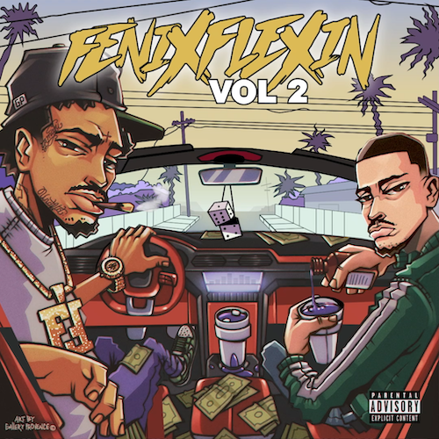
DOWNLOAD HI-RES ARTWORK

Multi-platinum hip-hop icon Fenix Flexin has shared his long awaited new mixtape, FENIX FLEXIN VOL. 2, available today via Atlantic Records at all DSPs and streaming services. The project is highlighted by the new single, “Red Flag,” along with such recently premiered tracks as “Threat“ and “ZaZa,” both now joined by official music videos streaming now at YouTube HERE.

FENIX FLEXIN VOL. 2 was first heralded late last year with the braggadocious first single “Fenix Flexin Vol. 2 Intro,” followed by the bold and boastful “Dead Homies,” both joined by official visuals streaming now at YouTube HERE.

Known worldwide for his flashy West Coast flow, Fenix Flexin kicked off his solo career in style with last summer’s debut mixtape, FENIX FLEXIN VOL. 1, reaching Spotify’s “Top 10 – USA” while earning more than 35M global streams thanks to such stand-out singles as “10 Toes,” the Ron-Ron and Menace-produced “For Me,” “NDS,” “True 2 This (Feat. Bravo The Bagchaser),” and the fan favorite, “Risky.” Fenix followed the successful project with his first ever solo multi-city tour, “Fenix Flexin Vol. 1 Tour,” as well as show-stealing sets at such festivals as Rolling Loud LA. In addition, last year saw Fenix open the doors on his own Burnt Co, a new lifestyle and skateboard apparel company launched with a top team of pro skaters including Kevin Viernes, Blazzy, Kevin Scott, and others.

Fenix Flexin is of course renowned as a founding member of the multi-platinum certified hip-hop group, Shoreline Mafia, propelling them to over 1B worldwide streams, sold out arena tours, and a long string of hugely popular, critically acclaimed releases including 2017’s now-classic debut mixtape, SHORELINEDOTHATSHIT, as well as such singles as the RIAA platinum certified “Musty” and “Nun Major,” the gold certified “Whuss The Deal” and “Bottle Service,” and the 2x platinum smash, “Bands (Feat. Rob Vicious).”

“The group had a bunch of respect, a huge following, and a whole lot of people behind us,” Fenix Flexin says. “Now I’m claiming all of those things for myself as an individual, and I’m off to a good start.”
# # #

CONNECT WITH FENIX FLEXIN
WEBSITE | INSTAGRAM | SOUNDCLOUD | TWITTER | YOUTUBE | BURNT CO.

PRESS CONTACT:
Brittany Bell | Brittany.Bell@atlanticrecords.com

