FOR IMMEDIATE RELEASE
JUNE 12, 2020

FRED AGAIN.. RELEASES “ADAM (ACT LIKE)”

TRACK SAMPLES FREESTYLE BY RAPPER AMINÉ

WATCH “ADAM (ACT LIKE)” HERE

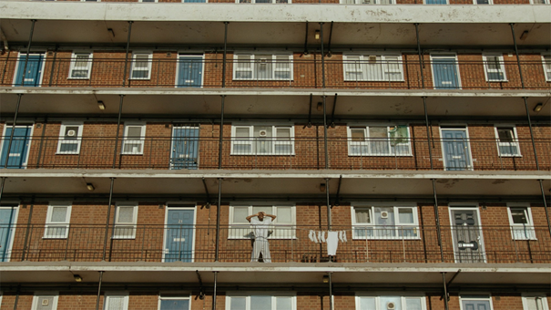
(download high res video stills HERE)

“A mixture of muted, subtle electronics carry the faintest hint of a rave influence, yet there's a noticeable edge of melancholy about it….The result is a melancholic look back at what our social lives used to look like — and the video that comes with it reflects that perfectly”
COMPLEX

“Listening to Fred again..’s music feels like you’ve stumbled onto something very personal... it’s how he collaborates with the world outside music that makes his sound especially visceral.”
HIGH SNOBIETY

“It’s the search for authenticity that makes Fred again.. so exciting – and makes us reckon he could be the real deal.”
MIXMAG

Today, London-based musical polymath Fred again.. has released his new single “Adam (Act Like).” The track is built around a sample of a freestyle by Portland rapper Aminé -- watch the official video, which premiered via Complex, HERE.

“I made this tune from sampling an Aminé freestyle I saw on Insta,” says Fred again... “At one point he goes, ‘and we act like, it’s alright, when it’s not’ and it was so direct it cut through the whole verse to me. So I made a song around it and sang some verses. Another line he says is, ‘I bench press my problems like ‘add another weight.’’ And that’s a really beautiful modern macho line to me. Also LOVE to Aminé for being so safe about this as alwayyyss”

The prolific producer originally previewed the track last month as part of his much-hyped mix for High Snobiety’s High Snobiety Soundsystem, premiering it among a host of brand new Fred again.. original music and exclusive edits.

Following “Kyren (My Son),” the new track is the latest in a collection of music Fred describes as ‘Actual Life’. His signature sound sees him building tracks around vocals uncovered from the unlikeliest of sources; from obscure YouTube clips to personal FaceTime conversations, random Instagram accounts and iPhone video footage of half-remembered nights out. Rather than creating songs about experiences, the music is actually made out of those experiences. The end results - often made on the move wherever Fred has his laptop - shift between dancefloor-inspired euphoria and yearning melancholy.

This latest release follows the success of Fred again..’s acclaimed artist collaboration with Headie One. Their GANG mixtape, released in April via Relentless, was the culmination of months of collaboration in the studio between the two artists, who first struck up a close friendship in 2019. Since then the pair worked together to take their individual signature sounds into a unique new direction and GANG is their full length statement, the sound of two musical worlds coming together. Across the mixtape's eight tracks, the duo are joined by exciting and innovative artists including FKA twigs, Jamie xx, Sampha, Octavian and Berwyn.

In addition, Fred continues to debut exclusive new music on his Rinse FM residency, regularly building entire shows out of the tracks and collaborations he’s currently working on in the studio. A full archive of the shows can be found at Fred’s Soundcloud

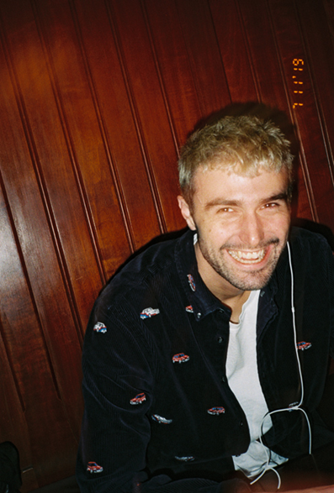
(Fred again.. photographed by Jack Bridgland. High res here)

Fred again.. Instagram / Soundcloud

FOR PRESS INQUIRIES, PLEASE CONTACT
KELLY MCWILLIAM // KELLY.MCWILLIAM@ATLANTICRECORDS.COM

