FOR IMMEDIATE RELEASE
FEBRUARY 22, 2021

FRED AGAIN.. RELEASES “MAREA (WE’VE LOST DANCING)”

THE NEW SINGLE OUT NOW
FEATURING THE BLESSED MADONNA

LISTEN TO “MAREA (WE’VE LOST DANCING)” HERE

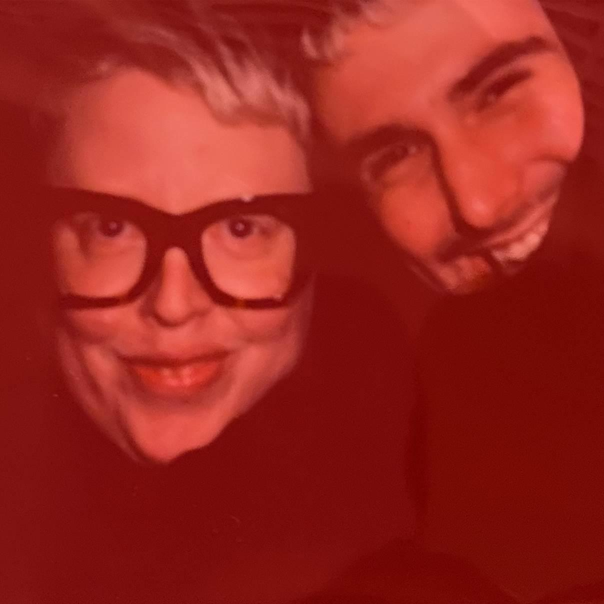

Today, February 22nd, multi-faceted London-based artist Fred again.. releases his latest single “Marea (We’ve Lost Dancing)”. Featuring the voice of dance music icon Marea Stamper aka The Blessed Madonna on record for the very first time, the track is a eulogy to the dancefloor and to the things we used to take for granted. It’s simultaneously nostalgic, longing and hopeful with a sense of optimism best summed up in Marea’s own words on the record: “if I can live through this next six months / day by day / if I can live through this / what comes next will be… marvellous!”

STREAM / DOWNLOAD “MAREA (WE LOST DANCING)” HERE

Talking about the song, Fred again.. says:

“Marea and I met in Palestine around 5 years ago now. I call her my rave shaman. I think she’s that for a lot of other people too to be honest! Her ability to tell stories and share things has always been a particularly beautiful part of her beautiful mind so I guess it makes sense that i ended up making a song out of sampling one of our conversations! She's a real hug of a human.“

Meanwhile Marea Stamper adds:

“Right from the second I met Fred there was a real closeness and even though I didn’t know him at all, I always felt like “this is gonna be a person in my life”. On this particular night in lockdown, Fred asked how I was feeling and I just talked to him like I normally would. Somehow he digs in all my babble and makes it into something beautiful and personal. Fred is a singular artist. He had such a tender way of looking at sound. You can’t fake it. You gotta have real heart. No one has a heart like that.”

The release follows the recent success of “Don’t Judge Me”, Fred’s highly acclaimed artist collaboration with FKA twigs and Headie One which fully realised the potential of the “Judge Me” interlude from Fred and Headie’s 2020 GANG mixtape. Co-produced by Boston Bun, “Marea (We Lost Dancing)” is the latest in a series of ‘Actual Life’ releases from Fred again.. including “Julia (Deep Diving)”, “Jessie (I Miss You)” and “Kyle (I Found You)”. It’s a signature sound that sees him building tracks around vocals uncovered from the unlikeliest of sources; from obscure YouTube clips to personal FaceTime conversations, random Instagram accounts and iPhone video footage of half-remembered nights out

In recent months, Fred has also added his production skills to tracks as diverse as Headie One, AJ Tracey and Stormzy’s “Aint It Different” and “Lifetime” the acclaimed debut solo single from The xx’s Romy. In 2020, he also released GANG, his project with Headie One that saw the two friends collaborating alongside features from some of the UK's most exciting and innovative artists including FKA twigs, Jamie xx, Sampha, Slowthai and Berwyn.

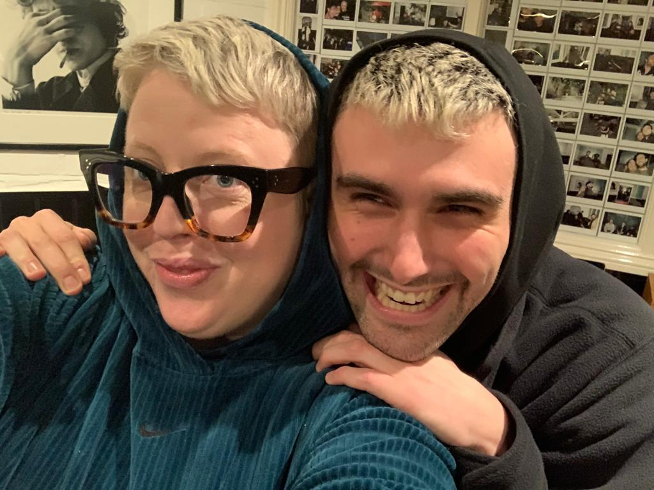

"Fred again... is on fire this year."
- THE FADER

“It’s the search for authenticity that makes Fred again.. so exciting – and makes us reckon he could be the real deal.”
- MIXMAG

"Fred again.. is solidifying himself as the producer of the moment and, quite possibly, the future"
- LOUD & QUIET

“Fred again.. is a British artist taking a unique approach to his mesmerizing dance tracks”
- PIGEONS & PLANES

“Listening to Fred again..’s music feels like you’ve stumbled onto something very personal. In many ways, his oeuvre is a diary with multiple authors. Fred again.. is the producer behind some of the UK’s biggest tracks in recent years can count Stormzy, Headie One, and Ed Sheeran as collaborators.
But it’s how he collaborates with the world outside music that makes his sound especially visceral”
- HIGH SNOBIETY

Fred again.. Instagram / Soundcloud

For press inquiries, please contact:
Kelly McWilliam // Kelly.McWilliam@atlanticrecords.com

