FOR IMMEDIATE RELEASE
MAY 18, 2022

JEHKAI SHARES “SUNNY DAYS”

UP-AND-COMING COMPTON RAPPER SWITCHES UP THE BEAT WITH MELODIC NEW TRACK

OFFICIAL MUSIC VIDEO PREMIERES TODAY AT YOUTUBE

POVERTY POET EP ARRIVES VIA ATLANTIC RECORDS LATER THIS SUMMER

“SUNNY DAYS” AVAILABLE NOW AT ALL DSPS AND STREAMING SERVICES

LISTEN TO “SUNNY DAYS” | WATCH OFFICIAL MUSIC VIDEO

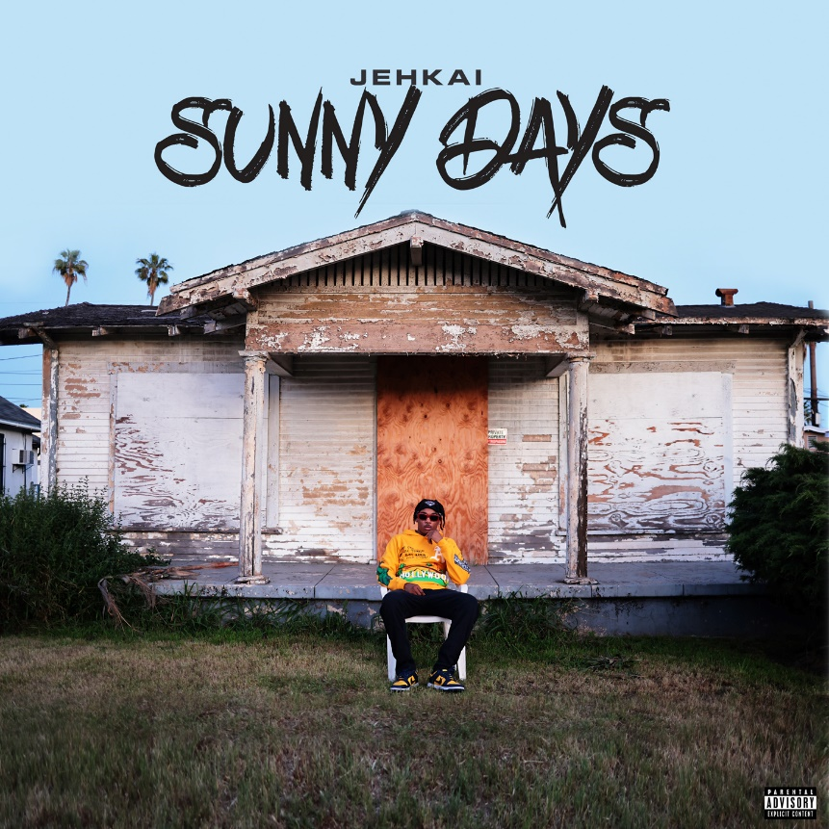
DOWNLOAD HI-RES ARTWORK

Rising Compton, CA rapper Jehkai has announced today’s premiere of “Sunny Days,” available now at all DSPs and streaming services. The deeply personal track is joined by an official music video streaming now at YouTube HERE.

“Sunny Days” – which features an irresistible interpolation of New Edition’s classic 1988 R&B hit, “Can You Stand the Rain” – sees Jehkai switching up the beat to convey raw emotions, both the good and the bad, despite the adversities of his Compton youth. Produced by SpeakerBangerz x LC, the track marks the latest single from the up-and-coming MC’s highly anticipated Poverty Poet EP, due later this summer.

2022 has already seen Jehkai unleash a steady stream of new music, including “Count Me Out,” “Emotional Ride,” and “To Live and Die in LA,” all joined by electrifying music videos is streaming now at his official YouTube channel HERE.

Jehkai made his Atlantic Records debut with last year’s summer-ready banger, “Frostbite (Feat. Bankroll Freddie),” available now at all DSPs and streaming services HERE; an official music video – which features the two rappers flexing their ice, throwing bands, and driving sportscars – is streaming now via YouTube HERE. He quickly followed up with the powerful “This Ain’t The Life,” available for streaming and download HERE. Produced by HoodWithAnotha1 (Boosie Badazz, OBN Jay) and JM Productions Worldwide, the emotive trap cut is also joined by an official music video, streaming now HERE.

Jehkai’s music feels like a tour through his hometown of Compton, CA. The talented rapper, singer, and artist was born the sixth of eight kids and immediately understood hardship, living in the projects with his grandmother, and eventually in a van. Nevertheless, he immersed himself in music, listening to everyone from Michael Jackson to Tupac to Drake. Jehkai dropped his first independent single, “The Field,” in 2020 and honed his signature style on follow-up “Glory To God,” blending new age street rap, impressive pitch, and vocal acrobatics.

Since then, Jehkai has been steadily building momentum on SoundCloud with his weekly Free the Pain Preacher Fridays drops, garnering more than 1.2M streams with such tracks as “True Colors,” “Steal Me,” “Life Goes On,” “Trenches,” “Dead Homies,” and “Gang Signs.”

“When you listen to me, I hope you relate and want to hear the next chapter,” Jehkai says. “I want you to think. I want you to cry. I want you to feel my pain and maybe, because of it, feel better.”

# # #

(DOWNLOAD HI-RES IMAGE // PHOTO CREDIT: ROYAL & RAE, LLC)

CONNECT WITH JEHKAI
INSTAGRAM | TWITTER | SOUNDCLOUD | YOUTUBE

Press contact | corey.brewer@atlanticrecords.com

