FOR IMMEDIATE RELEASE
AUGUST 18, 2022
KALI MAKES THINGS “WET” IN LATEST VISUAL AND SINGLE
RISING RAP STAR RECENTLY APPEARED ON THE COVER OF XXL’S 2022 FRESHMAN CLASS
FOLLOW UP TO RECENT “FNF (FREESTYLE)” AND HER XXL FRESHMAN CYPHER
TOXIC CHOCOLATE EP RELEASED EARLIER THIS YEAR AVAILABLE FOR STREAMING
WATCH “WET” VISUAL
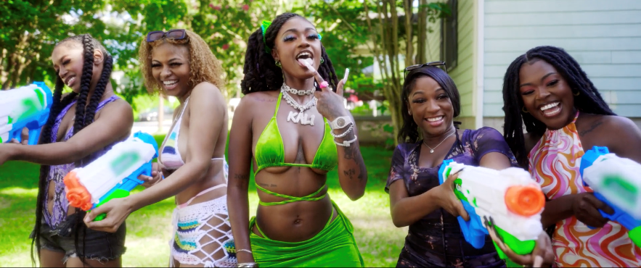

Rising Atlanta, GA rap star Kali has released her latest single for “Wet” available now for streaming on all DSPs. The single is accompanied by a visual streaming now via YouTube. “Wet” also comes on the heels of her recent admission to the XXL 2022 Freshman class. This momentous, career-defining feat is supported by her thrilling freestyle and cypher performances streaming now. Kali also recently brought her intoxicating flow to her “FNF (Freestyle)” available for streaming now.

Toxic Chocolate – available now at all DSPs and streaming services – arrived earlier this year amidst both popular and critical acclaim, with Hot New Hip Hop simply declaring her “Rap's Next ‘It’ Girl.” The EP is highlighted by the incendiary singles, “UonU (Feat. Yung Bleu)“ and “Standards,” the latter of which had its exclusive premiere – alongside Kali’s debut interview – on Apple Music’s New Music Daily Radio with Zane Lowe. Kali then increased the power of Toxic Chocolate with the surprise addition of the fan favorite “Chainzzz (Feat. Muni Long)” as well as a revised sequence.

The arrival of Toxic Chocolate was further joined by an electrifying performance of the EP standout, “New Day,” filmed exclusively for UPROXX Sessions and streaming now HERE. UPROXX further praised Kali for “her gift for wordplay and her spicy relationship sensibilities,” adding, “(Kali) turns the tables on the f*ckboys of hip-hop, using their manipulative tactics to even the odds and give them a taste of their own medicine.”

# # #

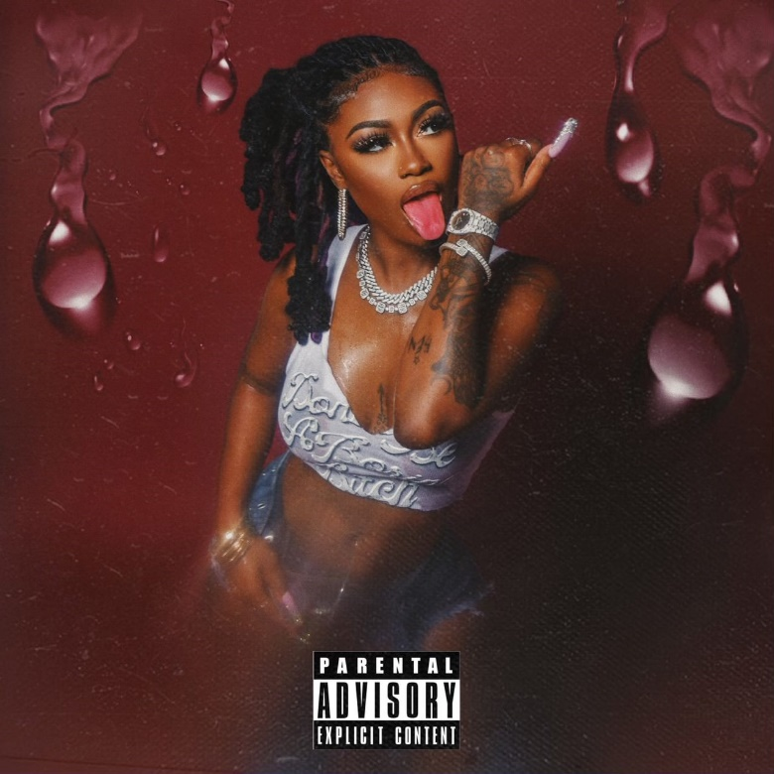

CONNECT WITH KALI
TIKTOK | TWITTER | INSTAGRAM | FACEBOOK | YOUTUBE

PRESS CONTACT
Ariana White | Ariana.White@AtlanticRecords.com

