FOR IMMEDIATE RELEASE
AUGUST 24, 2022

KEVIN GATES DROPS LATEST SINGLE “MAJOR LEAGUE”

FOLLOW UP TO “BAD FOR ME” VISUAL STREAMING NOW

KHAZA ALBUM AVAILABLE NOW FOR STREAMING AND DOWNLOAD

BIG LYFE TOUR KICKED OFF LAST WEEK IN DALLAS, TX

STREAM AND DOWNLOAD “MAJOR LEAGUE”

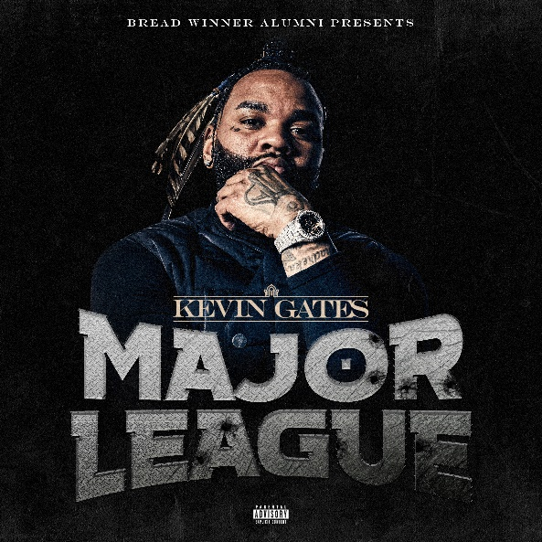
DOWNLOAD HI-RES ART

RIAA multi-platinum certified rap superstar Kevin Gates released his latest single “Major League” via Bread Winner Alumni/Atlantic Records. “Major League” comes on the heels of his third studio album, released in June, KHAZA. The track is also a follow up to visuals for “Bad For Me,” “Intro,” and “Super General (Freestyle).” The latter at over 30M streams via YouTube.

KHAZA, the 19-track album released earlier this year, includes the acclaimed songs, “Intro,” “Bad For Me” and “Big Lyfe,” all available now to stream via YouTube HERE. Named after his son Khaza, the body of work was birthed from Kevin’s innate parental instinct to give Khaza free game he’s picked up over the years in addition to the critical importance of paying forward all the advice he’s received, and the tough lessons learned so that Khaza can be an even grander man than him. Gates will also celebrate KHAZA with the epic “Big Lyfe Tour,” which kicked off last week in Dallas, TX’s The Pavilion at Toyota Music Factory and will continue into mid-October. For updates, please visit www.kvngates.com/tour.

# # #

Kevin Gates is of course among the most impactful and inimitable rappers of the modern era, racking up more than 19B worldwide streams, 7B views, countless RIAA multi-platinum, platinum, and gold certifications, and a social media reach exceeding 31M followers around the globe. For 15 years, the Baton Rouge, LA-based icon’s artistry has drawn critical acclaim and unprecedented popular success, resulting in four top 5 entries on the Billboard 200 – including 2016’s 2x RIAA platinum certified classic, ISLAH, 2017’s BY ANY MEANS 2, 2018’s LUCA BRASI 3, and 2019’s I’M HIM – as well as seven debuts among the top 5 on both the “Top Rap Albums” and “Top R&B/Hip-Hop Albums” charts. An electrifying live performer, Gates has lit up countless stages around the world, spanning headline tours, show-stopping festival sets, and arena tours alongside such fellow superstars as Cardi B. Indeed, Gates has been an in-demand collaborator, with featured appearances on hit tracks from Gucci Mane, YoungBoy Never Broke Again, Da Baby, and Lil Durk, to name only a few. In addition, his inspirational online series, The Kevin Gates Helpline, is currently in its second season and streaming now via VICE. With the wind at his back, Gates has released his third full-length Bread Winner Alumni/Atlantic Records LP, the hugely anticipated KHAZA, setting his own exceptional path towards greatness with every step.

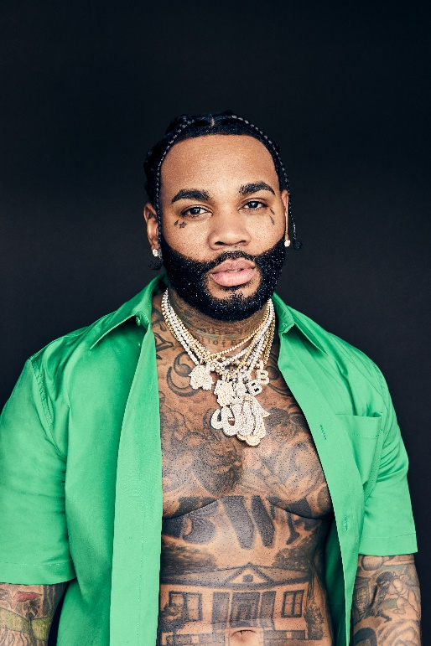

# # #

CONNECT WITH KEVIN GATES
WEBSITE | TWITTER | TIKTOK | INSTAGRAM | FACEBOOK | SOUNDCLOUD | YOUTUBE

FOR KEVIN GATES INQUIRIES, CONTACT
SYDNEY.MARGETSON@ATLANTICRECORDS.COM

