FOR IMMEDIATE RELEASE
AUGUST 30, 2022

MULTI-PLATINUM LATIN SENSATION MALÚ TREVEJO SHARES NEW SINGLE
“TU LO TIENES (FEAT. YOVNGCHIMI)”

FOLLOW UP TO EXPLOSIVE SINGLE “CULO CHAPA (FEAT. LA PERVERSA, QUIMICO ULTRA MEGA & HARACA KIKO)”

SINGLE FEATURES THE BAD BUNNY CO-SIGNED AND PUERTO RICAN BREAKOUT STAR YOVNGCHIMI

LISTEN TO “TU LO TIENES” | WATCH “TU LO TIENES”

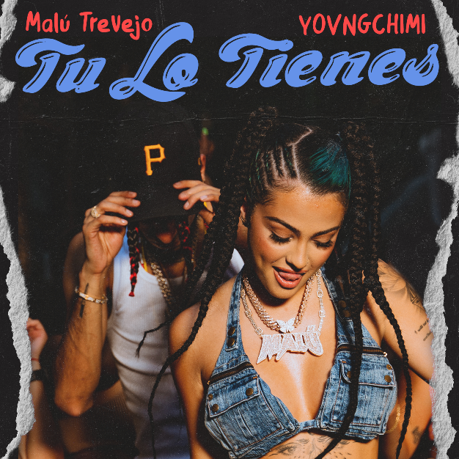
DOWNLOAD HI-RES ART

Multi-platinum Latin music sensation Malú Trevejo has released her latest single “Tu Lo Tienes (feat. YOVNGCHIMI).” The undeniable summer anthem features, YOVNGCHIMI, the Puerto Rican breakout star recently co-signed by Bad Bunny. “Tu Lo Tienes” is also accompanied by a visual directed by the dynamic duo Ring Ring (Alex and Tristan Demic) streaming via YouTube now. The energetic yet fun single is a follow up to the vibrant and sexy “Culo Chapa (Feat. La Perversa, Quimico Ultra Mega & Haraca Kiko” and is streaming now via YouTube.

Teased via TikTok to viral praise from Malú’s dedicated fanbase, the track written by Malú, features production from DVLP and Jota Rosa. Previously released “Culo Chapa,” saw the Miami-based Cuban/Spanish-American star continuing her meteoric rise to the top of the Latin music scene with the visual now at almost 8M views via YouTube and streaming now. “Cula Chapa” followed last year’s Atlantic Records debut single, “Complicado (Feat. Luar La L.),” available now for streaming and download HERE. The electrifying track is joined by an official music video, now boasting over 21M views via Malú’s official YouTube channel HERE.

With a show-stopping voice, undeniable energy, and no shortage of attitude, Malú Trevejo emerged as an undeniable phenomenon by simply being herself. She initially exploded with the RIAA Latin platinum-certified breakout, “Lune Lluna,” paving the way for collaborations with the likes of superstar duo Gented e Zona, Haraca Kiko, and Jeon, as well as packed shows across the United States, Spain, and Latin America.

With a social media following now exceeding 37M across all platforms - including more than 11.5M on Instagram alone – Malú has proven a show-stopping live performer, including a historic appearance at Lollapalooza as one of the first Latina artists to ever grace the Chicago stage. Along with her growing music career, Trevejo is also set to make her big screen debut in the forthcoming feature film, Wolf Mountain.

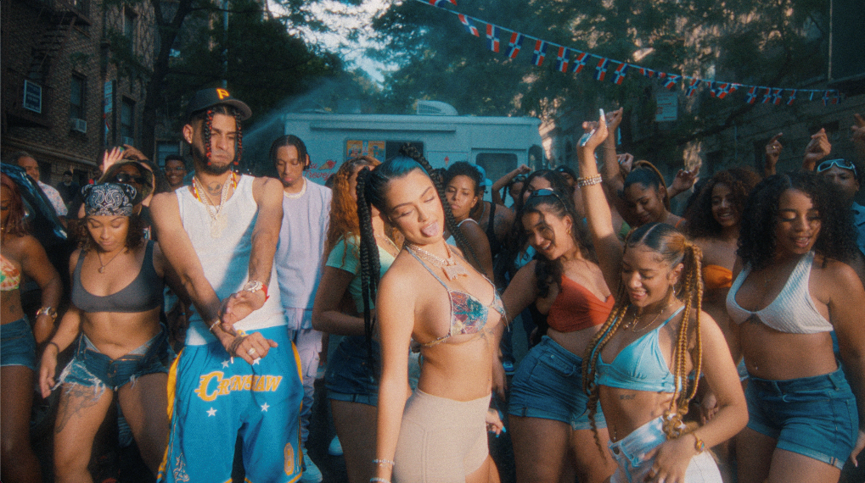

# # #

CONNECT WITH MALÚ TREVEJO
TIKTOK | TWITTER | INSTAGRAM | FACEBOOK | YOUTUBE

PRESS CONTACTS
Ariana White Ariana.White@atlanticrecords.com

