**MASON RAMSEY RETURNS WITH OFFICIAL MUSIC VIDEO FOR “BEFORE I KNEW IT”**

**NEW MUSIC COMING SOON**

[**WATCH HERE**](https://www.youtube.com/watch?v=RP2rCjMbWbo)

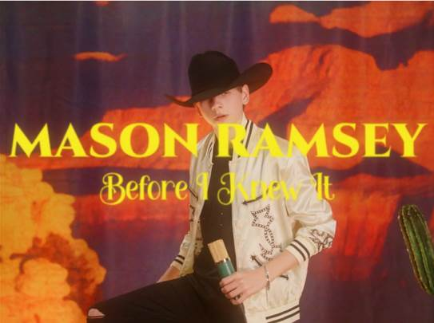

[**DOWNLOAD/STREAM HERE**](https://masonramsey.lnk.to/BeforeIKnewIt)

**(NEW YORK, NY – April 20, 2022)** – Rising country music star, **Mason Ramsey** returns with the official music video for viral single, **“Before I Knew It,”** directed by **Luke Harvey**. **WATCH** [**HERE**](https://www.youtube.com/watch?v=RP2rCjMbWbo)**.**

At the top of 2022, **“Before I Knew It,”** went viral on [**TikTok**](https://www.tiktok.com/@masonramsey/video/7056925572278078766?is_copy_url=1&is_from_webapp=v1&lang=en) amassing 550K creates and 3 billion views on the platform, over 2.7 million on the song’s visualizer, and over 30 million streams, to date.

**“Before I Knew It”** comes off Ramsey’s 2019 project, ***TWANG EP.*** Ramsey then hit the road on his sold out **“How’s Your Girl and How’s Your Family”** tour and took the stage with **Lil Nas X** at the 62nd annual Grammy Awards to perform their record breaking collab **“Old Town Road.”**

Look out for new music from 15-year-old country superstar coming later 2022.

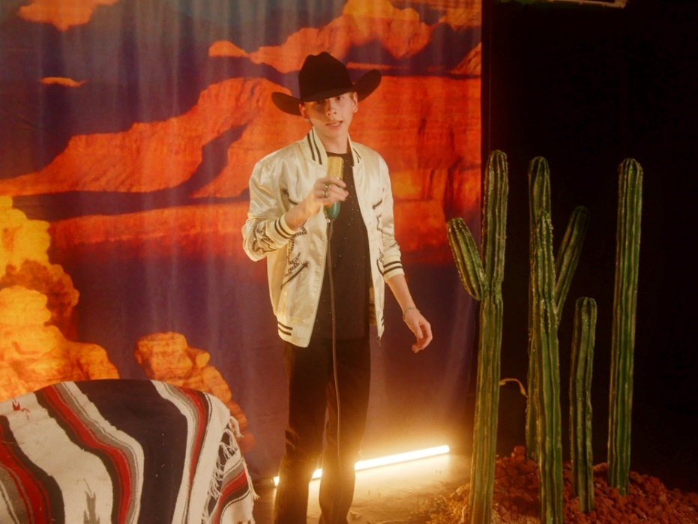

**Connect with Mason Ramsey**

[INSTAGRAM](https://nam04.safelinks.protection.outlook.com/?url=https%3A%2F%2Fwww.instagram.com%2Fmasonramsey%2F%3Fhl%3Den&data=05%7C01%7CTaylor.Apel%40atlanticrecords.com%7C3a2cf4fdcbc24046fb3d08da22d7b3aa%7C8367939002ec4ba1ad3d69da3fdd637e%7C0%7C0%7C637860607065643145%7CUnknown%7CTWFpbGZsb3d8eyJWIjoiMC4wLjAwMDAiLCJQIjoiV2luMzIiLCJBTiI6Ik1haWwiLCJXVCI6Mn0%3D%7C3000%7C%7C%7C&sdata=VsPnDwSYr9WVw%2FdNYhZVE%2Bvx4HDMqMIH7ndaRsiHg7E%3D&reserved=0) | [TWITTER](https://nam04.safelinks.protection.outlook.com/?url=https%3A%2F%2Ftwitter.com%2Fmasonramsey%3Flang%3Den&data=05%7C01%7CTaylor.Apel%40atlanticrecords.com%7C3a2cf4fdcbc24046fb3d08da22d7b3aa%7C8367939002ec4ba1ad3d69da3fdd637e%7C0%7C0%7C637860607065643145%7CUnknown%7CTWFpbGZsb3d8eyJWIjoiMC4wLjAwMDAiLCJQIjoiV2luMzIiLCJBTiI6Ik1haWwiLCJXVCI6Mn0%3D%7C3000%7C%7C%7C&sdata=OcesMlsq8QSC5crlOOzqKoA3a7VAtbetTWHxGBcHEEs%3D&reserved=0) | [FACEBOOK](https://nam04.safelinks.protection.outlook.com/?url=https%3A%2F%2Fwww.facebook.com%2FtheMasonRamsey&data=05%7C01%7CTaylor.Apel%40atlanticrecords.com%7C3a2cf4fdcbc24046fb3d08da22d7b3aa%7C8367939002ec4ba1ad3d69da3fdd637e%7C0%7C0%7C637860607065643145%7CUnknown%7CTWFpbGZsb3d8eyJWIjoiMC4wLjAwMDAiLCJQIjoiV2luMzIiLCJBTiI6Ik1haWwiLCJXVCI6Mn0%3D%7C3000%7C%7C%7C&sdata=%2FJw%2F%2BklSAf4YERbkXYw0Fq8e2SRN1XkiufE%2Fovxrq0A%3D&reserved=0) | [TIKTOK](https://nam04.safelinks.protection.outlook.com/?url=https%3A%2F%2Fwww.tiktok.com%2F%40masonramsey%3Flang%3Den&data=05%7C01%7CTaylor.Apel%40atlanticrecords.com%7C3a2cf4fdcbc24046fb3d08da22d7b3aa%7C8367939002ec4ba1ad3d69da3fdd637e%7C0%7C0%7C637860607065643145%7CUnknown%7CTWFpbGZsb3d8eyJWIjoiMC4wLjAwMDAiLCJQIjoiV2luMzIiLCJBTiI6Ik1haWwiLCJXVCI6Mn0%3D%7C3000%7C%7C%7C&sdata=2paDBqsMA0uwnB%2BUYbe3Uz1II%2FGoUEfMf6xL0rJtGxA%3D&reserved=0)

**Press Contact**

**Jason Davis** – [Jason.Davis@atlanticrecords.com](mailto:Jason.Davis@atlanticrecords.com)  
**Andrew George** – [andrew.george@atlanticrecords.com](mailto:andrew.george@atlanticrecords.com)

**ABOUT MASON RAMSEY:**  
As the youngest major label Country artist signed in the genre in nearly two decades, MASON RAMSEYcontinues his fast-track to stardom after being discovered singing in an aisle at his local Walmart. Praised by ***THE NEW YORK TIMES*** as delivering "a stylistically diverse country and roots music EP,” the **ATLANTIC RECORDS** artist’s debut ***FAMOUS EP*** (Atlantic Records/Big Loud Records) spawned a hit single of the same name which scored a **#4 spot on *Billboard*’s Hot Country Songs Chart**. In addition to making his debut at the famed Grand Ole Opry, the Golconda, IL-bred phenom has also performed at several high-profile festivals including **CMA FEST**, **iHEARTCOUNTRY FESTIVAL**, **STAGECOACH**, and **COACHELLA**, with high profiled TV performances on **THE** **ELLEN DEGENERES SHOW** and **THE** **TODAY SHOW**.

###