FOR IMMEDIATE RELEASE
April 15, 2022

RAEDIO / ATLANTIC RECORDING ARTIST NCOGNITA GIVES YOU THE KEY TO HER LIFE WITH DEBUT EP THE PLAYBOOK
STREAM HERE

EP ACCOMPANIED BY OFFICIAL MUSIC VIDEO FOR FOCUS TRACK
“JUST WHAT IT SEEM”
WATCH HERE

NCOGNITA LIGHTS UP INDIE RAP SHOW BARS ON I-95 WITH HOT NEW FREESTYLE + EXCLUSIVE INTERVIEW FILMED ON LOCATION AT HER COLLEGE
LOYOLA UNIVERISTY NEW ORLEANS
WATCH HERE

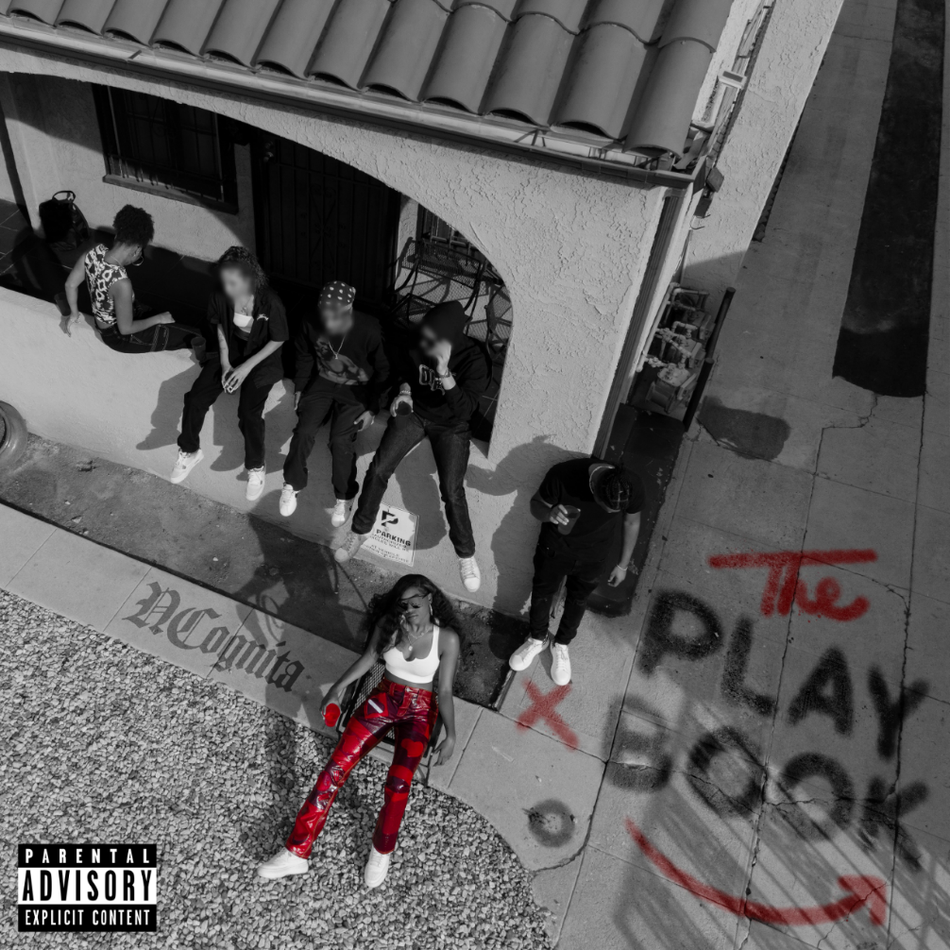
Download High-Res Artwork HERE | Photo Credit: Emilio Sanchez

Raedio / Atlantic Records recording artist and rising lyricist NCognita releases her major label debut EP, The Playbook today across all streaming platforms HERE. In her seven-track EP, NCognita flaunts her ability to effortlessly switch flows while delivering her unfiltered personality on every bar. The long-awaited project drops with focus track + official music video “Just What it Seem”. NCognita spits unapologetically about her nonchalant way of being, as she confidently strolls through the alleys of LA. Giving you a glimpse into NCognita's world. Watch HERE.

“I wrote this project for people like me. People who find life in words and make moments out of details.” says NCognita. “The Playbook is for the ones who are challenged in everyday causalities but still find ways to turn those challenges into drills that strengthen their every play. This EP itself came with a lot of blood, sweat and tears. But now I can finally say it’s time to play!”

Capturing her in her true element as a skilled lyricist and captivating performer, NCognita sets fire to the Bars On I-95 platform with live freestyle and interview filmed on location at her college—Loyola University New Orleans. Nita packed out the room with a live audience bringing the student body and professors to their feet. Watch her episode HERE.

NCognita aims to win over new fans with the release of The Playbook, showcasing how her strengths translate exceptionally well from the page to the mic. Using her killer mic instincts, she set fire to the 2022 BUKU Fest (BUKU Music + Arts Project) stage with a live performance on 3.26. Check out her live performance recap via IG Reels HERE. Leading a double life as both a full-time college student at Loyola University New Orleans and a burgeoning Hip Hop artist, NCognita is effortlessly balancing both of her worlds and is making a tremendous mark in music.

The Playbook Tracklist:

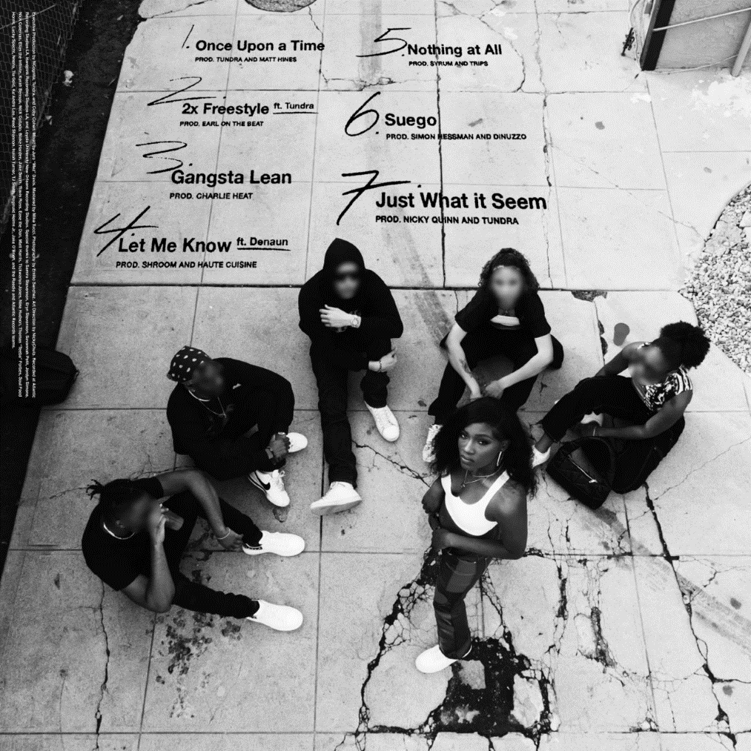

ABOUT NCOGNITA:
Standing firm in the belief that words have incredible power, NCognita is a 21-year-old rapper and poet from Los Angeles. As the latest addition to Issa Rae's music imprint under the renowned Atlantic Records umbrella, the South Central native brings her unabashed confidence and impassioned lyrical dexterity to the consciously curated Raedio roster. With poetry as her first love, NCognita's vibrant musical upbringing encouraged her to come into her own as a rapper. First embarking on the path of a recording artist during her senior year at the Los Angeles County High School for the Arts, NCognita decided to continue her musical education at Loyola University in New Orleans. Currently a junior in the Urban Electronic Music Production program, NCognita is grinding in every sense of the word, balancing her schoolwork with her forthcoming debut EP, The Playbook. Placing trust in her journey to unfold organically as it is destined to, NCognita is happily keeping her budding fanbase engaged with an array of one-off freestyles to come this summer.

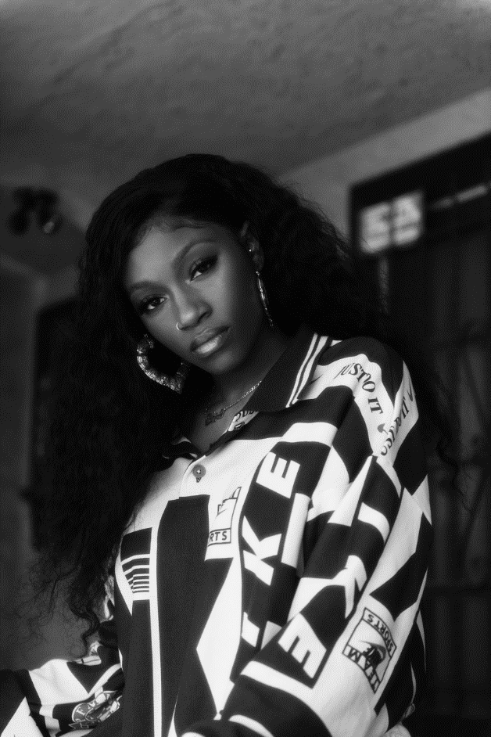
Download Press Asset HERE | Photo Credit: Emilio Sanchez

CONNECT WITH NCOGNITA
WEBSITE | TWITTER | INSTAGRAM | FACEBOOK | YOUTUBE

PRESS CONTACTS
Fairley McCaskill | Fairley.McCaskill@atlanticrecords.com

# # #

