FOR IMMEDIATE RELEASE

AUGUST 12, 2022

**GENEVIEVE STOKES UNVEILS NEW SINGLE “HABITS”**

**ALT-POP SINGER-SONGWRITER FOLLOWS DEBUT** [***SWIMMING LESSONS***](https://genevievestokes.lnk.to/SwimmingLessonsEPPR)**EP**

**WITH VIRAL FAN FAVORITE TRACK**

[**LISTEN TO “HABITS”**](https://genevievestokes.lnk.to/Habits) **|** [**WATCH THE OFFICIAL VISUALIZER**](https://GenevieveStokes.lnk.to/HabitsVisualizerPR)



**(DOWNLOAD HIGH-RES** [**PHOTOS**](https://warnermusicgroup.app.box.com/s/6z8wsz8zoaqzwt7gl4ztc6f47txchc8p) **// CREDIT: ABBIE PITRE)**

*“Stokes channels beautiful scenery and performs gut-wrenching ballads.”* – [**PAPER**](https://www.papermag.com/genevieve-stokes-habits-2657854522.html)

Acclaimed alt-pop singer-songwriter-pianist **Genevieve Stokes** has returned with her new single, “[**Habits**](https://genevievestokes.lnk.to/Habits),” available now via Atlantic Records at all DSPs and streaming services. An official visualizer is streaming now at YouTube [**HERE**](https://GenevieveStokes.lnk.to/HabitsVisualizerPR).

Written by Genevieve and produced by the esteemed Tony Berg (**Taylor Swift**, **Phoebe Bridgers**, **Paul McCartney**), “Habits” has already proven a viral fan favorite earning over **50M** views via a hugely popular series of [TikTok](https://www.tiktok.com/@hiigenevieve?) teaser videos.

“*I wrote ‘Habits’ in my parents’ garage last spring – my favorite time of year to make music,*” Stokes says. “*The lyrics are my stream of consciousness, flowing from feelings of self-pity and boredom to my worries about an emotionally turbulent relationship. It’s about longing for change after a dark winter.*”

“Habits” follows the Portland, ME-based musician’s acclaimed 2021 debut EP, [*Swimming Lessons*](https://GenevieveStokes.lnk.to/SwimmingLessonsEPPR), which features standout tracks “[Surface Tension](https://www.youtube.com/watch?v=lah6_gWVhsI),” “[Parking Lot](https://www.youtube.com/watch?v=EGZW0rXqQSI)” and “[Running Away](https://www.youtube.com/watch?v=QLZK9HgTsfs).” The critically acclaimed EP went on to earn over **16M** streams worldwide while receiving praise from publications including *Flaunt*, *NYLON*, *Billboard, Refinery29*, *FLOOD* and more. Named by *Alternative Press* as a “New Artist You Need To Hear,” Stokes recorded her debut EP in a cabin just a stone’s throw from her Maine childhood home, bringing a delicate, youthful and intimate touch to her storytelling. Over the past year, she celebrated the success of *Swimming Lessons* with a series of US tour dates alongside artists including **Noah Kahan**, **Briston Maroney**, and **Sarah Kinsley**.

At only 21-years-old, Genevieve has quickly drawn attention and applause for her intimate yet lush approach to alternative pop. Having taught herself piano at the age of eight, Stokes spent much of her teens developing her own unique sound, inspired by iconic female musicians like **Cat Power** and **Regina** **Spektor** but infused with personal experience and perspective. Before releasing her debut EP, Stokes had already amassed over **7M** streams independently, ascended esteemed playlists and garnered support from *Complex*, *Flaunt*, *EARMILK* and more.

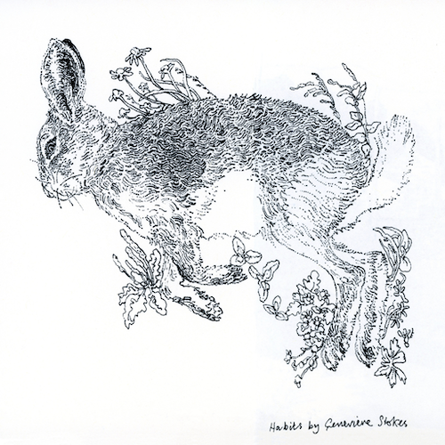

**(DOWNLOAD HIGH-RES** [**ARTWORK**](https://warnermusicgroup.app.box.com/s/5fo450n46x3lo7nfhg3oyhsz99xqrdyh) **// ILLUSTRATOR: JOHN HEWITT)**

**CONNECT WITH GENEVIEVE STOKES**

[OFFICIAL](https://www.genevievestokes.com/) | [INSTAGRAM](https://www.instagram.com/chowdergiirl/) | [TWITTER](https://twitter.com/hiigenevieve) | [YOUTUBE](https://www.youtube.com/channel/UCTJZrEMmkrtGqMohJC4P0Lg) | [FACEBOOK](https://www.facebook.com/hiigenevieve/) | [TIKTOK](https://www.tiktok.com/@hiigenevieve?) | [PRESS ASSETS](http://press.atlanticrecords.com/genevieve-stokes/)

**PRESS CONTACT:**

[ANDREW.GEORGE@ATLANTICRECORDS.COM](mailto:ANDREW.GEORGE@ATLANTICRECORDS.COM)