FOR IMMEDIATE RELEASE
AUGUST 12, 2022

JUSTICE CARRADINE SHARES “BETTER OFF ALONE”

DEBUT WHAT A WEIRD DREAM EP ARRIVES SEPTEMBER 16

LISTEN TO “BETTER OFF ALONE” | WATCH OFFICIAL VISUALIZER

PRE-ORDER/PRE-SAVE WHAT A WEIRD DREAM EP

DOWNLOAD HI-RES EP ARTWORK
CREDIT: BRANDON PHILLIPS

Chosen Music/Atlantic Records recording artist Justice Carradine has unveiled his latest single, “Better Off Alone,” which arrives alongside the announcement of his debut EP, What A Weird Dream, out Friday, September 16 and available to pre-order/save now HERE. Listen to “Better Off Alone” HERE and watch the official visualizer now streaming at YouTube HERE.

“To make a long story short, I’d rather be alone than be with the wrong company”

“I’ve had the title for this EP in my back pocket for literal years, so it’s been strange to finally see ‘what a weird dream’ come to life. I think this project captured a time of uncertainty, transition, and newness for me. so many people who were in my life are gone now, I feel like a completely different person, the world looks different to me. I’ve gained little bit more self-awareness, and kind of just accepted how temporary everything is. I feel like this EP scratches the surface of my mind and really solidified the feeling I have that life is just a weird dream.”

– JUSTICE CARRADINE

Justice officially kicked off this more vulnerable, self-assured new era with last month’s release of “Tears In My Eyes” and the beautiful visualizer, shot in his home state of Utah – watch HERE. Co-written by Justice and produced by JHart (Justin Bieber, Camila Cabello), Jesse St. John, and Pink Slip, the emotionally charged single was inspired by Justice’s first-ever panic attack, which he experienced driving from Utah to LA to record new music. Upon release, V Magazine quickly praised the singer-songwriter’s return writing, “The floaty, vibey track culminates in a quiet moment of introspection, where Carradine turns the studio into a therapy session, recounting his experience.”

“Tears In My Eyes” follows the self-reflective “Okay,” which similarly centered around mental health struggles Justice endured in his teens. PAPER called the “tender track,” joined by a cinematic music video (watch HERE), “quietly reflective and equally as vulnerable” while Billboard praised Justice’s vocal performance, writing, it “glistens with a warmth and sturdiness, his tone bouncing off the plucked guitar strings and eventually floating into a croon.”

Hailed by EUPHORIA as “an undeniable rising star,” Justice grew up in a household surrounded by music, picking up ukulele, drums, piano, and guitar at just five years of age. His rich family heritage – Italian on his dad’s side and half-Samoan/half-Apache on his mom’s – proved huge inspiring, with his Native American background especially influencing him on a profoundly personal level. At 13, Carradine began posting videos on Vine, quickly developing a devout social media following whilst still in junior high. He transitioned to YouTube in 2015, racking up more than 5M views for his inventive covers of artists including The 1975, Post Malone, and Ed Sheeran. Justice soon began penning his own songs fusing alternative, R&B, rock and more into his own brand of pop reminiscent of Conan Gray and Troye Sivan.

In 2019, Justice made his Chosen Music/Atlantic Records debut with the soulful single, “Dangerous Love,” for which the video premiered on Billboard. Soon after, the follow-up single, “Necessary Evil,” prompted Ones To Watch to declare him “a veritable pop tour-de-force.” Additional acclaimed releases followed including “Can’t Feel A Thing” and “Limbo.”

Known for his remarkable range and undeniable charisma, Justice proved an equally charming live performer, earning acclaim while touring North America alongside fellow rising stars Spencer Sutherland and K-Pop star Amber Liu. Carradine’s distinctive presence and unique style has also seen him featured in high profile campaigns for such diverse brands as Hollister, Puma, and M&Ms.

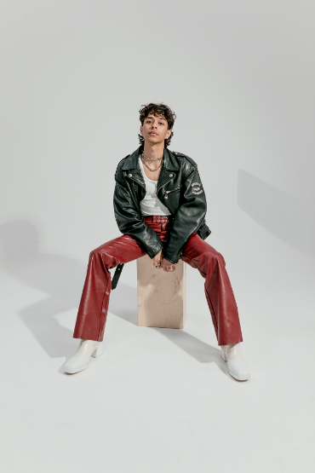
DOWNLOAD HIGH-RES PRESS PHOTOS
CREDIT: BRANDON PHILLIPS

CONNECT WITH JUSTICE:
OFFICIAL | INSTAGRAM | FACEBOOK | YOUTUBE | TWITTER | tiktok | PRESS ASSETS

PRESS CONTACT:
ANDREW.GEORGE@ATLANTICRECORDS.COM

