FOR IMMEDIATE RELEASE
AUGUST 12, 2022

MULTI-PLATINUM SINGER-SONGWRITER SORANA SHARES “WILD GIRLS”

EMPOWERING NEW SINGLE SAMPLES ENNIO MORRICONE’S ICONIC
THEME FROM “THE GOOD, THE BAD AND THE UGLY”

LISTEN HERE | WATCH OFFICIAL VISUALIZER

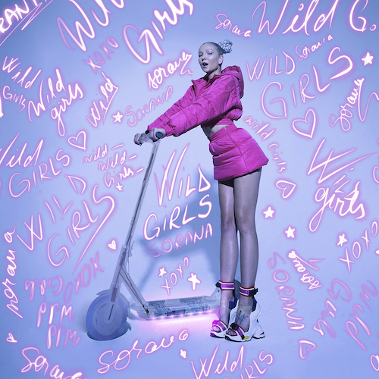
DOWNLOAD HI-RES ARTWORK

Multi-platinum singer-songwriter Sorana is back with her latest pop anthem, “Wild Girls,” available now at all DSPs and streaming services. See Sorana look out of this world as a futuristic cowgirl in the official animated visualizer – available to stream now HERE. Stemming from Sorana’s out of the box idea, “Wild Girls” features an interpolation of the late legendary composer Ennio Morricone’s “The Good, the Bad and the Ugly” theme and approved directly from the Morricone family, marking the first time the historical composition has been used in a pop song. The energetic and innovative track was produced by Nicki Adamsson (Icona Pop, Tove Lo) and co-written by Morten Schjolin (Jennifer Lopez) and Kes Noel.

“’Wild Girls’ is a female empowerment, western-inspired record that shows that no one can cross one of us girls and get away without a broken heart,” says Sorana. “It interpolates Ennio Morricone’s iconic theme from ‘The Good, The Bad, and The Ugly,’ to give it that cinematic vibe. I wanted to flip the male-dominated Western genre on its head. Women are really the fiercest cowboys.”

“Wild Girls” follows this spring’s release of Sorana’s debut solo single, “Karaoke” which POPDUST quickly called “stunning,” praising the song as an “epic heartbreaker ready for arenas.” Produced by chart-topping, GRAMMY® Award-winner Ali Payami (The Weeknd, Taylor Swift), the emotionally charged track is joined by an official music video streaming HERE.

Sorana kicked off 2022 with “redruM,” her explosive collaboration with superstar DJ/producer David Guetta, now boasting over 23.7M global audio streams. A dark and twisted music video – which sees Sorana haunting the halls of a Shining-style hotel with glowing blue braids, evoking her Sailor Moon obsession – streaming HERE. “redruM’ was also joined by a pair of high-energy remixes by GRAMMY® Award-nominated, German producer/DJ Robin Schulz (streaming HERE) and UK artist/producer MistaJam (streaming HERE), the latter of which received strong support across UK radio as well as being playlisted on Capital Dance. Since the release of the remixes, they have garnered a combined 8M+ streams to date.

Named by PEOPLE as one of “The Talented Emerging Artists Making Their Mark in 2022,” Sorana left her hometown of Romania and brought her dream to life with ambition, determination, and good old-fashioned hustle. The wildly gifted, LA-based songstress has swiftly gone from penning multi-platinum hits (including the chart-topping, RIAA platinum-certified “Takeaway (Feat. Lennon Stella)” for The Chainsmokers & Illenium, the BRIT Award-nominated, platinum-certified, “Heartbreak Anthem” for Galantis, David Guetta, & Little Mix, which hit #3 in the UK. She also co-wrote “Beg For You” for Charli XCX & Rina Sawayama, which reached #1 on UK Airplay charts, in additional to co-writing and lending her voice to Alan Walker’s “Lost Control (Feat. Sorana),” which generated over 120M worldwide streams and counting. With her debut solo singles, “Karaoke” and “Wild Girls” – and more unique and powerful pop music on the horizon – Sorana cements her status as a major new artist and unstoppable pop force to be reckoned with.

DOWNLOAD HI-RES PRESS PHOTOS
CREDIT: BRIAN ZIFF

CONNECT WITH SORANA:
FACEBOOK | INSTAGRAM | YOUTUBE | TIKTOK | PRESS ASSETS

PRESS CONTACT:
ANDREW.GEORGE@ATLANTICRECORDS.COM

