FOR IMMEDIATE RELEASE

AUGUST 19, 2022

SILK SONIC’S DEBUT ALBUM
AN EVENING WITH SILK SONIC EARNS RIAA PLATINUM CERTIFICATION
AFTER SWEEPING THE 64THANNUAL GRAMMY® AWARDS
OF ALL FOUR NOMINATED CATEGORIES

DUO RELEASES AN EVENING WITH SILK SONIC VINYL SET
AUGUST 26TH AVAILABLE VIA WEB STORE + IN-STORE
PURCHASE HERE

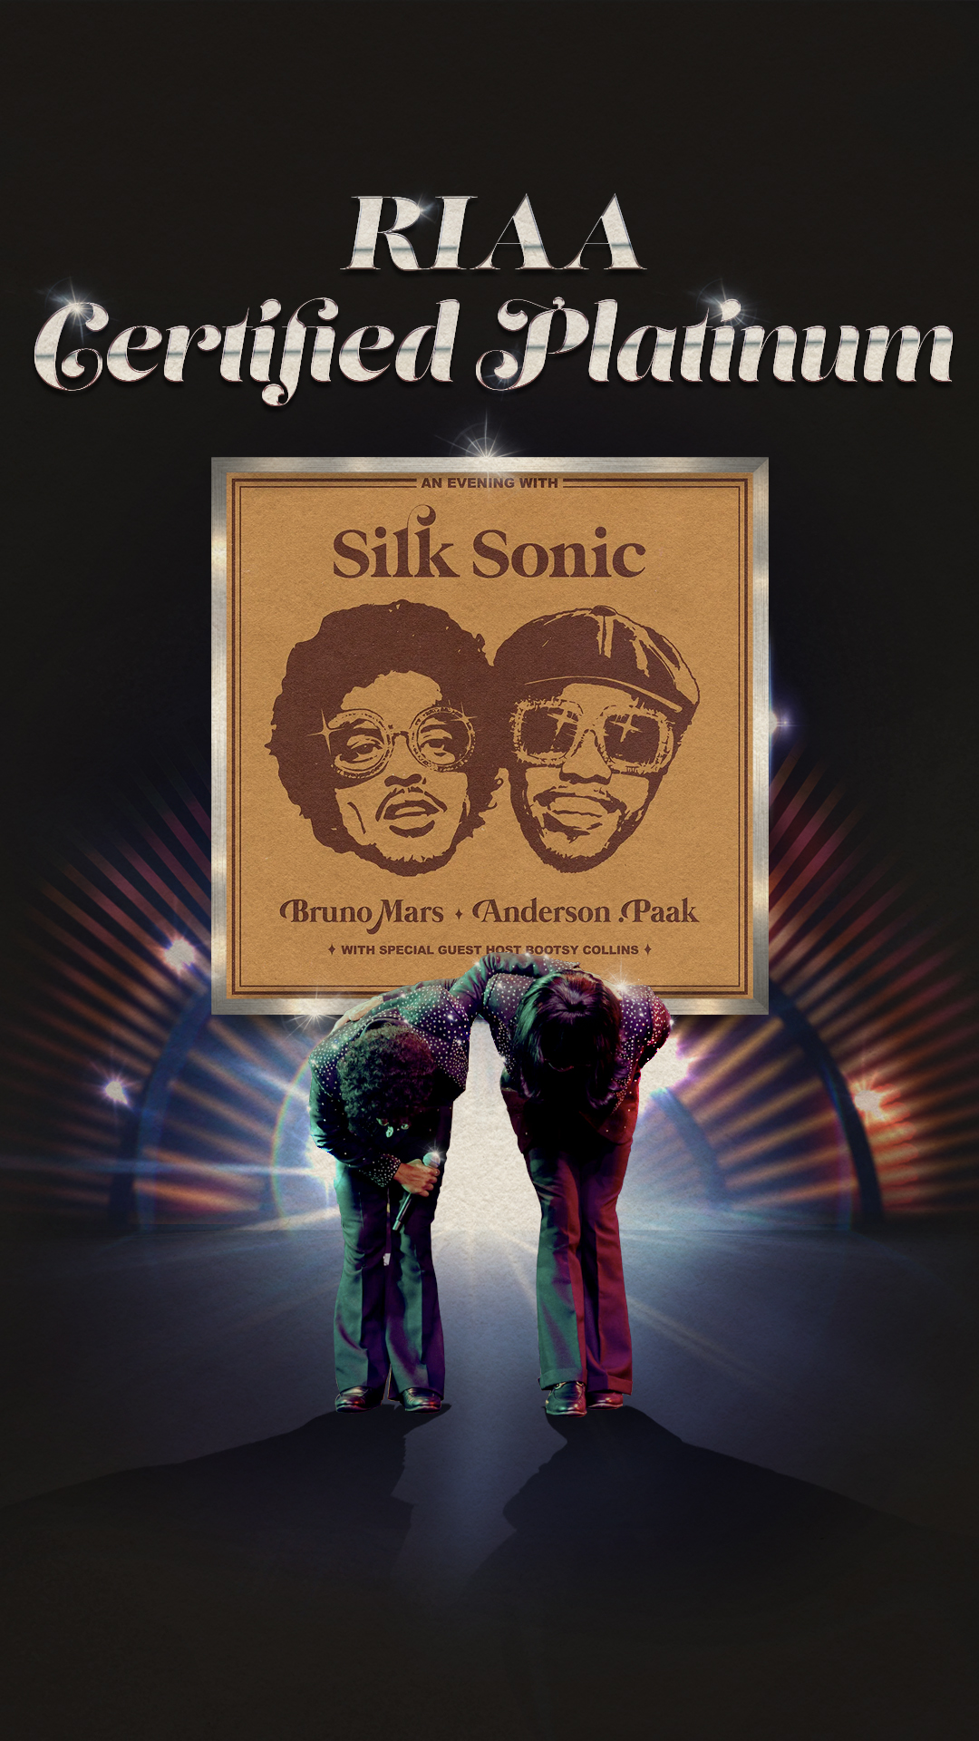
DOWNLOAD ASSET HERE

LOS ANGELES, CA – AUGUST 19, 2022: With the success of their debut album, An Evening With Silk Sonic, the superstar duo claims a platinum certification. This comes after having swept the 64th Annual GRAMMY® Awards for their 2x RIAA platinum certified, worldwide chart-topping smash, “Leave The Door Open”. Mars and .Paak walked away with Record Of The Year ("Leave The Door Open"), Song Of The Year ("Leave The Door Open"), Best R&B Performance ("Leave The Door Open"), and Best R&B Song ("Leave The Door Open") as they kicked off the award show with a mesmerizing 70s funky style live performance of “777”.

Available for pre-order now via Silk Sonic’s official online store, the An Evening with Silk Sonic vinyl, is slated to be available in store on August 26th. Purchase HERE or check out an exclusive version at your nearest Walmart or Target.

ABOUT SILK SONIC:
Silk Sonic introduced “Leave The Door Open” in March 2021 alongside an official music video directed by Mars and Florent Déchard, which won Best R&B Video and Best Editing at the 2021 MTV Music Video Awards. The track was followed by a hugely popular social media campaign, #LetSilkSonicThrive, which earned them a debut live performance at the GRAMMY® Awards (plus a powerful tribute to Little Richard) followed quickly by iconic live sets at the iHeartRadio Music Awards and the BET Awards. “Leave The Door Open” became Silk Sonic’s first #1 single on the Billboard Hot 100, spending two non-consecutive weeks at #1 and 18 consecutive weeks in the top 10. In the meantime, their infectious jingle co-written and performed for SelvaRey Rum amassed widescale praise over the summer. The duo then coasted into their sophomore release of “Skate,” which saw them glide into a second top 10 hit on Billboards Hot R&B/Hip-Hop Songs as it debuted at #4 and began as the genre’s best-selling song of the week. “Smokin Out The Window” later arrived with Billboard noting how “Anderson .Paak and Bruno Mars take it all the way back to the 1970s Soul Train era in the retro video. [It]finds them going through their choreo on an old school TV set while rocking wide lapel tuxedo jackets.” An Evening With Silk Sonic is out now.

CONNECT WITH SILK SONIC
WEBSITE | FACEBOOK | TWITTER | INSTAGRAM | YOUTUBE | TIKTOK | SPOTIFY | APPLE MUSIC

CONNECT WITH BRUNO MARS
WEBSITE | FACEBOOK | TWITTER | INSTAGRAM | YOUTUBE

CONNECT WITH ANDERSON .PAAK
WEBSITE | FACEBOOK | TWITTER | INSTAGRAM | YOUTUBE

CONTACT FOR SILK SONIC/BRUNO MARS:
SHEILA.RICHMAN@ATLANTICRECORDS.COM
BRITTANY.BELL@ATLANTICRECORDS.COM

CONTACT FOR ANDERSON .PAAK:
KRISTEN.FOSTER@FULLCOV.COM
ERICA.GERARD@FULLCOV.COM

CONTACT FOR ATLANTIC RECORDS:
BRITTANY.BELL@ATLANTICRECORDS.COM

###

