FOR IMMEDIATE RELEASE
JULY 29, 2022

SUECO SHARES “NEXT EX”

BRAND NEW SINGLE HERALDS DELUXE EDITION OF ACCLAIMED DEBUT ALBUM,
IT WAS FUN WHILE IT LASTED, DUE LATER THIS YEAR

SOLD OUT HEADLINE TOUR BEGINS SEPTEMBER 13 IN DALLAS, TX
SPECIAL GUESTS INCLUDE LIL AARON AND KILLBOY

GENRE-BUSTING VIRAL STAR ALSO SET TO ROCK FESTIVALS AROUND THE WORLD
INCLUDING “OLIVER TREE PRESENTS: FIRE FESTIVAL,” SET FOR AUGUST 4 IN SAN DIEGO

LISTEN TO “NEXT EX” HERE | WATCH OFFICIAL MUSIC VIDEO HERE

“Sueco is as on brand as ever…” – BILLBOARD

“Sueco’s discography hasn’t failed to thrill or delight…” - MTV

“Sueco is known for mixing pop, pop punk and rap with inventive beats to create something entirely unrestrained by genre.” - ALT PRESS

“Sueco is undoubtedly a product of a new generation, one whose humor and meteoric success is unexpected, unpredictable, and nothing short of enthralling.” – ONES TO WATCH

RIAA platinum certified singer/producer Sueco has shared his latest single, “Next Ex,” available now via Atlantic Records at all DSPs and streaming services HERE. An official music video premieres today at Sueco’s YouTube HERE. “Next Ex” heralds the upcoming arrival of It Was Fun While It Lasted (Deluxe), an expanded release of his acclaimed debut LP set to arrive everywhere later this summer.

It Was Fun While It Lasted (Deluxe) was first heralded this spring by the brand new emo anthem, “Salt,” hailed by Alternative Press as “a heartfelt ballad about how easy it is to torture yourself after ending a relationship” and available now via Atlantic Records at all DSPs and streaming services HERE. Produced by Colin “DOC” Brittain (5 Seconds of Summer, All Time Low, Papa Roach, Sum 41), dwilly (Royal & The Serpent, Trevor Daniel, bbno$, Arizona Zervas) and Matt Lukasiewicz, the track is joined by an official music video – directed by Los Angeles-based artist/filmmaker Nas Bogado – is streaming now at YouTube HERE.

Sueco is currently set to embark on his biggest world headline tour thus far, with North American dates getting underway September 13 at Dallas, TX’s Trees and then traveling through late October. Special guests include Lil Aaron and KILLBOY. Tickets for all dates are on sale now. For complete details and ticket information, please visit www.sueco.com

In the meantime, Sueco will join chart-topping viral icon Oliver Tree at “Oliver Tree Presents: Fire Festival,” an all-star, one-day event slated for August 4 at San Diego, CA’s Petco Park. What’s more, Sueco – who recently joined Tree on his sold-out Cowboy Tears Tour – will also light it up with eagerly awaited performances at such top international festivals as Gonzalez, TX’s Float Fest (July 23-24), Gampel-Bratsch, Switzerland’s Open Air Gampel (August 18), the UK’s Reading Festival (August 27) and Leeds Festival (August 28), Fountain, CO’s #GRIDLIFE - Alpine Horizon Festival (September 10), Atlanta, GA’s Music Midtown (September 17-18), and Dover, DE’s Firefly Music Festival (September 24).

SUECO
IT WAS FUN WHILE IT LASTED TOUR ‘22

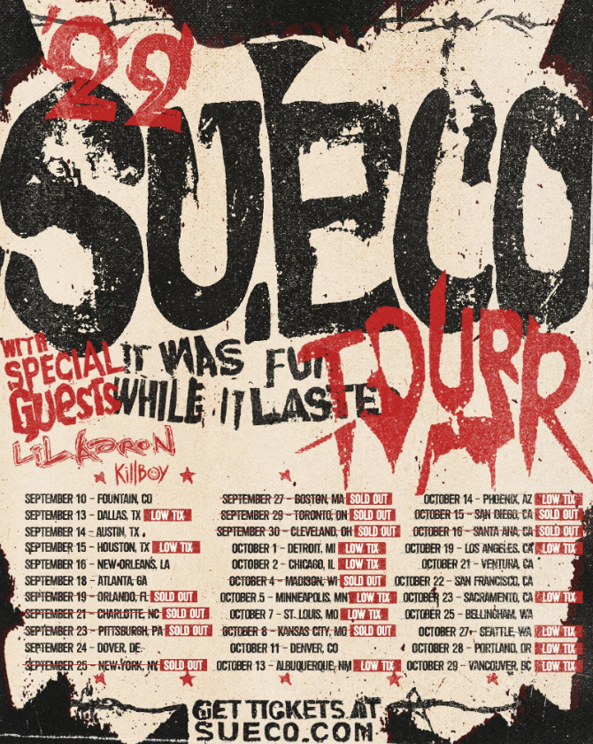

JULY
23-24 - Gonzalez, TX - Float Fest *

AUGUST
4 - San Diego, CA - Oliver Tree Presents: Fire Festival @ Petco Park *
15 – Berlin, German – Hole 44
16 – Hamburg, Germany – Gruenspan
18 – Gampel, Switzerland – Open Air Gampel *
19 – Munich, Germany – Backstage Halle
20 – St. Poelten, Austria – FM4 Frequency Festival *
22 – Cologne, Germany – Buergerhaus Stollwerck
23 – Amsterdam, Netherlands – Melkweg
25 – London, UK – O2 Islington Academy
26 – Manchester, UK – Gorilla
27 – Reading, UK – Reading Festival *
28 – Leeds, UK – Leeds Festival *

SEPTEMBER
10 – Fountain, CO – #GRIDLIFE - Alpine Horizon Festival *
13 – Dallas, TX – Trees
14 – Austin, TX – Antone’s Night Club
15 – Houston, TX – Studio @ Warehouse Live
16 – New Orleans, LA – Toulouse Theatre
18 – Atlanta, GA – Music Midtown *
19 – Orlando, FL – Abbey – SOLD OUT
21 – Charlotte, NC – Neighborhood Theatre – SOLD OUT
23 – Pittsburgh, PA – Thunderbird Music Hall – SOLD OUT
24 – Dover, DE – Firefly Music Festival *
25 – New York, NY – Gramercy Theater – SOLD OUT
27 – Boston, MA – Brighton Music Hall – SOLD OUT
29 – Toronto, ON – Velvet Underground – SOLD OUT
30 – Cleveland, OH – Mahall’s – SOLD OUT

OCTOBER
1 – Detroit, MI – El Club
2 – Chicago, IL – Lincoln Hall
4 – Madison, WI – High Noon – SOLD OUT
5 – Minneapolis, MN – Amsterdam
7 – St. Louis, MO – Old Rock House
8 – Kansas City, MO – recordBar – SOLD OUT
11 – Denver, CO – Bluebird Theater
13 – Albuquerque, NM – Launch Pad
14 – Phoenix, AZ – Crescent Ballroom
15 – San Diego, CA – House of Blues Voodoo Room – SOLD OUT
16 – Santa Ana, CA – Constellation Room – SOLD OUT
19 – Los Angeles, CA – The Roxy
21 – Ventura, CA – Ventura Music Hall
22 – San Francisco, CA – August Hall
23 – Sacramento, CA – Harlow’s
25 – Bellingham, WA – Wild Buffalo
27 – Seattle, WA – Neumos
28 – Portland, OR – Hawthorne
29 – Vancouver, BC – Fortune

* FESTIVAL PERFORMANCE

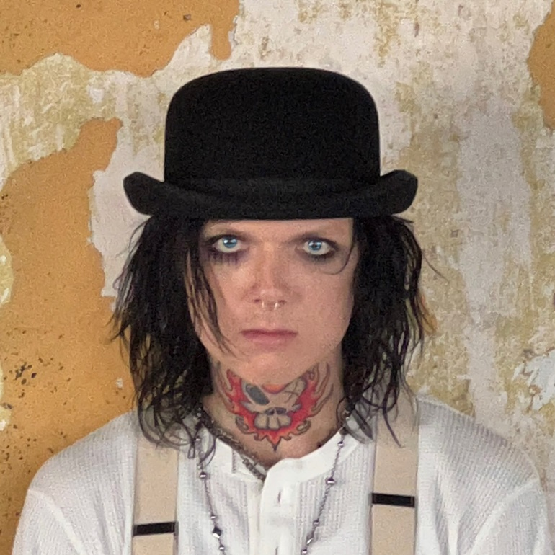
DOWNLOAD HI-RES ARTWORK HERE

It Was Fun While It Lasted sees Sueco – who recently starred on the cover of Alternative Press – channeling the spirit of 90’s pop-punk through a 21st century lens, tapping into the unpredictability of hyperpop and the catharsis of punk rock. The project includes such breakthrough singles as “Loser,” “SOS (Feat. Travis Barker),” “Sober/Hungover (Feat. Arizona Zervas),” “Drunk Dial,” and the RIAA gold certified #1 hit, “Paralyzed,” the latter of which first exploded last summer with a hugely popular TikTok teaser and has since gone on to earn more than 125M worldwide streams, reaching #1 on Spotify’s “Viral 50 US” while proving the Los Angeles-based singer, producer, and multi-instrumentalist’s first ever Billboard “Hot 100” and Rolling Stone “Top 100” hit. “Paralyzed” further saw Sueco make his Rolling Stone “Top 500 Popular Artists” chart debut after landing at #1 on Billboard’s “Rock Digital Song Sales,” #2 on “Alternative Digital Song Sales,” and #2 on Rolling Stone’s “Top 25 Breakthrough Music Artists.”

“The album is a journey from dark to light,” Sueco says, “going from a place of emptiness to everything being alright. It’s the end of one chapter, and the beginning of another. It really was fun while it lasted.”

# # #

CONNECT WITH SUECO
WEBSITE | INSTAGRAM l TIKTOK | TWITTER l SOUNDCLOUD l YOUTUBE

For press inquiries, please contact:
Jessica Nall // Jessica.Nall@atlanticrecords.com

