FOR IMMEDIATE RELEASE
AUGUST 25, 2022

SUECO AND THE SANDBOX UNVEIL THE “SUECO SPLIT PERSONALITIES” EXPERIENCE
RIAA PLATINUM CERTIFIED ARTIST BECOMES WARNER MUSIC GROUP’S FIRST ARTIST TO BE FEATURED IN THE SANDBOX
ACCESS THE EXPERIENCE IN THE SANDBOX’S ALPHA SEASON 3
AVAILABLE NOW HERE

IT WAS FUN WHILE IT LASTED (DELUXE) ALBUM COMING SOON
WATCH TRAILER HERE
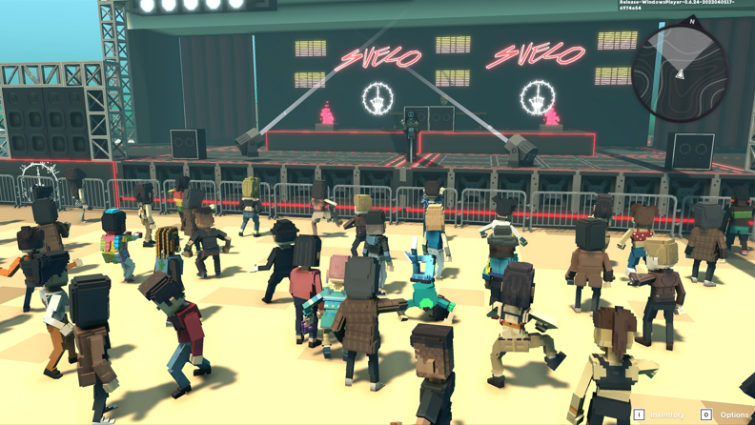
DOWNLOAD GRAPHICS HERE
As an artist who’s no stranger to Web3 and is committed to bringing his fans unique experiences, Sueco has unveiled his trailblazing experience in the metaverse via social gaming platform, The Sandbox. Sueco premiered the trailer of his experience at the WMG/The Sandbox NFT.NYC event back in June, in which he was also a featured panelist. Built on WMG’s music metaverse, which is centrally located on the map and in the heart of The Sandbox’s music district, The Sueco Portal is a first look at his wide-ranging activation on the platform. The experience is featured in The Sandbox’s Alpha Season 3 and is available now HERE.
Over the past year, Sueco’s team and The Sandbox have been working closely to create a narrative-based experience inspired by Sueco’s artistic evolution as a musician. As someone that likes to experiment with their fashion and artist outlook, the experience is aptly named ‘Sueco’s Split Personalities,’ a single player voxel game that takes you through Sueco’s iconic looks. In the game, players can help Sueco find his missing car pieces, fight through a crowd of mosh-pitting fans, and more. Featuring three distinct worlds representing various Sueco music videos, players will work through each of the levels and listen to select tracks from his forthcoming album, It Was Fun While It Lasted (Deluxe).

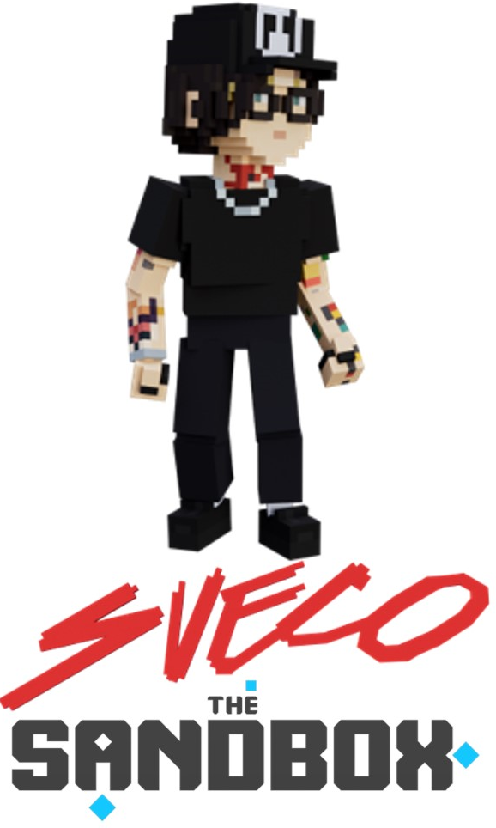
ABOUT SUECO
Sporting signature spectacles under a loose mane of wild long hair, Sueco practically drips attitude. The RIAA certified Los Angeles-based singer, producer, and multi-instrumentalist channels the spirit of nineties pop-punk through a 21st century lens, tapping into the unpredictability of hyperpop, the catharsis of hardcore, and a whole lot of hip-hop finesse. His debut single “Fast” blew up in a big way during 2019. It captured #1 on TikTok, #1 on Spotify’s Viral 50 - Global, and #1 on the Viral 50 - US, reached gold status, and attracted Offset and A Boogie Wit Da Hoodie for its high-powered Official Remix. On the heels of his first full-length project MISCREANT, he teamed up with Ty Dolla $ign, Wiz Khalifa, and Lil Yachty for “Speed Of Life,” Papa Roach on “Swerve” [feat. FEVER 333 & Sueco], and Illenium on “Story Of My Life” [feat. Sueco & Trippie Redd]. Along the way, he kicked off his next chapter, embracing his earliest influences with producers and cowriters such as John Feldmann [Machine Gun Kelly, Avril Lavigne, Jxdn, 5SOS] and Colin “DOC” Brittain [5SOS, Papa Roach] for his debut album, It Was Fun While It Lasted. The critically-acclaimed project serves up hit after hit including, “SOS” [feat. Travis Barker], “Sober/Hungover” [feat. Arizona Zervas], “Drunk Dial,” and his RIAA gold-certified smash, “Paralyzed.” Earning global DSP playlist support and critical acclaim, “Paralyzed” marked Sueco’s first entry on the Billboard “Hot 100” and Rolling Stone “Top 100” charts, amassing over 150 million global streams. After generating nearly 1 billion streams and receiving praise from the likes of Rolling Stone, NYLON, Alternative Press, Billboard and OnesToWatch, Sueco says, The album is a journey from dark to light,” Sueco says, “going from a place of emptiness to everything being alright. It’s the end of one chapter, and the beginning of another. It really was fun while it lasted.”

WHAT PEOPLE ARE SAYING ABOUT SUECO:
“Sueco is as on brand as ever…” - BILLBOARD
“Sueco’s discography hasn’t failed to thrill or delight…” - MTV
“Sueco is known for mixing pop, pop punk and rap with inventive beats to create something entirely unrestrained by genre.” - ALT PRESS
“Sueco is undoubtedly a product of a new generation, one whose humor and meteoric success is unexpected, unpredictable, and nothing short of enthralling.” - ONES TO WATCH

CONNECT WITH SUECO
WEBSITE | INSTAGRAM l TIKTOK | TWITTER l SOUNDCLOUD l YOUTUBE

