**SYMBA ENLISTS PUSHA T FOR “NEVER END UP BROKE PT. 2”**

**OUT EVERYWHERE TODAY**

[**DOWNLOAD/STREAM HERE**](https://symba.lnk.to/NeverEndUpBrokePt2)

***DJ DRAMA PRESENTS: RESULTS TAKE TIME (A GANGSTA GRILLZ SPECIAL EDITION)***

***ARRIVES EVERYWHERE SEPTEMBER 16***

**“NEVER END UP BROKE PT. 2 (FEAT. PUSHA T)” WAS FEATURED AS TODAY’S ZANE LOWE WORLD FIRST**

**RISING BAY AREA NATIVE & RAP ICON TEAM UP FOR NEW VERSION OF PREVIOUSLY RELEASED SONG PRODUCED BY DR. DRE & DEM JOINTZ**

[**PRE-SAVE "DJ DRAMA PRESENTS: RESULTS TAKE TIME (A GANGSTA GRILLZ SPECIAL EDITION)"**](https://symba.lnk.to/ResultsTakeTime)

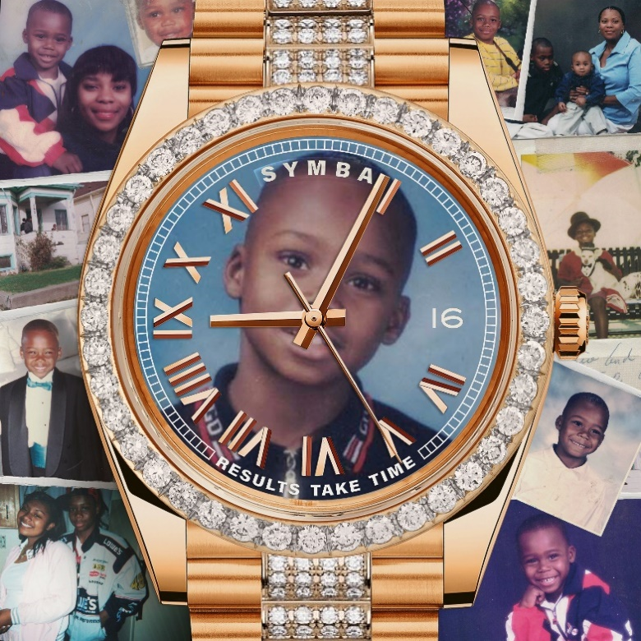

[DOWNLOAD ARTWORK](https://press.atlanticrecords.com/symba)

Rising rapper **SYMBA** enlists legendary rapper **Pusha T** for **“Never End Up Broke Pt. 2,”** a continuation of the Bay Area-native’s recently released original version, both of which were produced by **Dr. Dre** & **Dem Jointz**.

**“Never End Up Broke Pt. 2 (feat. Pusha T),”** was featured as today’s **Zane Lowe’s World First** and will appear on Symba’s upcoming new project, ***DJ Drama Presents: Results Take Time (A*** ***Gangsta Grillz Special Edition),*** out everywhere **September 16**. The long-awaited project will also include previously released songs **“Don’t Condone 2”** and **“GOAT,”** the latter which the rising rapper performed on **Jimmy Kimmel Live!**.

Fresh off a homecoming performance at [Outside Lands Festival](https://nam04.safelinks.protection.outlook.com/?url=https%3A%2F%2Fwww.instagram.com%2Fp%2FChAPuPZOBW8%2F%3Fhl%3Den&data=05%7C01%7CTaylor.Apel%40atlanticrecords.com%7Cd16888f07899413e021308da7aeb586b%7C8367939002ec4ba1ad3d69da3fdd637e%7C0%7C0%7C637957448460698897%7CUnknown%7CTWFpbGZsb3d8eyJWIjoiMC4wLjAwMDAiLCJQIjoiV2luMzIiLCJBTiI6Ik1haWwiLCJXVCI6Mn0%3D%7C3000%7C%7C%7C&sdata=2%2Bc4GeeaO5sIqgIW4h7PR35mwXejmO7E2ctSMbSTSYo%3D&reserved=0) this past weekend, Symba took over Los Angeles’ The Roxy Theatre last night for a one-night-only Results Take Time Experience, which included surprise performances from **2 Chainz, Ty Dolla $ign, OT Genasis, Problem,  RJmrLA,** and **Jayson Cash,**as well as special guest, **Lebron James,** who watched the rapper he’s called his *‘favorite new artist’* from the audience.Looking ahead, the rapper will celebrate the release of ***DJ Drama Presents: Results Take Time (A Gangsta Grillz Special Edition)*** by hitting the road on his first major nationwide tour, as direct support for rapper **Joyner Lucas**, as well as a set at **Rolling Loud NYC**.

[**DOWNLOAD/STREAM “DON'T CONDONE 2"**](https://nam04.safelinks.protection.outlook.com/?url=https%3A%2F%2Ftherealsymba.lnk.to%2FDontCondone2&data=05%7C01%7CTaylor.Apel%40atlanticrecords.com%7Cd16888f07899413e021308da7aeb586b%7C8367939002ec4ba1ad3d69da3fdd637e%7C0%7C0%7C637957448460698897%7CUnknown%7CTWFpbGZsb3d8eyJWIjoiMC4wLjAwMDAiLCJQIjoiV2luMzIiLCJBTiI6Ik1haWwiLCJXVCI6Mn0%3D%7C3000%7C%7C%7C&sdata=o%2B0AyuIxn9QAK%2F1oQ8xHSBy6mj%2BJnx9xPimC0s2jtHc%3D&reserved=0)

[**DOWNLOAD/STREAM “GOAT”**](https://nam04.safelinks.protection.outlook.com/?url=https%3A%2F%2Ftherealsymba.lnk.to%2Fgoat&data=05%7C01%7CTaylor.Apel%40atlanticrecords.com%7Cd16888f07899413e021308da7aeb586b%7C8367939002ec4ba1ad3d69da3fdd637e%7C0%7C0%7C637957448460698897%7CUnknown%7CTWFpbGZsb3d8eyJWIjoiMC4wLjAwMDAiLCJQIjoiV2luMzIiLCJBTiI6Ik1haWwiLCJXVCI6Mn0%3D%7C3000%7C%7C%7C&sdata=YE7Z0XeEzYM36ozGp%2BvaO6kX8JJOeMVndPYtGH1xdOU%3D&reserved=0)

[**WATCH SYMBA’S CHARLIE SLOTH FREESTYLE**](https://nam04.safelinks.protection.outlook.com/?url=https%3A%2F%2Fwww.youtube.com%2Fwatch%3Fv%3DQayKMNXtP2w&data=05%7C01%7CTaylor.Apel%40atlanticrecords.com%7Cd16888f07899413e021308da7aeb586b%7C8367939002ec4ba1ad3d69da3fdd637e%7C0%7C0%7C637957448460698897%7CUnknown%7CTWFpbGZsb3d8eyJWIjoiMC4wLjAwMDAiLCJQIjoiV2luMzIiLCJBTiI6Ik1haWwiLCJXVCI6Mn0%3D%7C3000%7C%7C%7C&sdata=xA%2FrR5BDT2i9jGwJDAHvM1zw9O6l%2BiZuU90qSAcnV%2F4%3D&reserved=0)

* * *

Inspired by everyone from JAY-Z to Steve Stoute and Steve Jobs, Bay Area-born and Los-Angeles based rapper Symba dove headfirst into the rap game following a rough up bringing. Symba’s series of collaborations took off in 2010 with Young Curt while also headlining early Los Angeles shows on bills with the likes of YG, Tyga, and DJ Mustard. The young rapper started turned heading heads with the 2MoreWords mixtape in 2015, boasting collaborations with the likes of Marc E. Bassy and IamSu!. After inking a deal with Atlantic Records, Symba put out his debut project *Don’t Run From R.A.P* with features from 2 Chainz, Ty Dolla $ign, Jayson Cash and more, which received praise from Billboard, XXL, Complex and more.

The Bay-area native set the stage for his upcoming project with singles “Don’t Condone 2” and “Never End Up Broke,” produced by Dr. Dre and Dem Jointz. Symba’s fiery lyrics and nimble delivery are on display on the instantly viral episode of LA Leakers Freestyle that has since garnered over 3.7M views and received praise from everyone from LeBron James to Dr. Dre.. This past June, Symba made his late-night television debut on Jimmy Kimmel Live! where he performed new single, “GOAT” off *DJ Drama Presents: Results Take Time (A Gangsta Grillz Special Edition)* due out September 16, 2022.

**PRESS CONTACT:**

JASON DAVIS | [JASON.DAVIS@ATLANTICRECORDS.COM](mailto:JASON.DAVIS@ATLANTICRECORDS.COM)

**CONNECT WITH SYMBA:**  
[INSTAGRAM](https://nam04.safelinks.protection.outlook.com/?url=https%3A%2F%2Fwww.instagram.com%2Faccounts%2Flogin%2F%3Fnext%3D%2Ftherealsymba%2F&data=05%7C01%7CTaylor.Apel%40atlanticrecords.com%7Cd16888f07899413e021308da7aeb586b%7C8367939002ec4ba1ad3d69da3fdd637e%7C0%7C0%7C637957448460698897%7CUnknown%7CTWFpbGZsb3d8eyJWIjoiMC4wLjAwMDAiLCJQIjoiV2luMzIiLCJBTiI6Ik1haWwiLCJXVCI6Mn0%3D%7C3000%7C%7C%7C&sdata=X2vAJsTykJcmhaNbsvo7dNZIlOId69VKDiRTKERbERw%3D&reserved=0) | [TWITTER](https://nam04.safelinks.protection.outlook.com/?url=https%3A%2F%2Ftwitter.com%2Ftherealsymba%3Flang%3Den&data=05%7C01%7CTaylor.Apel%40atlanticrecords.com%7Cd16888f07899413e021308da7aeb586b%7C8367939002ec4ba1ad3d69da3fdd637e%7C0%7C0%7C637957448460698897%7CUnknown%7CTWFpbGZsb3d8eyJWIjoiMC4wLjAwMDAiLCJQIjoiV2luMzIiLCJBTiI6Ik1haWwiLCJXVCI6Mn0%3D%7C3000%7C%7C%7C&sdata=zHVZ87GmAyNsdqcrKRll2ytbuC1EGztKnZnG8YOeMSg%3D&reserved=0) | [FACEBOOK](https://nam04.safelinks.protection.outlook.com/?url=https%3A%2F%2Fwww.facebook.com%2FTheRealSymba%2F&data=05%7C01%7CTaylor.Apel%40atlanticrecords.com%7Cd16888f07899413e021308da7aeb586b%7C8367939002ec4ba1ad3d69da3fdd637e%7C0%7C0%7C637957448460698897%7CUnknown%7CTWFpbGZsb3d8eyJWIjoiMC4wLjAwMDAiLCJQIjoiV2luMzIiLCJBTiI6Ik1haWwiLCJXVCI6Mn0%3D%7C3000%7C%7C%7C&sdata=Miyp6piEvsOKWGl8mq3IoO68%2BV%2BnCPtTC2x41d%2FjbWw%3D&reserved=0) | [YOUTUBE](https://nam04.safelinks.protection.outlook.com/?url=https%3A%2F%2Fwww.youtube.com%2Fuser%2FSymbaOnline&data=05%7C01%7CTaylor.Apel%40atlanticrecords.com%7Cd16888f07899413e021308da7aeb586b%7C8367939002ec4ba1ad3d69da3fdd637e%7C0%7C0%7C637957448460698897%7CUnknown%7CTWFpbGZsb3d8eyJWIjoiMC4wLjAwMDAiLCJQIjoiV2luMzIiLCJBTiI6Ik1haWwiLCJXVCI6Mn0%3D%7C3000%7C%7C%7C&sdata=Chqbkhu7BXoOnxj9ZuTkEs7R%2FfH8dKn04pWtvDo23Y8%3D&reserved=0) | [WEBSITE](https://nam04.safelinks.protection.outlook.com/?url=https%3A%2F%2Fwww.officialsymba.com%2F&data=05%7C01%7CTaylor.Apel%40atlanticrecords.com%7Cd16888f07899413e021308da7aeb586b%7C8367939002ec4ba1ad3d69da3fdd637e%7C0%7C0%7C637957448460698897%7CUnknown%7CTWFpbGZsb3d8eyJWIjoiMC4wLjAwMDAiLCJQIjoiV2luMzIiLCJBTiI6Ik1haWwiLCJXVCI6Mn0%3D%7C3000%7C%7C%7C&sdata=EBMAuAkjUsa3DEYxVfWu3bQPXaZGKS6umAQU8Zn%2FQf8%3D&reserved=0)

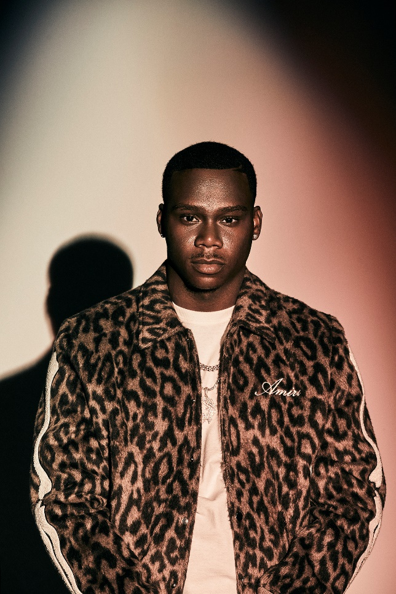

[DOWNLOAD PRESS PHOTOS HERE](https://nam04.safelinks.protection.outlook.com/?url=https%3A%2F%2Fpress.atlanticrecords.com%2Fsymba&data=05%7C01%7CTaylor.Apel%40atlanticrecords.com%7Cd16888f07899413e021308da7aeb586b%7C8367939002ec4ba1ad3d69da3fdd637e%7C0%7C0%7C637957448460698897%7CUnknown%7CTWFpbGZsb3d8eyJWIjoiMC4wLjAwMDAiLCJQIjoiV2luMzIiLCJBTiI6Ik1haWwiLCJXVCI6Mn0%3D%7C3000%7C%7C%7C&sdata=H%2Bc8LDmlYTCUyJWDJ2VlcGAeYKu9dIiyS5bGKwchf58%3D&reserved=0)

# # #