FOR IMMEDIATE RELEASE
AUGUST 19, 2022

GRAMMY AWARD WINNING, 9X NOMINEE, AND PLATINUM-SELLING
R&B SUPERSTAR TANK RELEASES HIS HIGHLY ANTICIPATED 10TH & FINAL ALBUM “R&B MONEY”

FEATURES CHRIS BROWN, ROTIMI, J VALENTINE, VEDO, BLAQ TUXEDO, TVERSE, FEATHER & ALEX ISLEY

"SLOW" FEATURING J. VALENTINE RISES TO THE TOP TEN ON THE R&B CHARTS STREAMING NOW

CELEBRATED ALBUM’S RELEASE WITH “THE R&B MONEY JAM” SHOW HOSTED BY TANK AND JAMIE FOXX IN WEST HOLLYWOOD AT THE PEPPERMINT CLUB

STREAM “R&B MONEY” ALBUM HERE

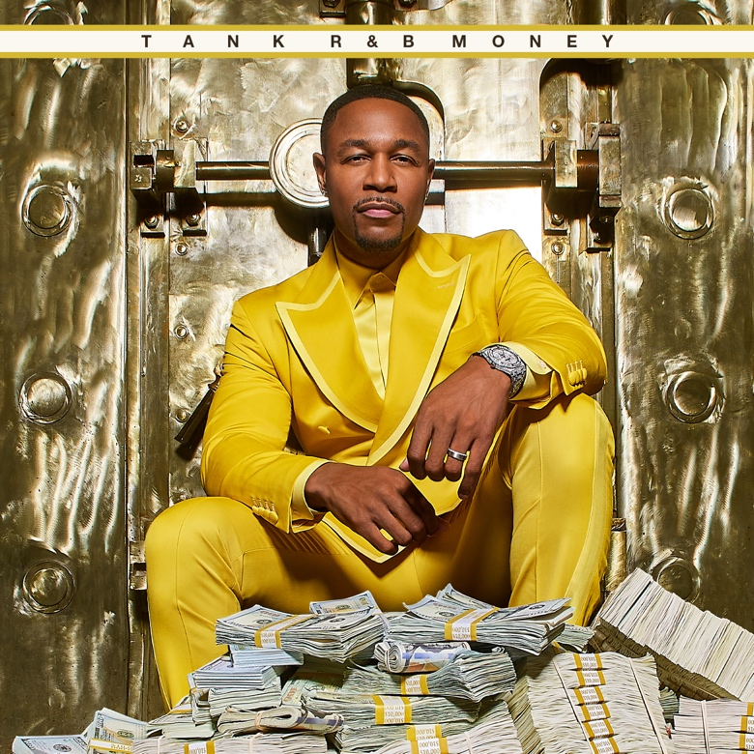

Today, Grammy Award winning, 9x nominee, and platinum-selling singer/songwriter/producer Tank released his highly anticipated 10th and final studio album R&B Money via his label R&B Money/Atlantic Records. The album also features Chris Brown, Rotimi, Vedo, Blaq Tuxedo, TVERSE, Alex Isley, and R&B Money artist Feather. R&B Money features chart-topping #1 hits "Can't Let It Show," "I Deserve," and the sultry fan favorite "Slow" featuring J. Valentine, which is surging up the R&B charts and currently sits in the Top 10. Tank supported the release of the album last night with his one-night only “The R&B Money Show” hosted by Tank and Jamie Foxx at the legendary Peppermint Club in West Hollywood, CA. He will also perform at DJ D-Nice’s “Club Quarantine” in Las Vegas on September 3rd.

“R&B Money is a labor of love to my fans and to the genre of R&B. This is who I am! I wouldn’t be here if it weren’t for artists like Marvin Gaye, Teddy Pendergrass, Keith Sweat, Al Green, and my fans who inspire me every day to make music,” says Tank. “I wanted this album to pay homage to my influences and my evolution as an artist, and I think that’s what this final album represents.”

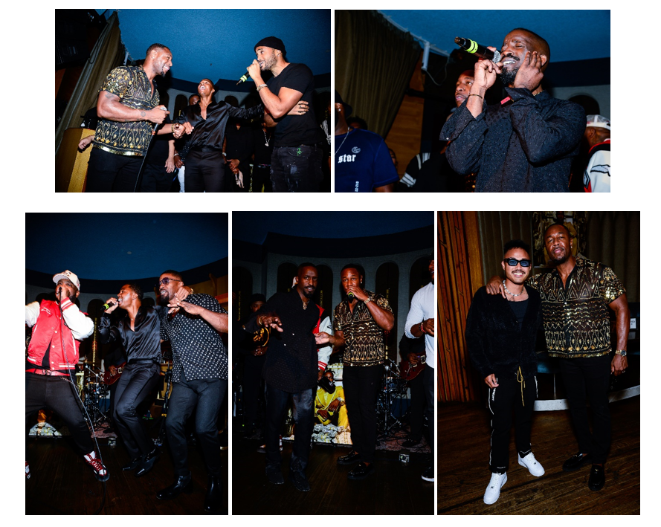
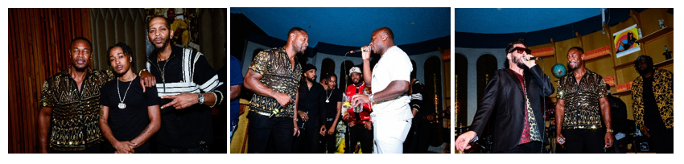

(Photo Credits: Ray Tamara | Download Hi-Res Images)

In addition to releasing his new album, Tank and J. Valentine celebrated the launch of their “R&B Money” podcast via iHeartMedia and Charlamagne tha God's Black Effect Podcast Network with Jamie Foxx as their first guest (click here). Debuting as the #1 Music Podcast, the show will celebrate the genre of R&B, representing the culture like no other. It will highlight everything from Marvin Gaye to Pink Sweat$. R&B Money has produced an exciting space for artists & executives in the game to reminisce with exceptionally compelling storytelling while building a place of discovery for the fans.

Throughout his 20+ year career, Tank has garnered over six #1 hits and has written and produced for names like Aaliyah, Chris Brown, Jamie Foxx, Alicia Keys, Beyonce, Kelly Rowland, and more. From his first hit single, “Maybe I Deserve,” Tank has been able to touch listeners that have garnered him a cult following with releases like “Slowly,” “Please Don’t Go,” and “I Can’t Make You Love Me.”

In 2021, Tank celebrated the long-overdue streaming debut of his landmark first three solo albums, 2001’s RIAA gold-certified, #1 debut, FORCE OF NATURE, 2002’s ONE MAN, and 2007’s chart-topping, GRAMMY® Award-nominated SEX, LOVE & PAIN. Rolling Stone acknowledged the historic streaming premiere with an exclusive interview with Tank, writing, “For the first time, fans will also be able to travel through his catalog in reverse, rewinding from 2021 to 2000.”

“R&B MONEY” TRACKLIST

- R&B MONEY
- When You Dance
- Home
- No Limit feat. Alex Isley
- Slow feat. J Valentine
- Morning feat. Vedo
- Can't Let It Show
- See Through Love feat. Chris Brown
- Spoil Her Alert
- I Deserve
- Too Late
- Make Sure feat. Feather
- Let's Take A Ride feat. Rotimi and TVERSE
- It's Nothing
- Awesome feat. Blaq Tuxedo
- Regular
- Summer Killa

###

FOLLOW TANK:
IG: @therealtank
TW: @therealtank
FB: @therealtank

FOR PRESS INQUIRIES
SYDNEY.MARGETSON@ATLANTICRECORDS.COM
TASHA@STRONGARMMEDIA.COM

