LAUNCH “BAND MEETING WITH TYLER & DAVE” PODCAST

DEBUT EPISODE FEATURING MARK TREMONTI AVAILABLE NOW

LISTEN HERE

NEW THEORY ALBUM SAY NOTHING OUT NOW ON ATLANTIC RECORDS

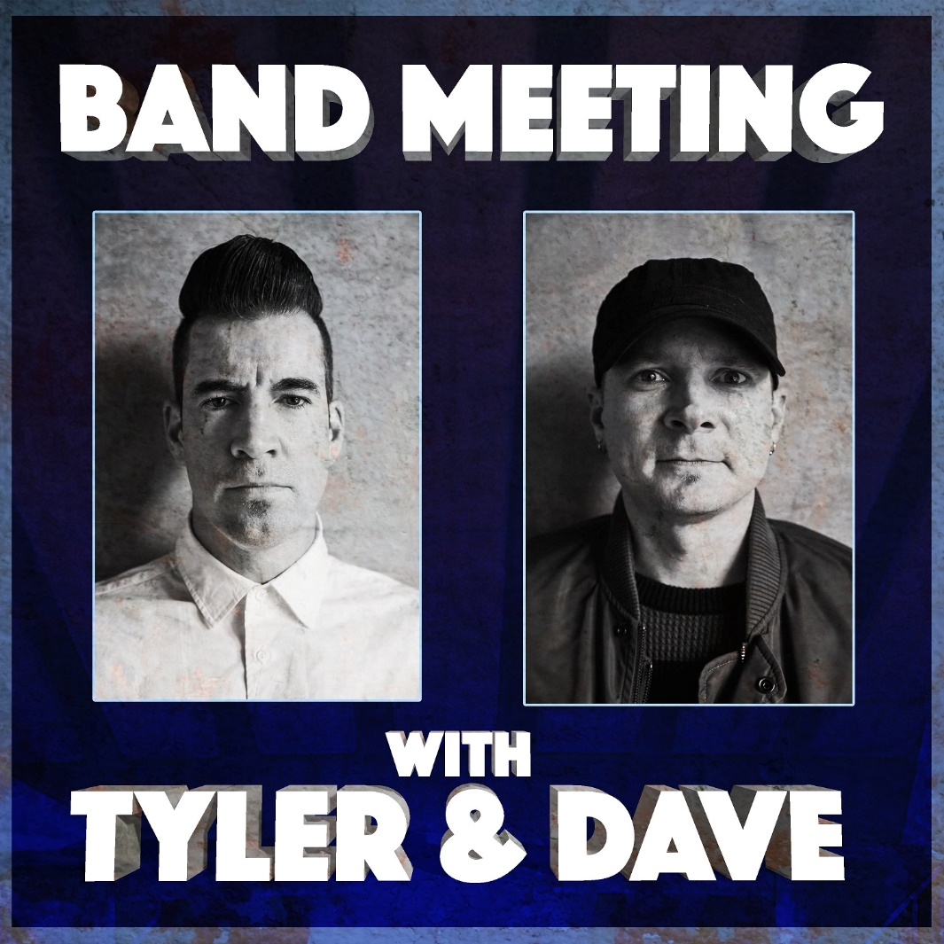

DECEMBER 2, 2020 – Tyler Connolly and Dave Brenner of multi-platinum band THEORY (Theory Of A Deadman) have launched their very own podcast, Band Meeting With Tyler & Dave. Available on all streaming platforms, Tyler and Dave have shared the debut episode which features special guest, longtime friend, and GRAMMY® Award-winning guitar hero Mark Tremonti of Alter Bridge, Tremonti, and Creed.

Captured remotely via ZOOM, they dig deep with Tremonti, sharing hilarious anecdotes about his days as a cook at Chili’s where he nearly got in a knife fight, the dangers of the Buick Sentry, guitar gods, and so much more.

Next up, Tyler and Dave graciously host everyone from Kara Dioguardi and Chris Porter to Howard Benson and Noodles of The Offspring for forthcoming episodes. This free-wheeling and free-spirited discourse illuminates yet another side of Tyler and Dave. Drawing on twenty-plus years of experience as interviewees together, they assume their position on the other side of the conversation on Band Meeting With Tyler & Dave, zinging with one eye-opening question after another and the hottest of hot takes. For updates and new episodes from Band Meeting With Tyler & Dave, visit www.bandmeetingpodcast.com.

THEORY recently released a new version of their single “Strangers” featuring Zero 9:36. It is available now on all streaming platforms now.

Earlier in the summer, THEORY unleashed “Live From MTELUS” - a 30-minute concert stream on the band’s official YouTube channel. Captured during their recent headline tour at Montreal’s MTELUS performing arts center, the historic performance sees THEORY delivering a career spanning set in front of a packed crowd. Culled from the show, they uncovered a live version of their single “World Keeps Spinning,” which went Top 15 at Active Rock radio. The powerful single – a personal track written by front man Tyler Connolly about depression and anxiety - followed THEORY’s #1 hit “History of Violence,” which became their sixth #1 on the Mediabase Active Rock Chart and fourth #1 on the Billboard Mainstream Rock Chart. Turning the tables on a story of domestic violence, “History of Violence” was joined by a gripping official music video illustrating a searing snapshot of a woman enduring an abusive husband as she plans to fight back, eventually ending up in jail but free of her abuser.

Already being hailed their best album to date, Say Nothing, which debuted at #2 on the Billboard Alternative Albums chart and #3 on the Rock Albums Chart and was produced by Martin Terefe [Jason Mraz, Yungblud], finds THEORY speaking up through timely lyrical commentary with the band’s finger on the pulse of the current climate and the issues that our society is grappling with today, all threaded together with a message that’s both a cautionary warning and a hopeful wish for our collective future. The title track offers up a stark, emotional confessional about a communication breakdown in a relationship that ultimately leads to its demise and "Strangers" addresses the current tense state of American politics and the divisive nature of our culture, calling out how nasty it has become between those with differing political affiliations and our society’s increasing inability to openly listen and relate to one another. With undeniable anthems, scorching songcraft, experimental vision, rock ‘n’ roll attitude, and clever pop ambition, Say Nothing is a continuation of their musical and thematic evolution, displaying the band’s powerful storytelling in full force and introducing fresh sounds and sonics.

THEORY’s 2017 album Wake Up Call featured their platinum single “Rx (Medicate),” which addressed the opioid epidemic and racked up more than 250 million streams, becoming their third #1 on the Billboard Hot Mainstream Rock Tracks chart and earning the band an iHeartRadio Music Award nomination for Rock Song of the Year. Over the course of nearly two decades, THEORY’s impressive catalogue has earned them several platinum and gold singles, a platinum album and two Top 10 album debuts on the Billboard Top 20. THEORY is: Tyler Connolly [lead vocals, guitar], Dave Brenner [guitar, backing vocals], Dean Back [bass], and Joey Dandeneau [drums, backing vocals].

About Theory Of A Deadman:
Multi-platinum band Theory Of A Deadman’s new album Say Nothing debuted at #2 on the Billboard Alternative Albums chart and #3 on the Rock Albums Chart. It features the #1 hit “History of Violence,” which became their sixth #1 on the Mediabase Active Rock Chart and fourth #1 on the Billboard Mainstream Rock Chart. THEORY’s 2017 album Wake Up Call featured their platinum single “Rx (Medicate),” which racked up more than 250 million streams, becoming their third #1 on the Billboard Hot Mainstream Rock Tracks chart and earning the band an iHeartRadioMusic Award nomination for Rock Song of the Year. Over the course of nearly two decades, THEORY’s impressive catalogue has earned them several platinum and gold singles, a platinum album and two Top 10 album debuts on the Billboard Top 20.

Follow THEORY:
Website / Facebook / Twitter / Instagram / YouTube / Spotify / Apple Music

For more information on THEORY, please contact:
Ross Anderson / RossAnderson@elektra.com

