ANNOUNCE “LIVE FROM MTELUS” CONCERT STREAM

HISTORIC PERFORMANCE AIRS TONIGHT AT 8:00 PM ET / 5:00 PM PT ON YOUTUBE

NEW ALBUM SAY NOTHING OUT NOW ON ATLANTIC RECORDS
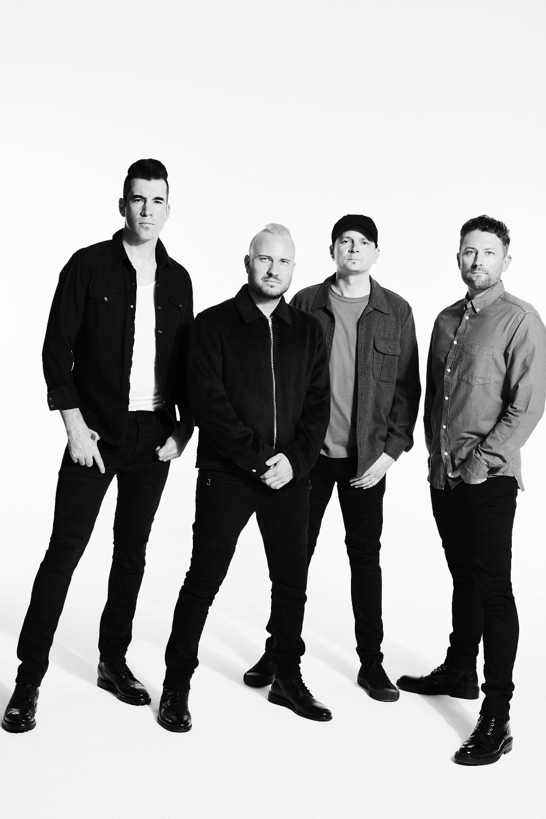
Photo Credit: Jimmy Fontaine

JUNE 30, 2020 – Multi-platinum band THEORY (Theory Of A Deadman), who recently released their new studio album Say Nothing (Atlantic Records), have announced “Live From MTELUS” - a 30-minute concert stream set to air tonight at 8:00 PM ET / 5:00 PM PT on the band’s official YouTube channel. Captured during their recent headline tour at Montreal’s MTELUS performing arts center, the historic performance sees THEORY delivering a career spanning set in front of a packed crowd. Furthermore, the band will join the YouTube livestream 30 minutes early at 7:30PM ET / 4:30 PM PT to chat with fans and answers questions in the comments section. Tune in tonight HERE.

In addition to the concert stream, this Friday, July 3rd, THEORY will release a live version of their single “World Keeps Spinning,” across all streaming platforms. Recorded during their MTELUS performance, the live version arrives as “World Keeps Spinning” approaches Top 15 at Active Rock radio. The powerful single – a personal track written by front man Tyler Connolly about depression and anxiety - follows THEORY’s #1 hit “History of Violence,” which became their sixth #1 on the Mediabase Active Rock Chart and fourth #1 on the Billboard Mainstream Rock Chart. Turning the tables on a story of domestic violence, “History of Violence” is joined by a gripping official music video illustrating a searing snapshot of a woman enduring an abusive husband as she plans to fight back, eventually ending up in jail but free of her abuser.

Already being hailed their best album to date, Say Nothing, which debuted at #2 on the Billboard Alternative Albums chart and #3 on the Rock Albums Chart and was produced by Martin Terefe [Jason Mraz, Yungblud], finds THEORY speaking up through timely lyrical commentary with the band’s finger on the pulse of the current climate and the issues that our society is grappling with today, all threaded together with a message that’s both a cautionary warning and a hopeful wish for our collective future. The title track offers up a stark, emotional confessional about a communication breakdown in a relationship that ultimately leads to its demise and "Strangers" addresses the current tense state of American politics and the divisive nature of our culture, calling out how nasty it has become between those with differing political affiliations and our society’s increasing inability to openly listen and relate to one another. With undeniable anthems, scorching songcraft, experimental vision, rock ‘n’ roll attitude, and clever pop ambition, Say Nothing is a continuation of their musical and thematic evolution, displaying the band’s powerful storytelling in full force and introducing fresh sounds and sonics.

THEORY’s 2017 album Wake Up Call featured their platinum single “Rx (Medicate),” which addressed the opioid epidemic and racked up more than 250 million streams, becoming their third #1 on the Billboard Hot Mainstream Rock Tracks chart and earning the band an iHeartRadio Music Award nomination for Rock Song of the Year. Over the course of nearly two decades, THEORY’s impressive catalogue has earned them several platinum and gold singles, a platinum album and two Top 10 album debuts on the Billboard Top 20. THEORY is: Tyler Connolly [lead vocals, guitar], Dave Brenner [guitar, backing vocals], Dean Back [bass], and Joey Dandeneau [drums, backing vocals].

MEDIA PRAISE FOR SAY NOTHING:
“[Say Nothing] The best album Theory has recorded to date.” – Glide Magazine

“A continuation of their sonic evolution, with Theory embracing the pillars of pop-rock…and intent on initiating a thoughtful conversation with their listeners.” – Alternative Press

“[‘Strangers’ is] a commanding anthem about the state of humanity…combining powerful lyrics with slick production and a rockin’ rhythm section.” – Parade

“Each song [on Say Nothing] is incredible in its own right…some of their best work to-date…” - CelebMix

“Not only has their sound evolved, their songwriting has put sometimes hard to talk about issues right at the forefront.” – Sound Vapors

“THEORY have struck gold with Say Nothing…A commanding statement about who and where we are as a society that isn’t afraid to bring uncomfortable issues to the conversation, THIS is an album that will long be remembered for that very reason. It’s perfect.”
– Amps and Green Screens

“[Theory] is back into making music with meaning.” – Alternative Addition

“With the release of Say Nothing, Theory has proven they cannot be boxed into any one particular genre and have showcased incredible maturity and growth in both their musical and lyrical content.” – Music Mayhem Magazine

“The arrangements for each of the ten songs on Say Nothing are brilliant, matched with some of their most bold lyrics to date, and the irresistible vocals of Tyler Connolly…Say Nothing flows flawlessly.” – Cryptic Rock

“Their most ambitious and soul-searching entry to date, Say Nothing is truly a rock record that showcases the strengths of a band unafraid to explore uncharted territory.” – Icon Vs Icon

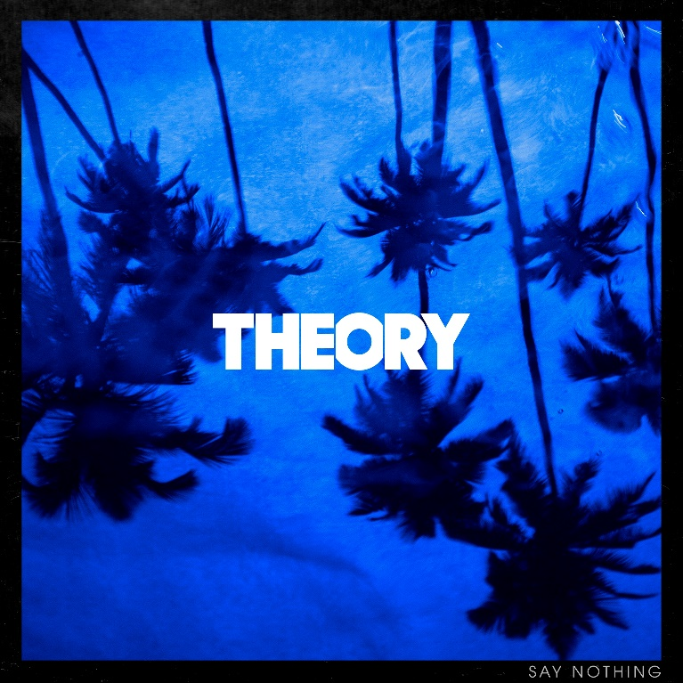
Say Nothing cover art

Follow THEORY:
Website / Facebook / Twitter / Instagram / YouTube / Spotify / Apple Music

For more information on THEORY, please contact:
Ross Anderson / RossAnderson@elektra.com

