RELEASE NEW VERSION OF “STRANGERS” FEATURING ZERO 9:36

LISTEN HERE

SAY NOTHING OUT NOW ON ATLANTIC RECORDS
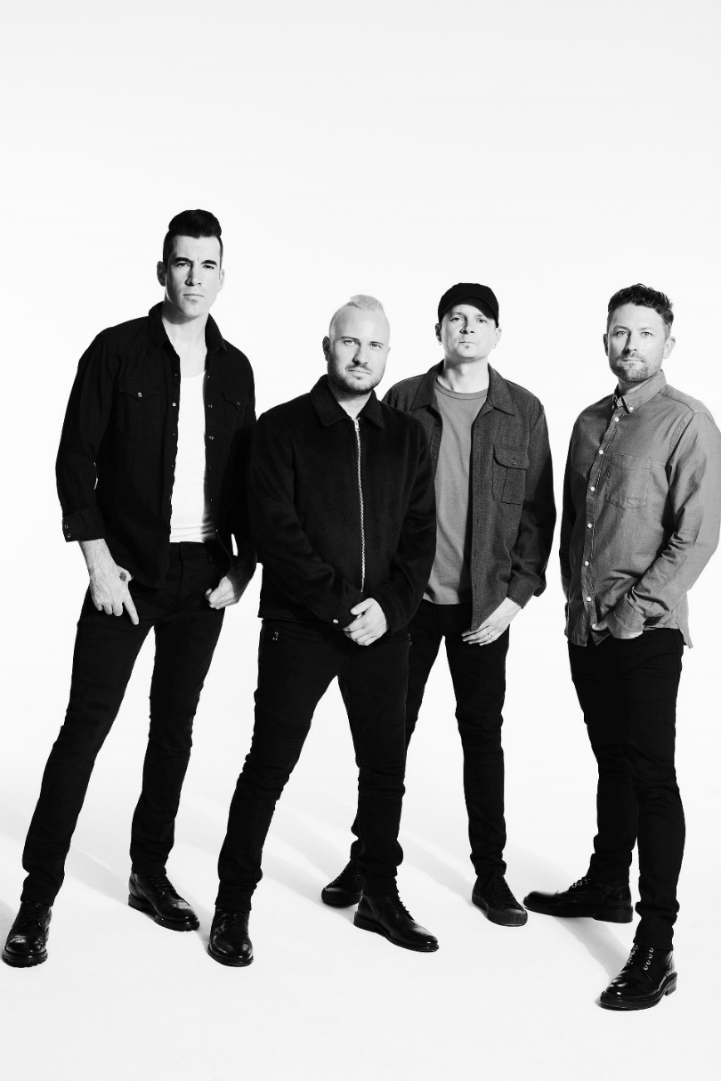
Photo Credit: Jimmy Fontaine

NOVEMBER 11, 2020 – Multi-platinum band THEORY (Theory Of A Deadman) have released a new version of their single “Strangers” featuring Zero 9:36. It is available now on all streaming platforms now.

“Strangers” originally appeared on the band’s acclaimed studio album Say Nothing (Atlantic Records)— which arrived at the top of this year. Widening the scope of the song with yet another dimension, the group recruited Philadelphia alternative genre-bender Zero 9:36 to guest on this recharged rendition. Locking into an airy melodic flow, he provides a counterpoint to the chantable chorus from THEORY singer and guitarist Tyler Connolly. Sharpened with this edge, the song packs an even bigger and bolder punch than before

Connolly said, “Man, I’ve been excited for a while now for people to hear this song! The ‘Strangers’ remix is heavier and more driving and with Zero 9:36 featured, it adds a new perspective to it that I think brings the song to another level.”

Zero 9:36 added, “I’ve been a fan of Theory for a while now and when the opportunity to collaborate with them came up, it was a no brainer. Getting to take 'Strangers,’ which is already a cool alternative rock song, and bring some heaviness to it was a lot of fun.”

Of that message, Parade wrote, “‘Strangers’ vocalizes the frustrations and powerlessness many feel.” Meanwhile, the Official Visualizer generated over 1.3 million YouTube views.

Earlier in the summer, THEORY unleashed “Live From MTELUS” - a 30-minute concert stream on the band’s official YouTube channel. Captured during their recent headline tour at Montreal’s MTELUS performing arts center, the historic performance sees THEORY delivering a career spanning set in front of a packed crowd. Culled from the show, they uncovered a live version of their single “World Keeps Spinning,” which went Top 15 at Active Rock radio. The powerful single – a personal track written by front man Tyler Connolly about depression and anxiety - followed THEORY’s #1 hit “History of Violence,” which became their sixth #1 on the Mediabase Active Rock Chart and fourth #1 on the Billboard Mainstream Rock Chart. Turning the tables on a story of domestic violence, “History of Violence” was joined by a gripping official music video illustrating a searing snapshot of a woman enduring an abusive husband as she plans to fight back, eventually ending up in jail but free of her abuser.

Already being hailed their best album to date, Say Nothing, which debuted at #2 on the Billboard Alternative Albums chart and #3 on the Rock Albums Chart and was produced by Martin Terefe [Jason Mraz, Yungblud], finds THEORY speaking up through timely lyrical commentary with the band’s finger on the pulse of the current climate and the issues that our society is grappling with today, all threaded together with a message that’s both a cautionary warning and a hopeful wish for our collective future. The title track offers up a stark, emotional confessional about a communication breakdown in a relationship that ultimately leads to its demise and "Strangers" addresses the current tense state of American politics and the divisive nature of our culture, calling out how nasty it has become between those with differing political affiliations and our society’s increasing inability to openly listen and relate to one another. With undeniable anthems, scorching songcraft, experimental vision, rock ‘n’ roll attitude, and clever pop ambition, Say Nothing is a continuation of their musical and thematic evolution, displaying the band’s powerful storytelling in full force and introducing fresh sounds and sonics.

THEORY’s 2017 album Wake Up Call featured their platinum single “Rx (Medicate),” which addressed the opioid epidemic and racked up more than 250 million streams, becoming their third #1 on the Billboard Hot Mainstream Rock Tracks chart and earning the band an iHeartRadio Music Award nomination for Rock Song of the Year. Over the course of nearly two decades, THEORY’s impressive catalogue has earned them several platinum and gold singles, a platinum album and two Top 10 album debuts on the Billboard Top 20. THEORY is: Tyler Connolly [lead vocals, guitar], Dave Brenner [guitar, backing vocals], Dean Back [bass], and Joey Dandeneau [drums, backing vocals].

THEORY – “STRANGERS” (FEAT. ZERO 9:36) – SINGLE ARTWORK
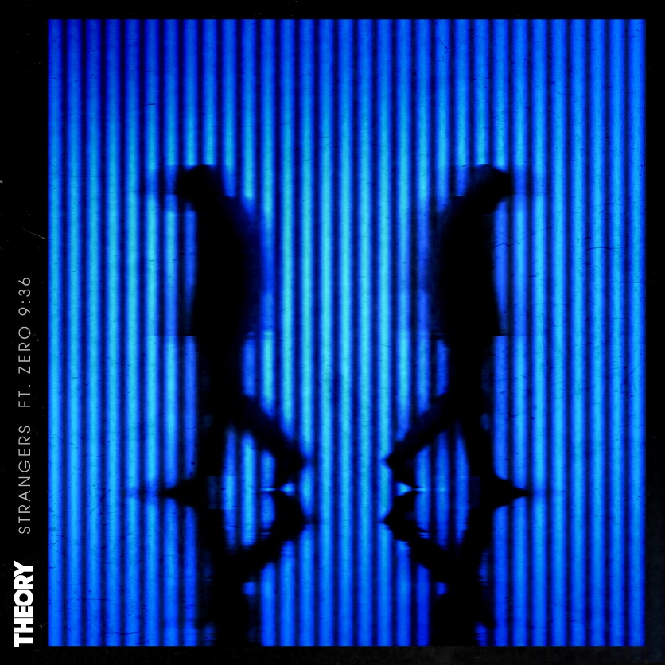

Follow THEORY:
Website / Facebook / Twitter / Instagram / YouTube / Spotify / Apple Music

For more information on THEORY, please contact:
Ross Anderson / RossAnderson@elektra.com

