FOR IMMEDIATE RELEASE
SEPTEMBER 1, 2022
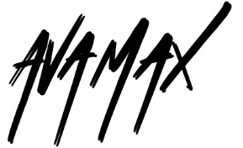
AVA MAX IS A “MILLION DOLLAR BABY”
GLOBAL POP SENSATION RETURNS WITH SULTRY POP ANTHEM
NEWEST SINGLE OFF MAX’S LONG AWAITED SOPHOMORE ALBUM DIAMONDS & DANCEFLOORS DUE OUT JANUARY 27TH
“MILLION DOLLAR BABY” ARRIVES TODAY WITH ANDREW DONOHO DIRECTED VIDEO
LISTEN TO “MILLION DOLLAR BABY” HERE | WATCH OFFICIAL MUSIC VIDEO HERE

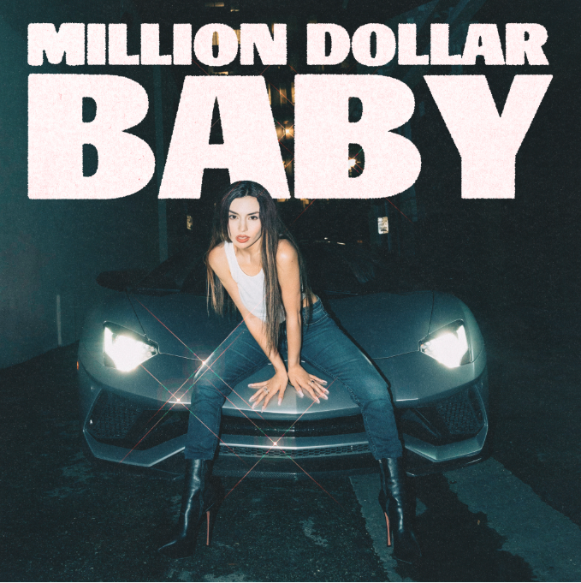
DOWNLOAD ARTWORK HERE

RIAA multi-platinum certified global pop sensation Ava Max has released her newest pop anthem, “Million Dollar Baby” – available now HERE. The new track is the latest single off her upcoming album, Diamonds & Dancefloors, releasing Friday, January 27th and available for pre-order and pre-save HERE. The upbeat and sassy track is an interpolation of LeAnn Rimes’ “Can’t Fight The Moonlight” and has already proven a fan favorite via a series of TikTok teaser videos featuring Rimes. “Million Dollar Baby” releases alongside an official music video, directed by Andrew Donoho (Khalid, Janelle Monae, Paul McCartney), premiering today at YouTube HERE.

“When I was creating this record, I was going through a really hard time in my life – heartbreak and just a lot of sadness,” shared Ava. “I titled it ‘Million Dollar Baby’ to remind myself of my self-worth and wrote the lyrics to show that you can overcome and achieve anything when you put your mind to it. The line ‘She broke out of her chains, turned the fire into rain’ shows the journey this song took me through – from feeling weighed down by sadness to breaking free and feeling like myself again.”

Ava first announced Diamonds & Dancefloors with standout lead single and uber confident track, “Maybe You’re The Problem,” which currently boasts over 20M views via YouTube HERE. “Maybe You’re The Problem” followed Ava’s collaboration with iconic DJ Tiësto for their worldwide hit, “The Motto,” which instantly became an international blockbuster, reaching the top 5 on Billboard’s “Dance/Electronic Songs” chart while earning close to 835M worldwide. The official music video was directed by Christian Breslauer (The Weeknd, Lil Nas X, Doja Cat) – currently flaunts over 94M views on YouTube HERE.

Highly anticipated sophomore album Diamonds & Dancefloors follows Ava’s debut album Heaven & Hell, an RIAA gold certified album that topped the charts worldwide with over 8.5B global streams and gold, platinum, and multi-platinum certifications in over a dozen countries. Ava has been praised by VOGUE, Rolling Stone, Vanity Fair, Billboard and PAPER, and was named to Forbes’ highly sought after “30 Under 30” list in 2021.

DOWNLOAD PRESS PHOTO HERE // CREDIT: BETH SARAVO BAETH

ABOUT AVA MAX:
Ava Max is ready to take her already extraordinary rise to the pinnacle of pop success to even greater heights with her first new single of 2022, “Maybe You’re The Problem” and sophomore album Diamonds and Dancefloors. With over 12B worldwide streams, an array of smash collaborations, and multiple RIAA gold and platinum certifications in the US alone, the first-generation Albanian American artist has fast proven a true pop superstar, hailed for her seismic voice, idiosyncratic high fashion mindset, and undeniable knack for cinematic, theatrical popcraft. 2018 saw Max make her explosive arrival with the blockbuster success of the RIAA 4x-platinum certified hit, “Sweet but Psycho.” Currently boasting more than 3.5B global streams, the track took the world by storm, spending three weeks in the top 10 on Billboard’s “Hot 100” while reaching #1 in more than 20 countries around the world and earning diamond certification in Brazil, France, Poland, as well as multi-platinum certification in Australia (5x), Austria (3x), Belgium (2x), Canada (6x), Denmark (3x), Germany (2x), Italy (3x), the Netherlands (2x), New Zealand, Norway (9x), Portugal (2x), Spain, Switzerland (4x), and the United Kingdom (3x). Joined by an official video that has now garnered over 780M views, “Sweet But Psycho” further earned Max a long string of international honors, including the 2019 MTV Europe Music Awards’ coveted “Best Push Artist” award, “Best New Artist” nominations at both the 2019 MTV Video Music Awards and the 2019 MTV Europe Music Awards, and an iHeartRadio Titanium Award marking over 1B spins in 2020 alone. Max kept up the pace with a series of smash singles, including the RIAA gold certified “So Am I,” “Salt,” and the Platinum “My Head & My Heart,” as well as the platinum certified title track to her acclaimed full-length debut, Heaven & Hell. The newly RIAA Platinum certified album made spectacular chart debuts around the globe, earning over 11B worldwide streams and gold, platinum, and multi-platinum certifications in over a dozen countries. 2021 saw Max unveil “EveryTime I Cry,” declared by PAPER as “an undeniably uplifting banger” and joined by an official music video, co-directed by Max and Charlotte Rutherford, currently boasting over 23M views via YouTube. What’s more, Tiësto & Ava Max’s worldwide hit anthem, “The Motto,” has proven an undeniable international blockbuster since its November 2021 release, reaching the top 5 on Billboard’s “Dance/Electronic Songs” chart while earning over 500M worldwide streams thus far.

Named to Forbes’ prestigious “30 Under 30” list in 2021, Ava has been feted with a wide range of media attention from such high profile outlets as VOGUE, Rolling Stone, Vanity Fair, Billboard, PAPER, to name but a few, while also delivering a long run of show-stopping performances on CBS’s The Late Late Show with James Corden, NBC’s TODAY, ABC’s Jimmy Kimmel Live!, Good Morning America, and Dick Clark’s New Year’s Rockin’ Eve with Ryan Seacrest 2020, the MTV Europe Video Music Awards, and more. A truly international artist, Max has teamed up with a stunning assortment of diverse musicians around the world, spanning Norwegian DJ/producer Alan Walker and Spanish superstar Pablo Alborán to David Guetta, Jason Derulo, AJ Mitchell (for the RIAA gold certified “Slow Dance”), and country stars Thomas Rhett & Kane Brown (the RIAA gold certified “On Me”). Now, with “Maybe You’re The Problem” – and more exhilarating new music to come – Ava Max is poised to push pop even further, setting a direct course toward the top and beyond.

CONNECT WITH AVA MAX:
OFFICIAL I INSTAGRAM I TIKTOK | TWITTER I FACEBOOK | YOUTUBE

Press Contacts:
Kelly McWilliam / Kelly.McWilliam@atlanticrecords.com
Ashley Kalmanowitz / Ashley.Kalmanowitz@atlanticrecords.com

