FOR IMMEDIATE RELEASE
SEPTEMBER 9, 2022

Anna Clendening UNVEILS UNTITLED X’S

RISING SINGER-SONGWRITER SHARES EAGERLY AWAITED NEW EP

FIVE-SONG COLLECTION INCLUDES THE ACCLAIMED SINGLES,
“SWEATSHIRT,” “GIRLS LIKE YOU,”
AND “I DON’T EVEN LIKE YOU ANYMORE”

NORTH AMERICAN TOUR KICKed OFF SEPTEMBER 7 IN NASHVILLE

UNTITLED X’S AVAILABLE NOW VIA ATLANTIC RECORDS

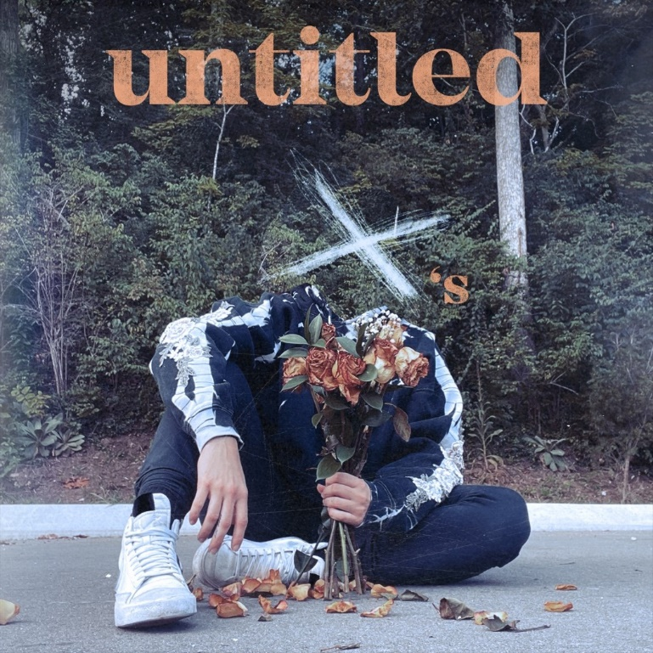
DOWNLOAD HIGH-RES ARTWORK

STREAM UNTITLED X’S: LINK

Acclaimed singer-songwriter Anna Clendening has shared her eagerly awaited new EP, UNTITLED X’S, available now via Atlantic Records at all DSPs and streaming services. An official music video for new song “Wrong” premieres today at YouTube HERE.

UNTITLED X’S follows an 18-month hiatus that found Clendening relocating from Los Angeles to Nashville where she fully embraced herself as an artist and songwriter, a period of deep personal growth which led to an outpouring of introspection and creativity. The five-track collection sees the multi-million streaming artist perfecting her very personal brand of gleefully chaotic pop on such recently released singles as “Sweatshirt,” “Girls Like You“ (which marks the spiritual successor to Clendening’s RIAA gold certified 2017 smash, “Boys Like You”), and the new fan favorite, “I Don’t Even Like You Anymore,” all of which are joined by official music videos streaming now at YouTube.

“I wanted to write about the past five relationships I’ve had just to get it all out there. Being a spiteful human sometimes, I thought it would be cool to name each song after a guy. My manager said it wouldn’t be cool to get sued—he was right. That’s how we came up with ‘UNTITLED X’S.’ Every song is very much about a specific person.”
-ANNA CLENDENING

Currently approaching 1M TikTok followers, Clendening is celebrating UNTITLED X’S with a number of U.S. tour dates, set to continue through early October. Additional North American headline shows will be announced soon. For updates, please visit www.annaclendening.com.

TRACKLIST
1. Sweatshirt
2.Girls Like You
3.I Don’t Even Like You Anymore
4.Bare Minimum
5.Wrong

ANNA CLENDENING
SEPTEMBER TOUR 2022

SEPTEMBER
19 – Brooklyn, NY – Baby’s All Right
21 – Boston, MA – Red Room Café 939
25 – Chicago, IL – Beat Kitchen

OCTOBER
5 – Los Angeles, CA – Hotel Café

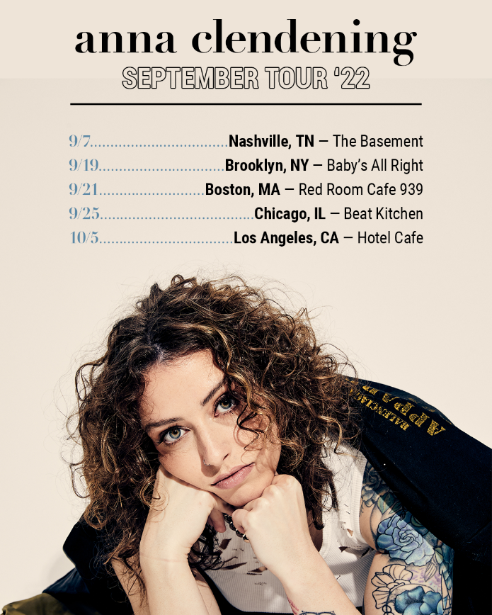j

# # #
Hailed by Flaunt for “her honest, soul-baring lyrics ripped directly from her daily notebook of real-life experiences,” Anna Clendening has amassed over 500M streams alongside critical acclaim from the likes of Billboard, Ones To Watch, Refinery29, and more. Her debut EP, 2019’s Waves, generated over 150M streams alone in under six months and led to collaborations with the likes of Illenium, Lost Kings, and Matoma. Clendening made her Atlantic Records debut with 2020’s Evolve EP – featuring the standout single, “Love Song” – arrived to applause from American Songwriter, Flaunt, Idolator, and more. With her honest, authentic songwriting, Clendening has proven a source of universal encouragement and an incredible advocate for mental health awareness. Sharing openly with fans about her own mental health journey managing anxiety, Clendening expertly channels these challenges through the healing power of music.

“We’re all very similar, our experiences, while different, are not isolated. People are going through the same things to not feel alone. When I was first diagnosed with anxiety, I thought I was crazy. I felt like nobody else knew what was going on, and it wasn’t happening to anyone but me. With my music and platform as an artist, I want to be the person I needed when I was 13- or 14-years-old. That’s all I want to do as long as I’m alive.”
-ANNA CLENDENING

DOWNLOAD HI-RES IMAGES

CONNECT:
OFFICIAL | FACEBOOK | TWITTER | INSTAGRAM | YOUTUBE | TIKTOK | PRESS ASSETS

CONTACT:
TED.SULLIVAN@ATLANTICRECORDS.COM

