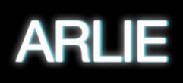

VISIONARY PSYCHEDELIC POP ACT ARLIE RELEASE OFFICIAL MUSIC VIDEO FOR “cool”
WATCH HERE

NEW VISUAL PREMIERES VIA UNDER THE RADAR

BUY/STREAM “cool” HERE

ANNOUNCING “A SPECIAL EVENING WITH ARLIE…” IN BROOKLYN
OCTOBER 25TH AT SAINT VITUS
TICKETS ON SALE HERE

OPENING FOR THE WRECKS ON TOUR THIS FALL
TICKETS ON SALE NOW
TOUR KICKS OFF OCTOBER 27TH

DEBUT ALBUM BREAK THE CURSE OUT NOW
BUY/STREAM THE ALBUM HERE

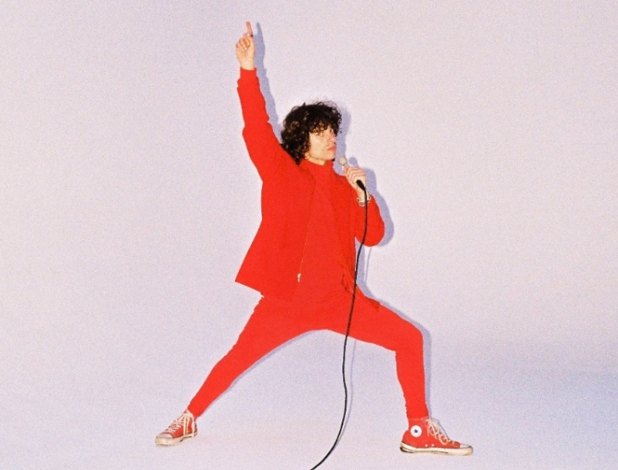
download hi-res press photo here; Credit: Gabe Drechsler

Today, visionary psychedelic pop act Arlie share the official music video (watch here) for “cool,” one of the many standout tracks off the band’s impressive first full-length, BREAK THE CURSE. Directed by frequent collaborator Gabe Drechsler, the joyful, lo-fi visual highlights Arlie’s signature sense of humor, with singer-songwriter and multi-instrumentalist Nathaniel Banks appearing as various characters throughout, including a mad scientist and red-caped superhero-type, among other delightfully color-blocked ensembles.

Under the Radar, who premiered the video this morning, proclaim: “‘cool’ has already proven to be one of the highlights of [BREAK THE CURSE] with its massive layered hooks and vibrant instrumental aesthetics, and the track’s accompanying video takes the track to even more surreal visual heights… the video’s vibrant color palette melds perfectly with the track’s playful lyricism and psych pop style.”

Of “cool,” Banks shares:

“This is one of those songs that formed around a line that just popped into my head out of nowhere, with full musical vision in mind. The main part wanted to feel like 10 Beatles songs on top of each other, but filtered through more modern psychedelic tonal sensibilities. Like I do in a lot of my songwriting, I’m sort of ridiculing myself in these lyrics: ‘people seem to think i’m cool sometimes when we first meet, i don’t know why, it’s very strange…’”

The official video for “cool” also arrives with the announcement of an upcoming show – “A Special Evening with Arlie…” – set for October 25th at Saint Vitus in Greenpoint (tickets here). The Brooklyn show will mark the band’s return to NYC following their sold-out performance at Mercury Lounge earlier this summer during their US headline BREAK THE CURSE tour.

In addition to the show at Mercury Lounge, the majority of their debut headlining run was entirely sold out, including shows in LA, Chicago, Austin, Denver and more.

Arlie will head back out on the road this fall with LA natives and fellow indie pop band The Wrecks, traversing the country from San Diego to Rhode Island. That tour kicks off on October 27th in New Haven, Connecticut.

The Nashville-based outfit released their highly-anticipated, debut full-length BREAK THE CURSE in June. The LP marked the follow-up to their 2018 debut EP WAIT, and was met with critical acclaim from outlets including Ones to Watch and V Magazine (“The indie-pop song ‘landline’ expands upon the band’s saturated sound heard on ‘WAIT,’ taking them to a groovier and more upbeat level.”).

“A true collage of everything from pop to alternative, pulled together with a squelching kaleidoscopic flare… beaming with lyrical savviness that exudes alternative infatuation.” – ONES TO WATCH

“…fusing a sound both futuristic and vintage… Arlie flirts with an aroma of nostalgic youth, like a mix between a 1984 Testarossa and The Jetsons’ hovercraft.” – FLAUNT

“Arriving in the wake of the band’s 2018 EP, WAIT, and a string of stellar singles, the record found lead singer/songwriter and multi-instrumentalist Nathaniel Banks returning to music after taking an extended hiatus for his mental health. His return once again burst with colorful melodies and irresistible indie pop grooves, but also cultivated a more vulnerable side, with Banks reflecting on ‘breaking the curse’ of societal and generational trauma.” – UNDER THE RADAR

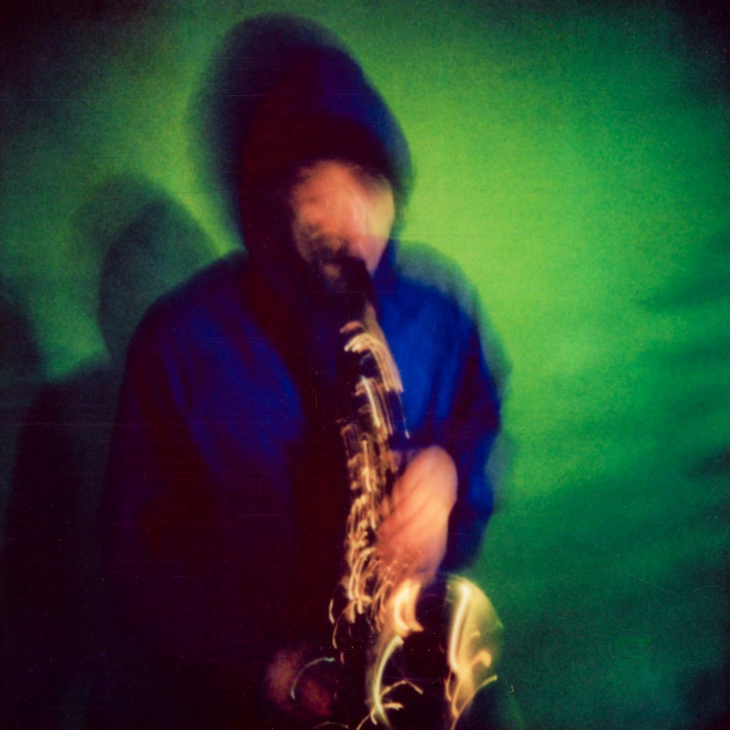
download hi-res “cool” single artwork here; Credit: Gabe Drechsler

With over 96M worldwide streams and counting, Arlie first began in the summer of 2015 as a solo bedroom project for Banks, eventually evolving to a full-band live act by 2017 and growing a fervent fan following in their hometown of Nashville and beyond.

Hailed for its striking synthesis of classic pop melodies with wildly creative modern production, Arlie’s 2018 WAIT EP included such hit singles as “didya think” and “big fat mouth.” The project immediately drew acclaim for its invigorating songcraft, meticulous production, and playful, summertime energy.

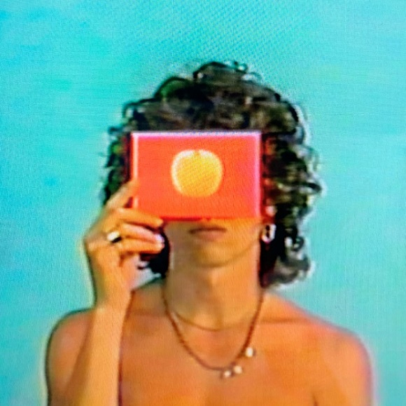
download album artwork here

*****

UPCOMING LIVE DATES:
OCTOBER 25, 2022 – BROOKLYN, NY – SAINT VITUS
OCTOBER 27, 2022 – NEW HAVEN, CT – TOAD’S PLACE*
OCTOBER 28, 2022 – PROVIDENCE, RI – FÊTE MUSIC HALL*
OCTOBER 29, 2022 – BALTIMORE, MD – RAMS HEAD LIVE!*
OCTOBER 30, 2022 – VIRGINIA BEACH, VA – ELEVATION 27*
NOVEMBER 1, 2022 – CARRBORO, NC – CAT’S CRADLE*
NOVEMBER 2, 2022 – ATHENS, GA – 40 WATT CLUB*
NOVEMBER 4, 2022 – MIAMI BEACH, FL – MIAMI BEACH BANDSHELL*
NOVEMBER 5, 2022 – TAMPA, FL – THE RITZ YBOR*
NOVEMBER 6, 2022 – JACKSONVILLE, FL – 1904 MUSIC HALL*
NOVEMBER 8, 2022 – BIRMINGHAM, AL – ZYDECO*
NOVEMBER 10, 2022 – NEW ORLEANS, LA – THE PARISH @ HOUSE OF BLUES*
NOVEMBER 11, 2022 – HOUSTON, TX – WAREHOUSE LIVE*
NOVEMBER 12, 2022 – SAN ANTONIO, TX – THE ROCK BOX*
NOVEMBER 13, 2022 – FORT WORTH, TX – TANNAHILL’S TAVERN & MUSIC HALL*
NOVEMBER 16, 2022 – TUCSON, AZ – CLUB CONGRESS*
NOVEMBER 17, 2022 – SAN DIEGO, CA – HOUSE OF BLUES*
NOVEMBER 18, 2022 – POMONA, CA – THE GLASS HOUSE*
NOVEMBER 19, 2022 – VENTURA, CA – MAJESTIC VENTURA THEATER*

*w/ The Wrecks

# # #

CONNECT WITH ARLIE:
OFFICIAL | INSTAGRAM | FACEBOOK | YOUTUBE | TWITTER

FOR ALL PRESS INQUIRIES, PLEASE CONTACT:
Libby Kober | Libby.Kober@AtlanticRecords.com
Gabby Reese | Tour/Online | Gabrielle.Reese@AtlanticRecords.com

