FOR IMMEDIATE RELEASE
SEPTEMBER 29, 2022

BIZZY BANKS IS BACK WITH HIS LATEST SINGLE “I CAN’T”

ACCOMPANYING VISUAL IS NOW AT OVER 200K VIEWS

ACCLAIMED NEW YORK DRILL STAR FOLLOWS UP ON PREVIOUSLY RELEASED
“DON’T KNOW HOW TO ACT”

SINGLE COMES ON THE HEELS OF HIS RECENT “ON THE RADAR” FREESTYLE

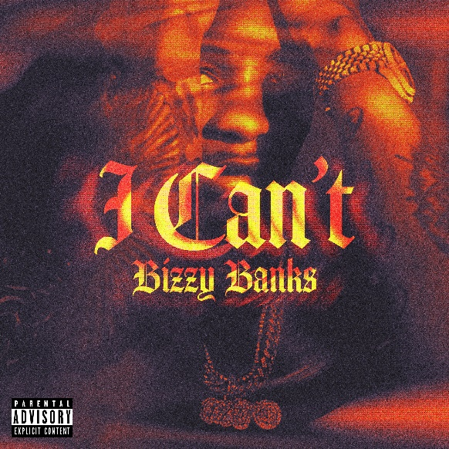

Acclaimed New York Drill rapper Bizzy Banks is back with his first single since his release, “I Can’t” available to stream via all DSPs HERE. “I Can’t” is accompanied by a visual streaming now via YouTube. He previously shared his first new single of 2022, “Don’t Know How To Act,” available at all DSPs HERE. “I Can’t” comes on the heels of Bizzy’s latest freestyle on the On The Radar podcast powered by Power 105.1 and is currently at over 327k views.

“Don’t Know How To Act” marked the long anticipated follow-up to last year’s stand-out mixtape, SAME ENERGY, available now at all DSPs and streaming services HERE. SAME ENERGY includes such singles as “Bandemic,” “My Shit,” “Azul,” “Driftin’,” “City Hot,” and “Adore You (Feat. PnB Rock),” all accompanied by official music videos streaming now at YouTube HERE. Produced by D.A. Got That Dope (Megan Thee Stallion, Da Baby), “Adore You,” featuring the late PnB Rock, was met by praise from such outlets as XXL, which raved, “Bizzy can jump from flow to flow, plus his references are clever…The slow groove puts the rhymer in a prime position to keep evolving.” “Some of the best music he's released yet,” enthused Brooklyn Vegan. “(Bizzy) seems poised to be one of New York drill's biggest breakouts since the untimely death of Pop Smoke.”

SAME ENERGY is currently boasting over 50.3 million global streams and was first heralded with the acclaimed single, “Bandemic,” which received praise from a range of national publications, including LA Weekly, which wrote, “Banks holds nothing back on the new tune…it’s representative of the material he’s currently working on.” An official video – shot and edited by Useless Films – has earned over 2.2M views via YouTube alone HERE. The mixtape also peaked at #13 on the Apple Music Top Hip Hop Albums and #20 on the overall chart.

In the short time since Bizzy emerged on the New York drill scene, he has racked up co-signs from some of the most notable names like NY heavyweights like Lil Tjay and Pop Smoke before his passing. His feature on Pop Smoke’s FAITH album, “30”, was touted by Brooklyn Vegan as the “best collab on the album” and received critical acclaim while sitting on the OCC for its 62nd week. Pitchfork named “Top 5”, a release from Bizzy’s 2020 label-debut mixtape “G.M.T.O. Vol. 1 (Get Money Take Over)” as one of “The 36 best rap songs of 2020” and is currently sitting at 5.3 million views. His single “Don’t Start Pt. 2” is a certified hit boasting over 8.1 million views on YouTube. The finesse and astute lyricism showcased on his debut mixtape won Bizzy a nomination for the XXL 2021 Freshman class as well as the #10 spot on Rolling Stone’s “Breakthrough 25” highlighting the fastest rising artists.

# # #

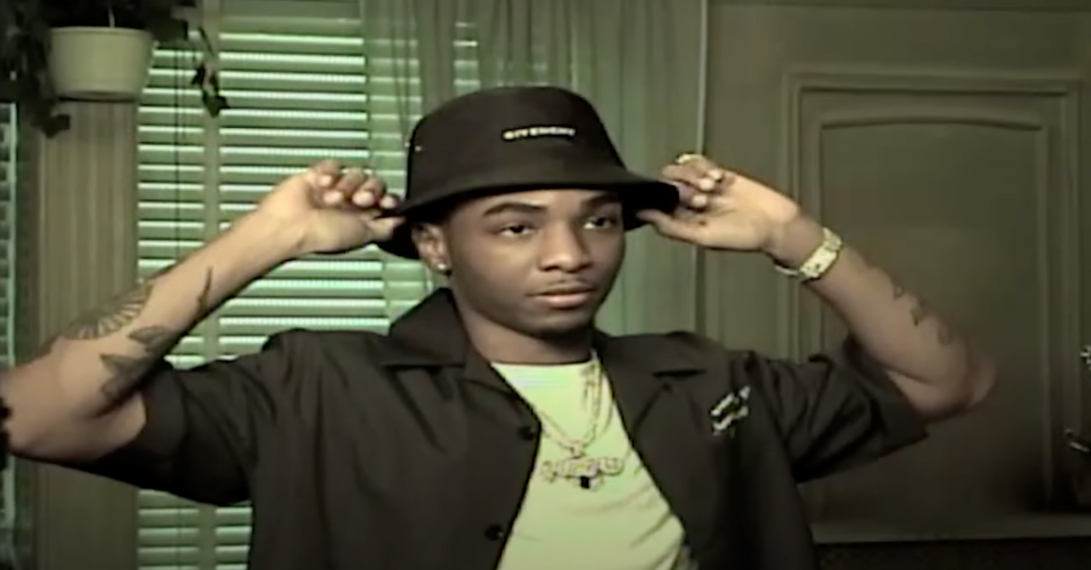

CONNECT WITH BIZZY BANKS
INSTAGRAM | TWITTER | YOUTUBE

FOR ALL INQUIRIES, CONTACT
ARIANA.WHITE@ATLANTICRECORDS.COM

