FOR IMMEDIATE RELEASE
SEPTEMBER 9, 2022

BRELAND’S HIGHLY ANTICIPATED DEBUT ALBUM CROSS COUNTRY OUT NOW
STREAM HERE

“FOR WHAT IT’S WORTH” MUSIC VIDEO FEATURES TRAIL-BLAZING PBR RIDER EZEKIEL MITCHELL, THE MOST PROMINENT AFRICAN AMERICAN RIDER IN THE PBR
watch here

AMAZON MUSIC PRESENTS “CROSS COUNTRY: A VISUAL EXPERIENCE” AT NATIONAL MUSEUM OF AFRICAN AMERICAN MUSIC (9/8); EXHIBIT OPEN FOR ONE WEEK ONLY
ICYMI:
FIRST TIME CMA AWARDS MUSICAL EVENT OF THE YEAR (“BEERS ON ME” – DIERKS BENTLEY WITH BRELAND & HARDY) SITS DOWN WITH GAYLE KING ON CBS MORNINGS FOR POIGNANT INTERVIEW; STACKING MORE HIGH-PROFILE HITS WITH ENTERTAINMENT TONIGHT, ASSOCIATED PRESS, BILLBOARD, FORBES, MUSICROW, AND MORE

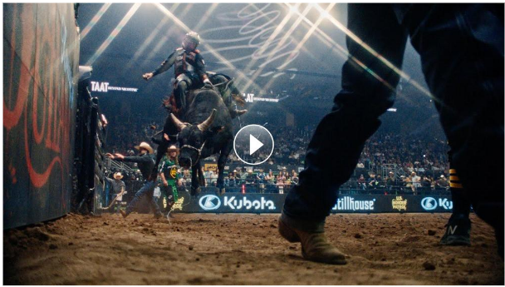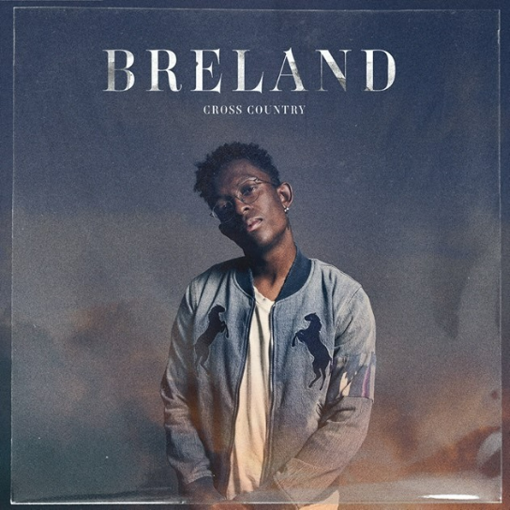
DOWNLOAD ALBUM ART HERE | PHOTO CREDIT: JIMMY FONTAINE
ALBUM ARTWORK CREDIT: NADA TAHA

LOS ANGELES, CA. (SEPTEMBER 9, 2022) – Bad Realm Records/Atlantic Records/Warner Music Nashville multi-talent BRELAND has released his “genre-melding” (Nashville Lifestyles) debut album, CROSS COUNTRY, continuing to prove he is “building bridges” as praised by HITS.

Aired yesterday morning (9/8) BRELAND sat down with Gayle King for a thought-provoking interview for CBS Mornings in his family’s home in his hometown of Burlington, NJ. Watch the interview here and listen to the full interview on CBS Mornings Podcast here (Spotify) or here (Apple).

Joining BRELAND for the "For What It's Worth" music video is special guest and PBR (Professional Bull Riders) star, Ezekiel Mitchell. Directed by Alex Bittan, the video was filmed in Texas and portrays the strength, determination, and dedication it takes for Mitchell who went from teaching himself bull riding by watching YouTube videos to becoming one of the world’s leading bull riders. Now competing on the No. 1 Austin Gamblers in the new PBR Team Series, his inspiring story has similar parallels to BRELAND’s career in music.

“Before shooting the music video, I had only peripherally been aware of PBR and wouldn’t have been able to imagine what these athletes endure in the spirit of competition,” explains BRELAND. “Learning about Ezekiel and his unusual path to PBR instantly reminded me of myself and the bridges I’m trying to build within Country music. I loved the filming process because I mostly just got to enjoy a thrilling new sport, but I also got to know an incredible young talent that is shifting people’s perception of bull riding. I’m excited to see where and how our paths cross again, but grateful to have such a budding star like Zeke represented in this video.”

“It was a shocker to be asked to be in a music video for a super vocally talented artist who I’ve followed on TikTok,” says Mitchell. “My cousin’s daughter loved ‘My Truck,’ and I’ve listened to that song a million times plus ten. BRELAND is an African American artist thriving in a genre not particularly dominated by African Americans — a parallel to my career, I guess you could say. It’s just really cool to be involved in this project, and everyone was incredible to work with. I sincerely appreciate being part of it, and I hope it helps to continue to push PBR into the mainstream.”

Last night (9/8) first time CMA Awards Musical Event of the Year (“Beers On Me” – Dierks Bentley with BRELAND & HARDY) nominee hosted a panel discussion during the opening of his exhibit “CROSS COUNTRY: A VISUAL EXPERIENCE” presented by Amazon Music at the National Museum of African American Music (NMAAM). With influential panelists including journalist Marcus Dowling from The Tennessean, Claude Kelly and Chuck Harmony of the R&B duo Louis York, NBA Sr. Director of Player Development Drew Franklin, Nada Taha, and Tonya Breland, BRELAND’s mother who holds a Doctorate in Education, the group discussed the impact being African American has had on their career sharing their thoughts and experiences.

The special exhibit spotlights art pieces created by 14 different visual artists - all Black Indigenous People of Color (BIPOC). Each artist painted their own depiction of one song off BRELAND’s debut, creating 14 unique pieces representing each of the 14 tracks on CROSS COUNTRY. For fans around the globe, the display can be viewed online here throughout the week-long run of the exhibit.

The Amazon Music Breakthrough Artist stacked high profile media looks in support of the drop with an exclusive CBS Mornings interview with Gayle King in BRELAND’s hometown in NJ, a “Day In The Life” segment on Entertainment Tonight, plus editorial features in Associated Press, Billboard, Forbes, MusicRow and more to come. And on September 12 at 1:30pm ET, BRELAND will host an album listening party on his live radio show on Amp, “The BRECAP,” to talk all about the recording process, each song on the album, how his collaborations came to be, plus special guests calling in. To listen to his show and for the opportunity to call in, fans can download Amp from the U.S. iOS App Store here, or follow BRELAND at live.onamp.com/breland to be notified when he goes live.

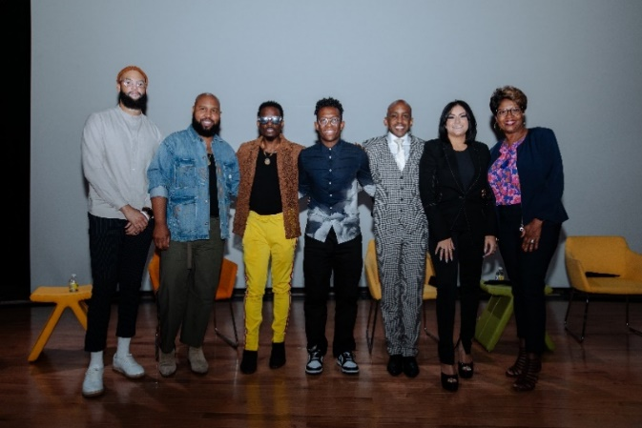
DOWNLOAD HERE | PHOTO CREDIT: CATHERINE POWELL / GETTY IMAGES
L-R: DREW FRANKLIN, NBA SR. DIRECTOR OF PLAYER DEVELOPMENT; CLAUDE KELLY AND CHUCK HARMONY OF R&B DUO LOUIS YORK; BRELAND;
MARCUS DOWLING, THE TENNESSEAN; NADA TAHA, APPLE MUSIC; TONYA BRELAND, BRELAND'S MOTHER AND DOCTORATE OF EDUCATION

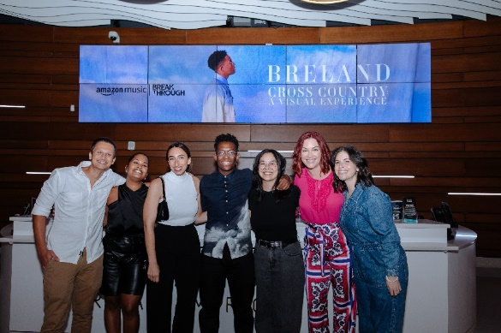
DOWNLOAD HERE | CREDIT: CATHERINE POWELL / GETTY IMAGES
L-R: AMAZON MUSIC’S ADAM BAHADURSINGH, MARIELLE PEÑA, EMMA KILCUP, JENNI TAY, MICHELLE TIGARD KAMMERER, EMILY COHEN BELOTE

ABOUT BRELAND:
With PLATINUM breakout “My Truck,” singer/songwriter/producer BRELAND has emerged as a bold new force on today’s music landscape. The Breakthrough Artist by Amazon Music first popped off when the Hip-Hop and Country hybrid hit #1 on Spotify’s Global Viral 50 in 2019, and a remix featuring Sam Hunt landed on best-of-the-year lists from NPR to The New York Times. Adding to his 650 MILLION+ career streams, BRELAND previewed the September 9th release of his debut album CROSS COUNTRY with infectious tracks “Told You I Could Drink (feat. Lady A),” “Natural,” “Praise The Lord (feat. Thomas Rhett),” GOLD-certified “Throw It Back (feat. Keith Urban) and title track (feat. Mickey Guyton). Hailed as the “symbol of Country music’s ongoing evolution” (Rolling Stone), the Bad Realm Records/Atlantic Records/Warner Music Nashville artist has scored high profile looks on CMT Crossroads, Good Morning America, Jimmy Kimmel Live!, TODAY, The Kelly Clarkson Show, New Year’s Eve Live: Nashville’s Big Bash, plus performances on the ACM, CMT, and CMA Awards. He’s currently touring with Fitz & The Tantrums and Andy Grammer’s THE WRONG PARTY TOUR this month and then will go global with upcoming shows at CMC Rocks Qld 2022 in Australia (9/23-9/25) before joining Russell Dickerson’s UK run in October.

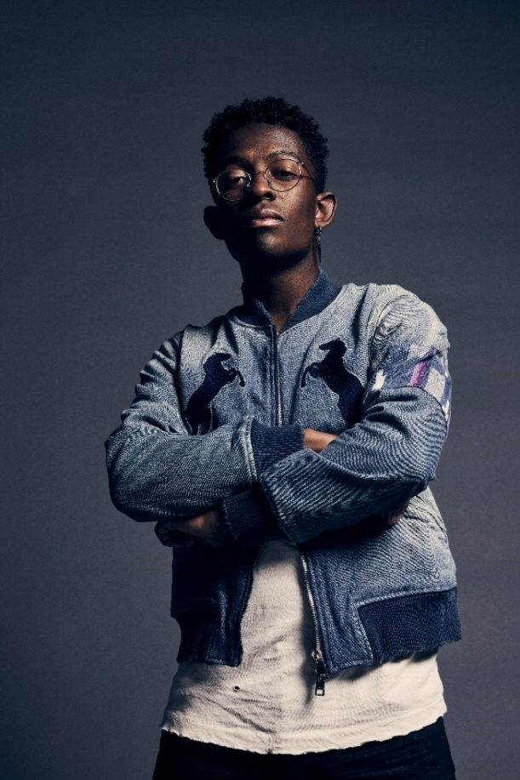
DOWNLOAD HIGH-RES PRESS ASSET(S) HERE

# # #

CONNECT WITH BRELAND
WEBSITE | INSTAGRAM | FACEBOOK | TWITTER | YOUTUBE | SOUNDCLOUD | AMAZON MUSIC

BRELAND PR CONTACTS
Fairley McCaskill / Fairley.McCaskill@atlanticrecords.com
Jensen Sussman / jensen@sweettalkpr.com
Mary Catherine Rebrovick / MaryCatherine@wmg.com

