FOR IMMEDIATE RELEASE
SEPTEMBER 7, 2022

BRELAND GOES CROSS COUNTRY WITH ALL-STAR MEDIA BLITZ, APPEARING ON CBS MORNINGS WITH GAYLE KING & ENTERTAINMENT TONIGHT TOMORROW (9/8), PLUS FEATURES IN ASSOCIATED PRESS, BILLBOARD, FORBES, MUSICROW AND MORE

TO CELEBRATE BRELAND’S DEBUT ALBUM, AMAZON MUSIC PRESENTS “CROSS COUNTRY: A VISUAL EXPERIENCE” AT NATIONAL MUSEUM OF AFRICAN AMERICAN MUSIC (NMAAM) IN NASHVILLE, TN – OPENING SEPTEMBER 8

STANDOUT COLLABS WITH INGRID ANDRESS, LADY A, MICKEY GUYTON, THOMAS RHETT, KEITH URBAN

CROSS COUNTRY AVAILABLE EVERYWHERE SEPTEMBER 9; PRE-SAVE/PRE-ADD HERE

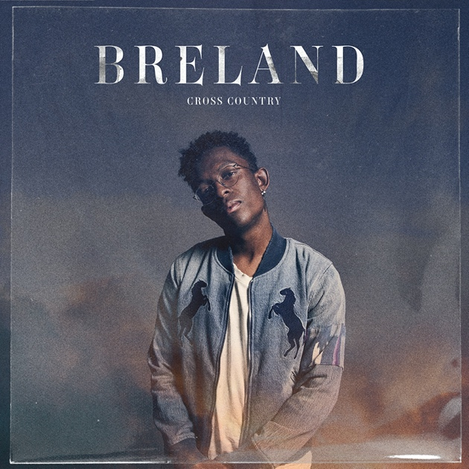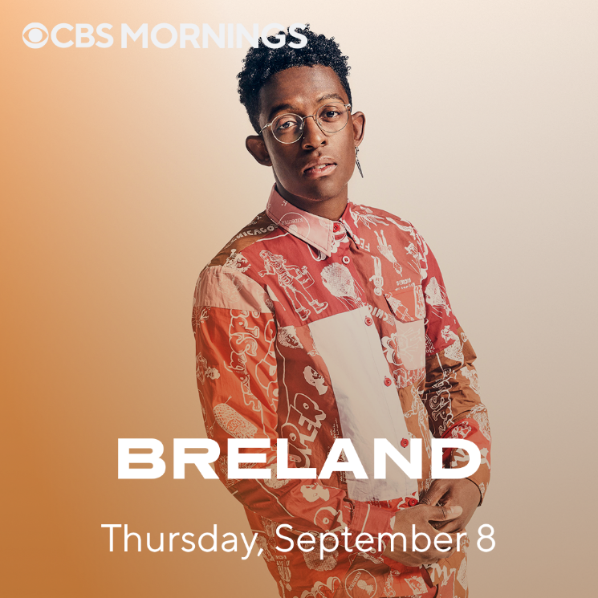
DOWNLOAD ALBUM ART HERE | PHOTO CREDIT: JIMMY FONTAINE DOWNLOAD ASSET HERE
ALBUM ARTWORK CREDIT: NADA TAHA

LOS ANGELES, CA. (SEPTEMBER 7, 2022) – Bad Realm Records/Atlantic Records/Warner Music Nashville multi-talent BRELAND readies the release of his highly anticipated debut album CROSS COUNTRY this Friday, September 9, with an all-star media blitz.

The NJ native will sit down with Gayle King for an exclusive CBS Mornings interview, airing tomorrow morning (9/8) followed by a segment tomorrow evening on Entertainment Tonight while stacking editorial features in Associated Press, Billboard, Forbes, MusicRow and more.

In celebration of the release, the Amazon Music Breakthrough Artist will open a special exhibit at the National Museum of African American Music (NMAAM) in Nashville, TN, called “CROSS COUNTRY: A VISUAL EXPERIENCE.” Presented by Amazon Music, this limited exhibition runs from September 8 to September 15. Continuing the festivities on September 12 at 1:30pm ET, BRELAND will host an album listening party on his live radio show on Amp, “The BRECAP,” to talk all about the recording process, each song on the album, how his collaborations came to be, plus special guests calling in. To listen to his show and for the opportunity to call in, fans can download Amp from the U.S. iOS App Store here, or follow BRELAND at live.onamp.com/breland to be notified when he goes live.

CROSS COUNTRY features standout collaborations with Ingrid Andress, Lady A, Mickey Guyton, Thomas Rhett and Keith Urban. Living up to his moniker as “The Pen Point Guard,” BRELAND’s pen name is on every song of the 14-track set alongside an impressive list of some of the most in-demand songwriters including Ashley Gorley, HARDY, Sam Hunt, ERNEST, Ryan Hurd and more.

This just announced CMA Awards Musical Event of the Year (“Beers On Me” – Dierks Bentley with BRELAND & HARDY) nominee is ready to take his music global with CMC Rocks Qld 2022 (9/23-9/25) in Australia and then jet to the UK to join Russell Dickerson’s tour throughout October. While in the UK, he will also be headlining his signature ‘BRELAND & Friends’ concert at The Garage in London on October 21. Check out his full list of tour stops here.

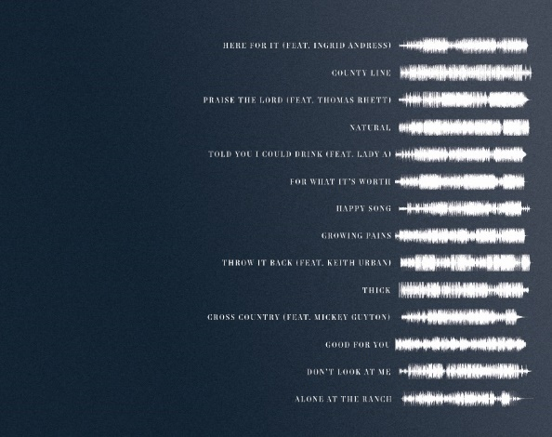

CROSS COUNTRY – TRACKLIST
- “Here For It (feat. Ingrid Andress)”
- “County Line”
- “Praise The Lord (feat. Thomas Rhett)”
- “Natural”
- “Told You I Could Drink (feat. Lady A)”
- “For What It’s Worth”
- “Happy Song”
- “Growing Pains”
- “Throw It Back (feat. Keith Urban)”
- “Thick”
- “Cross Country (feat. Mickey Guyton)”
- “Good For You”
- “Don’t Look At Me”
- “Alone At The Ranch”

See list of writing and production credits here
(-more-)

ABOUT BRELAND:
With PLATINUM breakout “My Truck,” singer/songwriter/producer BRELAND has emerged as a bold new force on today’s music landscape. The Breakthrough Artist by Amazon Music first popped off when the Hip-Hop and Country hybrid hit #1 on Spotify’s Global Viral 50 in 2019, and a remix featuring Sam Hunt landed on best-of-the-year lists from NPR to The New York Times. Adding to his 650 MILLION+ career streams, BRELAND previewed the September 9th release of his debut album CROSS COUNTRY with infectious tracks “Told You I Could Drink (feat. Lady A),” “Natural,” “Praise The Lord (feat. Thomas Rhett),” GOLD-certified “Throw It Back (feat. Keith Urban) and title track (feat. Mickey Guyton). Hailed as the “symbol of Country music’s ongoing evolution” (Rolling Stone), the Bad Realm Records/Atlantic Records/Warner Music Nashville artist has scored high profile looks on CMT Crossroads, Good Morning America, Jimmy Kimmel Live!, TODAY, The Kelly Clarkson Show, New Year’s Eve Live: Nashville’s Big Bash, plus performances on the ACM, CMT, and CMA Awards. He’s currently touring with Fitz & The Tantrums and Andy Grammer’s THE WRONG PARTY TOUR this month and then will go global with upcoming shows at CMC Rocks Qld 2022 in Australia (9/23-9/25) before joining Russell Dickerson’s UK run in October.

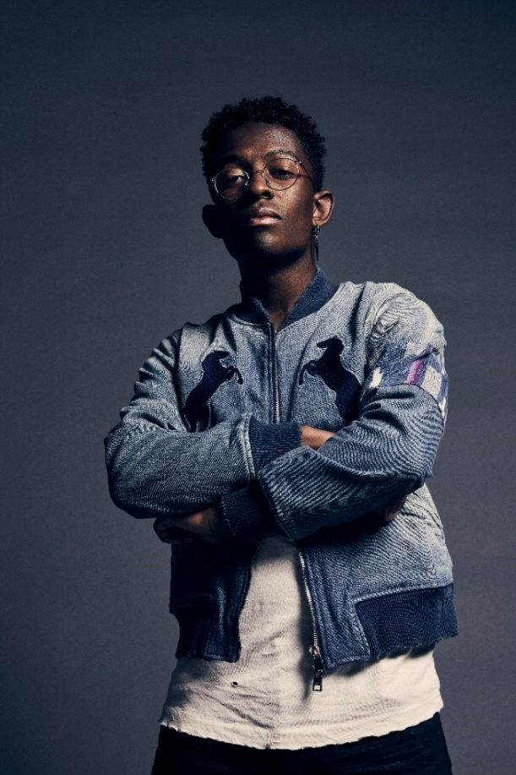
DOWNLOAD HIGH-RES PRESS ASSET(S) HERE

# # #

CONNECT WITH BRELAND
WEBSITE | INSTAGRAM | FACEBOOK | TWITTER | YOUTUBE | SOUNDCLOUD | AMAZON MUSIC

BRELAND PR CONTACTS
Fairley McCaskill / Fairley.McCaskill@atlanticrecords.com
Jensen Sussman / jensen@sweettalkpr.com
Mary Catherine Rebrovick / MaryCatherine@wmg.com

