FOR IMMEDIATE RELEASE
SEPTEMBER 20, 2022

CMA AWARD NOMINEE BRELAND ANNOUNCES FALL HEADLINE
HERE FOR IT TOUR

KICKS OFF NOVEMBER 16 IN OXFORD, OH, AND CONTINUES THROUGH DECEMBER; TICKETS ON SALE THIS FRIDAY (9/23)

STACKING CRITICAL ACCLAIM FOR DEBUT ALBUM CROSS COUNTRY

DEBUT COUNTRY RADIO SINGLE
“FOR WHAT IT’S WORTH” HITS AIRWAVES
OCTOBER 17

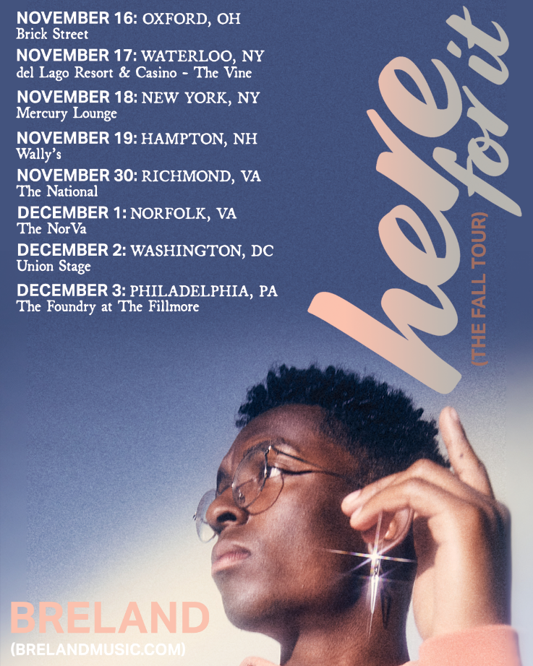
DOWNLOAD HERE

LOS ANGELES, CA. (September 20, 2022) – Lauded by MusicRow as a “magnetic entertainer,” BRELAND will bring his signature Cross Country sound nationwide with today’s announce of his fall headline HERE FOR IT TOUR.

Kicking off in Oxford, OH, at Brick Street on November 16, and continuing through December with more dates to be announced soon, tickets go on sale to the public this Friday (9/23) at 10 a.m. (local) at brelandmusic.com. BRELAND fans can get their tickets early – – via Artist Presale – tomorrow, September 21 at 10 a.m. CST through Thursday, September 22 at 10 a.m. CST.

Announced dates, cities, and venues of BRELAND’s HERE FOR IT TOUR:

November
16| Oxford, OH - Brick Street
17| Waterloo, NY - del Lago Resort & Casino - The Vine
18| New York, NY - Mercury Lounge
19| Hampton, NH - Wally's
30| Richmond, VA - The National

December
1| Norfolk, VA - The NorVa
2| Washington, DC - Union Stage
3| Philadelphia, PA - The Foundry at The Fillmore

*Check local venue websites for presale details.

This tour announce comes on the heels of the September 9 release of BRELAND’s debut album
CROSS COUNTRY via Bad Realm Records / Atlantic Records / Warner Music Nashville. Amassing acclaim from media and fans alike, check out his latest profile in PEOPLE (read here) and these early raves:

“King of collabs” – AP

“BRELAND's calling card as a keen, visionary solo artist” – Billboard

“Blends country, hip-hop, R&B, gospel and pop for a memorable sound” – Forbes

“Building bridges” – HITS

“Genre-melding” – Nashville Lifestyles
“43 minutes of fun, put-it-on-repeat music.” – PEOPLE

With the firsts continuing to stack up, BRELAND’s debut single “For What It’s Worth” will hit Country radio airwaves on October 17. This release follows his feature on Dierks Bentley’s #1, GOLD-certified collaboration “Beers On Me” with HARDY and is nominated for CMA Awards Musical Event of the Year. Revealing another side of the joyful, PLATINUM-selling artist, “For What It’s Worth” (written by BRELAND, Rocky Block, Jacob Durrett, Greylan James) is a break-up song that shows vulnerability and comes from the perspective of looking at what happened – and what he wished. Watch the music video here.
The Amazon Music Breakthrough Artist is wheels-up to Australia for CMC Rocks Qld 2022 (9/23-9/25) before joining Russell Dickerson’s UK run in October. Set to take the stage at the Opry on October 5, BRELAND also announced he'll be performing at Stagecoach 2023. Check out all tour dates here.

ABOUT BRELAND:
With PLATINUM breakout “My Truck,” singer/songwriter/producer BRELAND has emerged as a bold new force on today’s music landscape. The Breakthrough Artist by Amazon Music first popped off when the Hip-Hop and Country hybrid hit #1 on Spotify’s Global Viral 50 in 2019, and a remix featuring Sam Hunt landed on best-of-the-year lists from NPR to The New York Times. Adding to his 650 MILLION+ career streams, BRELAND’s debut album CROSS COUNTRY is out now and features infectious releases “Told You I Could Drink (feat. Lady A),” “Natural,” “Praise The Lord (feat. Thomas Rhett),” GOLD-certified “Throw It Back (feat. Keith Urban) and title track (feat. Mickey Guyton). Hailed as the “symbol of Country music’s ongoing evolution” (Rolling Stone), the Bad Realm Records/Atlantic Records/Warner Music Nashville artist has scored high profile looks on CBS Mornings, CMT Crossroads, Good Morning America, Jimmy Kimmel Live!, TODAY, The Kelly Clarkson Show, New Year’s Eve Live: Nashville’s Big Bash, plus performances on the ACM, CMT, and CMA Awards. He is set to go global with upcoming shows at CMC Rocks Qld 2022 in Australia (9/23-9/25) before joining Russell Dickerson’s UK run in October. Also just announced, his fall headline HERE FOR IT TOUR kicks off in November in Oxford, OH (11/16) and runs through December.

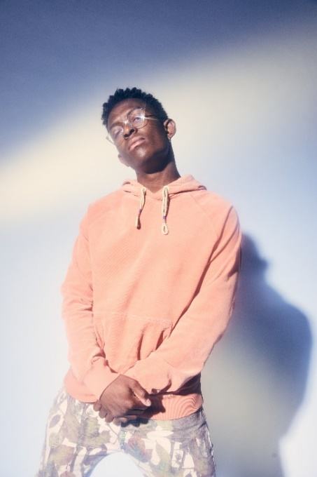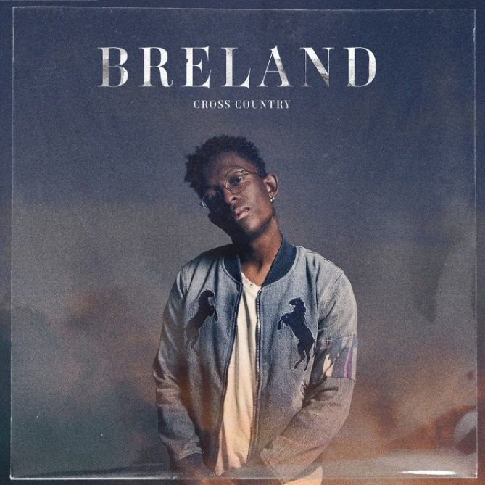
DOWNLOAD HIGH-RES PRESS ASSET(S) HERE DOWNLOAD ARTWORK HERE
PHOTO CREDIT: JIMMY FONTAINE PHOTO CREDIT: JIMMY FONTAINE | ARTWORK: NADA TAHA

# # #

CONNECT WITH BRELAND
WEBSITE | INSTAGRAM | FACEBOOK | TWITTER | YOUTUBE | SOUNDCLOUD | AMAZON MUSIC

BRELAND PR CONTACTS
Fairley McCaskill / Fairley.McCaskill@atlanticrecords.com
Jensen Sussman / jensen@sweettalkpr.com
Mary Catherine Rebrovick / MaryCatherine@wmg.com

