FOR IMMEDIATE RELEASE
SEPTEMBER 23, 2022

ONCE UPON A SAD ROMANCE: CKAY RELEASES HIS MUCH-ANTICIPATED DEBUT ALBUM SAD ROMANCE
ALBUM IS A FOLLOW UP TO LAST MONTH’S SINGLE RELEASE OF ‘YOU’
CKAY WILL BE HEADLINING HIS FIRST SOLO NORTH AMERICAN TOUR IN OCTOBER KICKING OFF IN OAKLAND, CA
EUROPEAN TOUR TO IMMEDIATELY FOLLOW
STREAM SAD ROMANCE
DOWNLOAD HI-RES ARTWORK
Along with other Nigerian musicians of this generation, CKay sits at the forefront of the Afrobeats canon, broadening Fela Kuti’s imagination of the music’s potential and the ever-expanding scope of the African music personage. Afrobeats owes much of its success outside of Nigeria to its diaspora which, through their relentless support of Nigerian music culture in varying spaces around the world, have shun a light on a colourful and sonorous African identity. This success underpins Nigerians’ vibrant spirit and their devotion to their culture. The release of CKay’s debut album Sad Romance then, becomes an exciting moment for Nigeria and by extension, the entire African continent.
CKay’s debut single ‘Nkechi Turn Up’ was released in 2016 and his first project #WTFiCKay EP the following year. Over the years the singer-songwriter has tapped into different parts of his musicality, taking an engaged approach in his music, as writer, producer and performer in many of his projects. On Sad Romance he holds producing credits on half the songs including ‘emiliana’ and ‘love nwantiti’, two of his biggest singles to date.
SAD ROMANCE TRACKLIST
- you
- mmadu
- leave me alone
- you cheated, i cheated too
- come close (feat. Ayra Starr)
- WATAWI (feat. Davido, Focalistic & Abidoza)
- samson and delilah
- by now
- emiliana
- lose you (feat. Ronisia)
- love nwantiti (Bonus)

As a body of work, Sad Romance accentuates a more self-possessed, emotionally disparate CKay who goes back and forth between loving and unloving. The album is a personal story wherein CKay thinks back to his most impactful romantic relationships, painting a picture of how he has often given and received love. The delicacy with which he approaches lyric, composition and singing help him tell a convincing and compelling story and highlights just how contemplated and intentional this work is.
The album boasts 12 tracks which vary in feel, rhythm and motive. Where ‘you’, the opening track, is successful in how it merges R&B, Afrobeats and Amapiano and exhilarating seduction, track two, ‘mmadu’ returns to a more orthodox afrobeats formula. With Track 3, CKay calls on Post Malone producer, Charlie Handsome, to deliver an emo-Afrobeat tour-de-force with ‘leave me alone’ followed immediately by ‘you cheated, I cheated too,’ which boasts a paired back, pop-influenced energy. The story then progresses into one of reciprocal harm with ‘soja’ and ‘come close’ as direct thematic annexures dovetailing into ‘WATAWI,’ the refrain being a perfect encapsulation of the turmoil plaguing complicated relationship dynamics, underpinning the album thesis. CKay then moves on to a duet with Cape Verdian vocalist Mayra Andrade on ‘samson & delilah’, speaking on toxicity in relationships and the pair teeter-totter over their passionate, undying flame. ‘by now,’ the penultimate track, moves the audience gently towards the other side of pain and heartbreak, as the album closes off with ‘lose you’ featuring French darling, Ronisia, which ushers us into ‘love nwantiti (bonus),’ an orchestral arrangement of his sensational global hit, where the story behind the album began.
In a recent Instagram post the superstar has expressed how stunned he is at his own success, reflecting on ‘how big, small beginnings can become’. For CKay, Sad Romance is a diary entry, which touches on many parts of his experiences and is sonic universe where ‘sad boys worldwide’ unite. But, more interestingly, Sad Romance is CKay’s proposition of Africa’s potential, possibility and ability to hold space and assume its posture as a now-continent.
From October 1st CKay will be headlining his first solo North American and European tour, titled the Sad Romance Tour. The tour will kick off in The New Parish, Oakland, California, giving fans an opportunity to connect and experience the album together. On the back of his US tour, CKay will head immediately into his first solo European tour. Full details of dates and cities for the European tour and cities will be announced imminently. Details on the North American tour can be found on www.ckay-music.com.
CKAY’S “SAD ROMANCE TOUR” NORTH AMERICAN DATES
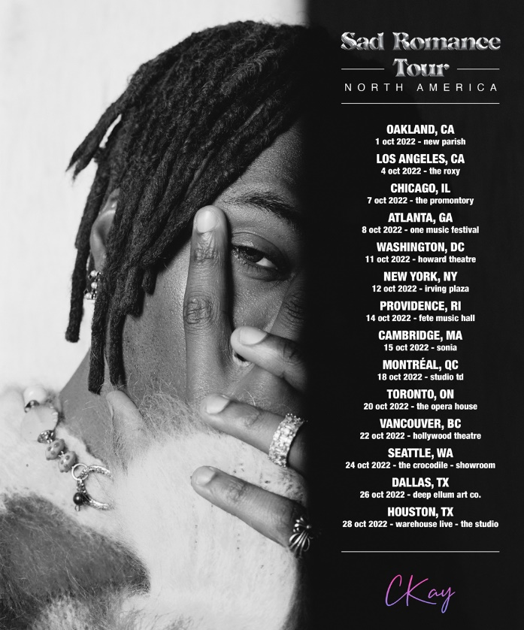
01 – Oakland, CA – New Parish
04 – Los Angeles, CA – The Roxy
07 – Chicago, IL – The Promontory
08 – Atlanta, GA – One Music Festival*
11 – Washington, D.C. – Howard Theatre
12 – New York, NY – Irving Plaza
14 – Providence, RI – Fete Music Hall
15 – Cambridge, MA – Sonia
18 – Montreal, QC – Studio Td
20 – Toronto, ON – The Opera House
22 – Vancouver, BC – Hollywood Theatre
24 – Seattle, WA – The Crocodile – Showroom
26 – Dallas, TX – Deep Ellum Art Co.
28 – Houston, TX – Warehouse Live – The Studio
*festival performance
ABOUT CKAY
Chukwuka Ekweani, known publicly as CKay, is the rising star in the ever-burgeoning Afrobeats scene. A multi-talented artist, whether behind the boards as a producer or in front of the mic performing his self-penned songs, it is CKay’s single-minded vision that shines through. The self-defined Emo-Afrobeat star has and continues to soar up charts across the globe thanks to his first globally recognized single ‘love nwantiti’.
The Nigerian singer, songwriter and producer originally released ‘love nwantiti (ah ah ah)’ back in 2019 as part of his debut EP, CKay The First. In 2021, CKay became the most streamed artist of the year and became the first African artist with two tracks on the Global Spotify Top 30 simultaneously. ‘love nwantiti’ has been certified platinum/multi-platinum in five countries, including the United States and India, The viral hit has also been certified gold in the UK, Australia, South Africa, Italy, and New Zealand. CKay became the first African artist in 50 years to hold a top 5 position on the UK Singles Chart for 4 straight weeks with ‘love nwantiti’.
CKay has continued to create a global presence with accomplishments such as the “most Shazam-ed song in the world”. His most recent globally recognized single, ‘Emiliana’, has followed suit and racked in global chart positions and currently has just under 100 million streams. ‘Emiliana’ peaked at #1 on the UK Afrobeats Chart, #2 on Shazam Top 200 (Afrobeats), and #1 in six countries on Apple Music.
With new music on the way in 2022, CKay is bound to continue creating amazing music that will catch the attention of fans, both old and new, on a global scale.

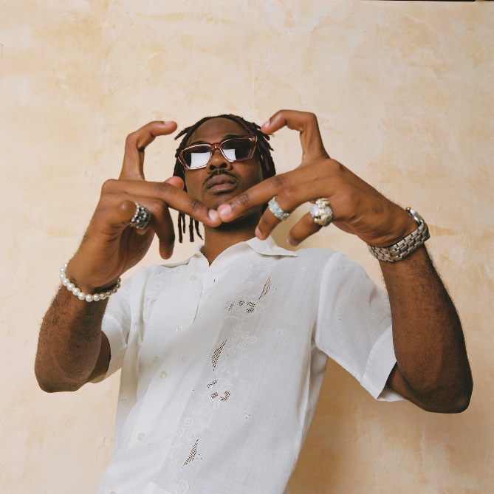
CONNECT WITH CKAY:
TWITTER | FACEBOOK | INSTAGRAM

PRESS CONTACT:
ARIANA.WHITE@ATLANTICRECORDS.COM

