FOR IMMEDIATE RELEASE
SEPTEMBER 21, 2022

2X GRAMMY® NOMINATED RAPPER CORDAE AND 3X GRAMMY® WINNING SUPER PRODUCER HIT-BOY RELEASE VISUAL FOR “CHECKMATE” TRACK
SINGLE IS FEATURED EXCLUSIVELY ON EA SPORTS MADDEN NFL 23 SOUNDTRACK
FOLLOW UP TO UNACCEPTABLE TWO PACK EP STREAMING NOW
EPIC WORLD TOUR UNDERWAY FEATURES HEADLINE DATES AND FESTIVAL PERFORMANCES
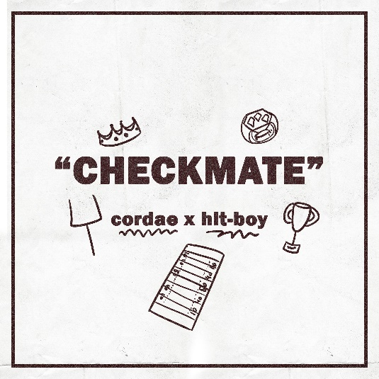
2x GRAMMY® Award-nominated rapper Cordae and 3x GRAMMY® winning producer Hit-Boy are back with the release of the visual for their single “Checkmate” from the official EA Sports Madden NFL 23 Soundtrack and is available for streaming now. The single is also produced by super producer Hit-Boy who also scored the cinematics for the game. The visual is also a follow up to the recent release of the two-pack EP Unacceptable available for streaming now.
Madden NFL 23 features 39 defining bangers including superstar collabs like Pusha T ft. Lil Uzi Vert & Don Toliver, Snoop Dogg ft. Nas and Ty Dolla $ign ft. Wiz Khalifa along with killer tracks by Joey Bada$$, Nas, and Kendrick Lamar. It also highlights unstoppable newcomers like innovative L.A. rapper/producer Malachiii, Japanese DJ and BAPE creator Nigo (with Tyler The Creator), and 2022 XXL Freshman Class female MC Doechii. More than a third of the soundtrack debuted new or exclusive music from artists, including Big K.R.I.T., King Green, Gizzle ft. BRE-Z, Symba, Erica Banks, Lord Afrixana, Marqus Clae, and Simon Said. & Jazzfeezy, with hard-hitting tracks by Killer Mike and Bas available only in game.
Along with the release of the EP, Cordae also released a visual for the lead single “So With That” streaming now via YouTube. Unacceptable also comes on the heels of the release of his visual only, live studio album, From A Birds Eye View, streaming exclusively via Facebook. The 10-track live, visual only album provides acoustic versions of each track featured on the original From A Birds Eye View. This upcoming fall, Cordae will also be back with the release of a new mixtape.

# # #
ABOUT CORDAE
Cordae knows exactly what he wants to say. He chooses his words and phrases carefully. He speaks from a place of truth. That’s why the two-time GRAMMY® Award-nominated gold-selling Maryland-raised rapper has quietly become one of the modern generation’s most trusted narrators. A remarkable life has given him a lot to say. He went from trailer parks and public housing with his mom to stratospheric success. After a series of buzzing singles, he reached critical mass with his 2019 full-length debut, The Lost Boy. It bowed in the Top 15 of the Billboard Top 200 and included four gold-certified singles— “RNP” [feat. Anderson .Paak], “Have Mercy,” “Broke As Fuck,” and “Kung Fu.” Beyond unanimous praise from Billboard, Complex, High Snobiety, New York Times, Pitchfork, and Stereogum, he garnered a pair of GRAMMY® Award nominations in the categories of “Best Rap Album” for The Lost Boy and “Best Rap Song” for “Bad Idea” [feat. Chance the Rapper]. He’s the rare artist whose presence can be felt on-screen in a Super Bowl commercial alongside legendary Academy® Award-winning director Martin Scorsese and among XXL’s coveted “Freshman Class.” Along the way, he linked up with Roddy Ricch and Ant Clemons for “Gifted” as well as joining forces with Eminem for “Killer.” Absorbing wisdom from a life-changing trip to Africa, enduring the loss of a friend gone too soon, and evolving as an artist and a man, he tells this story in widescreen technicolor on his 2022 second full-length offering, From A Birds Eye View [ART@WAR/Atlantic Records]. Cordae followed up the release of his sophomore album with the Facebook exclusive premiere of his visual only, From A Birds Eye View (Live) album.

ABOUT HIT-BOY
As one of the music industry’s most sought out producers and artists, the California-bred Hit-Boy has more than earned his moniker. Born Chauncey Hollis, 3x GRAMMY Award-winning multi-hyphenate artist from Pasadena and the neighboring Inland Empire, boasts an impressive roster of credits, from wielding pop smashes for Beyoncé, Rihanna and Ariana Grande to producing hit records for Jay-Z, Kanye West, Kendrick Lamar, Travis Scott, and more over his thirteen plus years in the industry. As a rapper and songwriter in his own right, Hit-Boy has recorded and released seven mixtapes and three collaborative albums. Recently earning a GRAMMY for Nas' King's Disease (Hit served as an executive producer on the 'Best Rap Album'), the super producer has earned his first-time GRAMMY nomination for the ‘Producer of the Year’ category in 2021. He has racked up several additional accolades, including ‘Producer of the Year’ at the 2021 and 2020 BET Hip-Hop Awards, ‘Producer of the Year’ at the XXL Awards, 'Outstanding Producer of the Year' at the 2021 NAACP Image Awards and Complex's 'Best Hip-Hop Producer Alive' of 2020. He recently served as executive producer for Nas' King's Disease (GRAMMY winner) and King’s Disease II, Big Sean's Detroit 2 (debuted No. 1 on the Billboard 200) and is currently working on his own artist project (title TBA) due out in November as well as producing ‘Thique’ on Beyoncé’s latest project Renaissance and producing the soundtrack for Madden23.

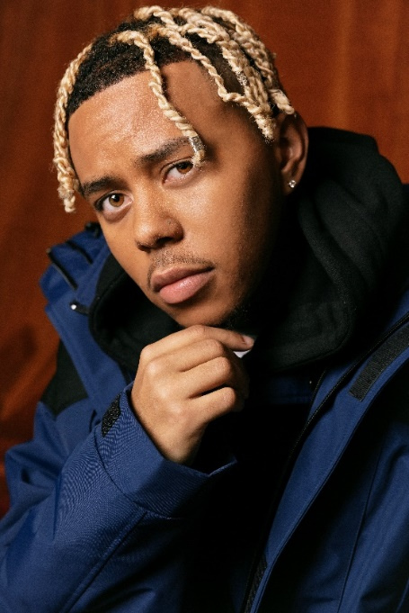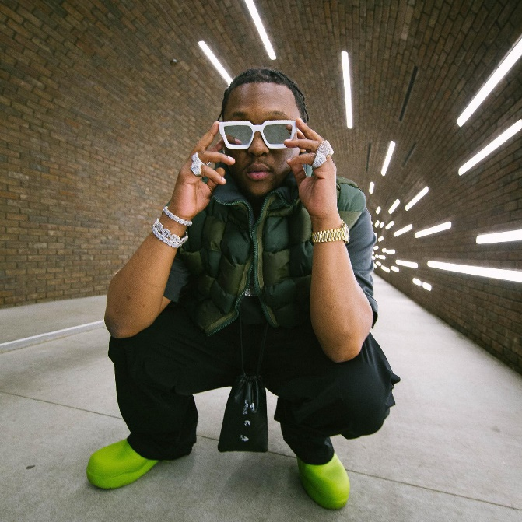

CONNECT WITH CORDAE
INSTAGRAM | YOUTUBE | TWITTER | FACEBOOK

CONNECT WITH HIT-BOY
INSTAGRAM | TWITTER | FACEBOOK | WEBSITE

FOR PRESS INQUIRIES
FOR CORDAE SYDNEY.MARGETSON@ATLANTICRECORDS.COM | FOR HIT-BOY AUSTIN@THECHAMBERGROUP.COM

