CHARLIE PUTH ANNOUNCES ‘ONE NIGHT ONLY’ TOUR
TICKETS ON SALE SEPTEMBER 23rd AT 10AM LOCAL TIME

THIRD STUDIO ALBUM CHARLIE OUT OCTOBER 7TH – PRE-ORDER HERE

RELEASES NEW TRACK “I DON’T THINK THAT I LIKE HER” TODAY
LISTEN HERE

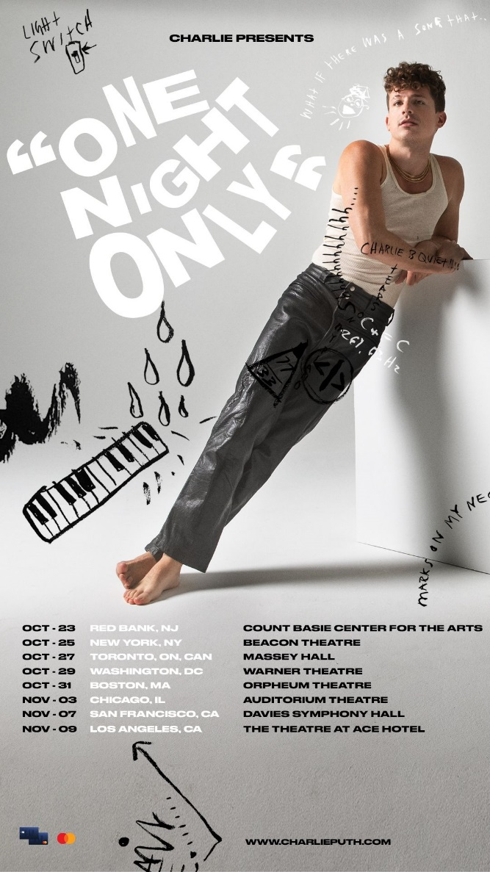
Download Tour Admat Here
Download “Smells Like Me” Cover Art Here

Los Angeles, CA – September 16, 2022 – Today, GRAMMY-nominated and multi-platinum singer/songwriter/producer Charlie Puth announces plans to bring his forthcoming third studio album, CHARLIE to fans around across North America with the ‘One Night Only’ tour, produced by Live Nation. Offering 8 dates across North America and Canada this fall, the run of intimate underplay shows will kick off in New Jersey on October 23rd at the Count Basie Center for the Arts, before making his way North to Massey Hall in Toronto on October 27th and finally, The Theatre at Ace Hotel in Los Angeles on November 9th.

Tickets will go on sale to the general public on Friday, September 23rd at 10AM local time. The Gap Inc. Credit Card is the official card of the ‘One Night Only’ tour. Gap Inc. (NYSE: GPS) includes Old Navy, Gap, Athleta and Banana Republic brands. Cardmembers with a Gap Inc family of brands credit card will have access to presale tickets on Monday, September 19th at 10AM local time until Thursday, September 22nd at 10AM local time. To access presale and find further ticket details head to charlieputh.com/tour.

Gearing up to release his highly anticipated third studio album CHARLIE, due October 7th via Atlantic Records, Puth has taken his fans along every step of the way. With the ‘One Night Only’ tour, he welcomes them up close and personal as puts his most personal body of work to date on display.

Releasing his newest track, “I Don’t Think That I Like Her,” from the forthcoming project today, Puth leans into a heavily voice-led melody while Travis Barker holds down a robust beat on drums to create a high-energy punk-style refrain. Listen here.

Despite being weeks out from its’ release, CHARLIE, has already surpassed one billion global streams with the help of latest releases “Smells Like Me,” “That’s Hilarious,” “Light Switch” and current single “Left and Right [feat. Jung Kook of BTS] which has garnered over 370 million streams alone and stands as Puth’s most successful chart debut to date. Continuing that momentum, he recently dropped a dynamic remix of the hit collaboration track with the help of GRAMMY-nominated electronic music duo Galantis. Click here to listen.

‘One Night Only’ Tour Dates:
10/23/22 – Red Bank, NJ – Count Basie Center for the Arts
10/25/22 – New York, NY – Beacon Theatre
10/27/22 – Toronto, ON, CAN – Massey Hall
10/29/22 – Washington, DC – Warner Theatre
10/31/22 – Boston, MA – Orpheum Theatre
11/3/22 – Chicago, IL – Auditorium Theatre
11/7/22 – San Francisco, CA – Davies Symphony Hall
11/9/22 – Los Angeles, CA – The Theatre at Ace Hotel

Download Hi-Res Image Here

Connect with Charlie Puth:
Website | Instagram | Facebook | Twitter | TikTok | YouTube | Spotify | Apple Music

# # #

About Charlie Puth
Charlie Puth has proven to be one of industry’s most consistent hitmakers and sought-after collaborators. Puth has amassed eight multi-platinum singles, four GRAMMY nominations, three Billboard Music Awards, a Critic’s Choice Award, and a Golden Globe nomination. His 2018 GRAMMY-nominated LP, Voicenotes, was RIAA Certified Gold only four days after its release and has logged over 5.6 billion streams worldwide. Puth’s 2020 collaboration with Gabby Barrett on their “I Hope” Remix earned him his fourth top 10 track on the Billboard Hot 100, hit number one on the Billboard “Adult Pop Songs” chart, and won a 2021 Billboard Music Award for “Top Collaboration.” Puth also co-wrote and produced The Kid Laroi and Justin Bieber’s record-breaking single, “Stay,” which quickly become one of the biggest songs of 2021 and holds the title for the longest-reigning No. 1 on the Billboard Global 200 chart and the first to lead it for double-digits - spending a total of eleven weeks at the top of the chart. Puth is currently gearing up to release his highly anticipated third studio album CHARLIE, due October 7th via Atlantic Records.

About Live Nation Entertainment
Live Nation Entertainment (NYSE: LYV) is the world’s leading live entertainment company comprised of global market leaders: Ticketmaster, Live Nation Concerts, and Live Nation Sponsorship. For additional information, visit www.livenationentertainment.com.

Press Contacts for Charlie Puth:
ID PR, Kelly Bush Novak, Macy Rivet, Courtenay Barrett, Amy Morse, Elif Mamak and Nora Carlblom
(TeamPuth@id-pr.com)

Atlantic Records, Sheila Richman (sheila.richman@atlanticrecords.com) and Ted Sullivan (ted.sullivan@atlanticrecords.com)

PR Contact for Live Nation Entertainment:
Monique Sowinski (moniquesowinski@livenation.com)

