FOR IMMEDIATE RELEASE

SEPTEMBER 23, 2022

CROOKED COLOURS CELEBRATE TOMORROWS

AUSTRALIAN INDIE-DANCE TRIO UNVEIL HIGHLY ANTICIPATED LABEL DEBUT ALBUM

NORTH AMERICAN HEADLINE TOUR BEGINS SEPTEMBER 29 IN BROOKLYN, NY AND INCLUDES LEGENDARY VENUES LIKE RED ROCKS AND THE FONDA THEATER

TOMORROWS AVAILABLE NOW VIA ATLANTIC RECORDS - LISTEN HERE

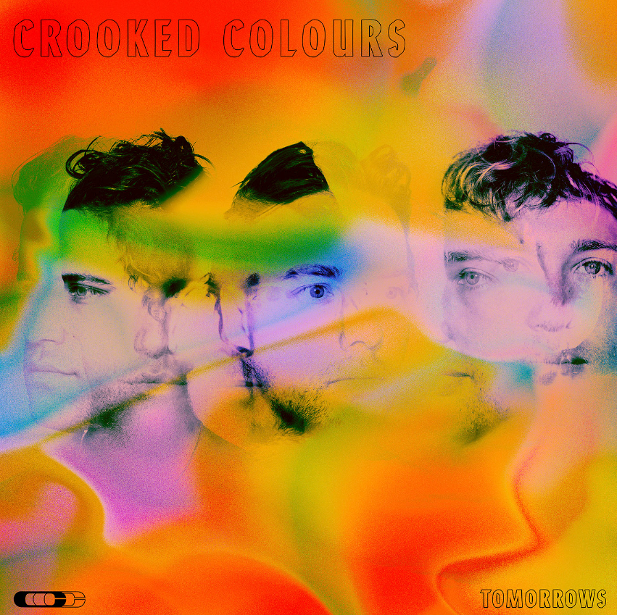
DOWNLOAD ARTWORK HERE

Acclaimed Australian indie-dance trio Crooked Colours have announced today’s release of their eagerly anticipated Atlantic Records debut album, Tomorrows, available now at all DSPs and streaming services – listen HERE.

Written and produced by Crooked Colours – Phil Slabber (vocals, guitar, production), Leon Debaughn (keys, production), and Liam Merrett-Park (drums) – TOMORROWS showcases a spectacular array of recent released singles, including “Feel It,” “Light Year (Feat. Masked Wolf & Jasiah),” “No Sleep,” “Falling,” “Love Language,” and most recently “Holiday,” which released alongside a beautiful visualizer filmed during the band’s trip to Bali – watch HERE. “Holiday” has already garnered over 412K worldwide streams since releasing just a few weeks ago. The trio has secured their position as electronica tastemakers thanks to standout tracks like “Flow”, “Do It Like You”, “Love Language”, “No Sleep” and their recent single “Light Year” that features global phenomenon Masked Wolf and underground rap wunderkind Jasiah.

“This was an album created during very testing times for us as a group. We started the writing process coming off the back of really great momentum following the success of our sophomore record Langata. With solid progress overseas after a run of international tours and festivals, we inked a deal with Atlantic Records and had everything mapped out when the rug was pulled from underneath us as the reality of the pandemic hit. We have always generated so much inspiration from performing live to our fans so we worried how this record may translate without having that energy to draw from. We bunkered down in our studio in Fremantle and focused on what we could control and that was writing and recording as much music as we could. It became a long process for us as we battled with the reality around us, not knowing what lay ahead while maintaining a creative output.

The title track 'Tomorrows' and the songs we ended up collating for this record is a reflection of us as a group coming to terms with how much the landscape had changed. We realised how hard we had been pushing ourselves in pursuit of tomorrow's success without taking a moment to appreciate how far we had come. We also didn't want to dwell on the hand we had been dealt and try to include a message of hope into these songs. As much as Tomorrows is a statement on what had been driving us in the past it is also us saying that we are looking forward to what is coming in the future and moving past this difficult period in our lives. From a personal level we have grown a lot while writing this record and we couldn't be prouder of what we have created. Musicians, creatives and everyone have been through a lot over the past three years. This album is to let all of our fans, friends and family who have helped us know that we are still here, we are fighting and we are really looking forward to what's coming tomorrow.”

- CROOKED COLOURS

###

CROOKED COLOURS
TOMOROWS
(Atlantic Records)

TRACKLIST
Love Language
Holiday
Feel It
Homecoming
No Sleep
Don’t Give Up On Me
Falling
Circles
Moving On
Tomorrows
Light Year (Feat. Masked Wolf & Jasiah)
Still Here
Fight Night

###

Crooked Colours will celebrate TOMORROWS with an epic world tour. North American headline dates get underway September 29 at Brooklyn, NY’s Music Hall of Williamsburg and then continue through late October. For complete details and ticket information, please visit www.crookedcoloursmusic.com.

CROOKED COLOURS
NORTH AMERICAN TOUR 2022

SEPTEMBER
29 – Brooklyn, NY – Music Hall of Williamsburg
30 – Philadelphia, PA – The Foundry

OCTOBER
1 – Boston, MA – The Sinclair
4 – Montreal, QC – Le Studio Td
5 – Toronto, ON – Axis Club
7 – Chicago, IL – The Vic Theatre
14 – Denver, CO – Ogden Theatre
21 – Los Angeles, CA – Fonda Theatre
22 – San Francisco, CA – The Regency Ballroom
26 – Portland, OR – Wonder Ballroom
27 – Seattle, WA – Showbox at the Market
28 – Vancouver, BC – Commodore Ballroom

# # #

Hailed by EDM.com for their “harmonious blend of indie, house, and pop,” Crooked Colours have quickly proven one of the world’s hottest electronic acts, fusing delicate acoustic instrumentation, evocative vocals, upbeat lyricism, and dancefloor-ready synth transmissions to create a dynamic, shape-shifting sound all their own. Fueled by tracks like 2017’s breakthrough smash, “Flow,” the Fremantle, Western Australia-based trio has quickly racked up nearly 150M worldwide streams while earning worldwide critical applause and an ever-growing fan following. An equally unstoppable live act, Crooked Colours have sold out countless shows on multiple continents while lighting up festivals around the world including an unforgettable set at 2019’s Bonnaroo Music & Arts Festival.

# # #

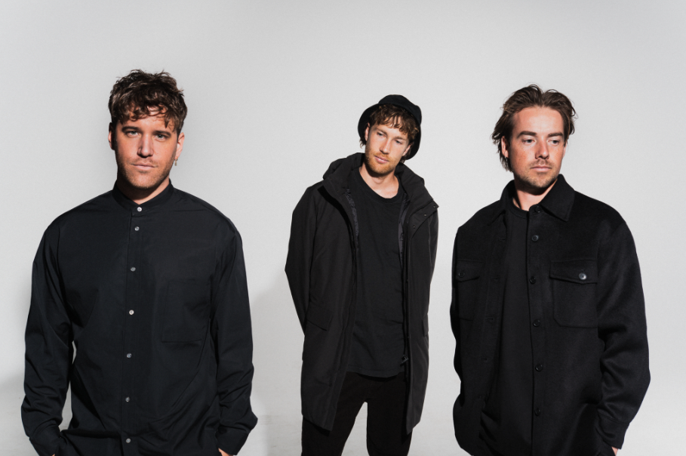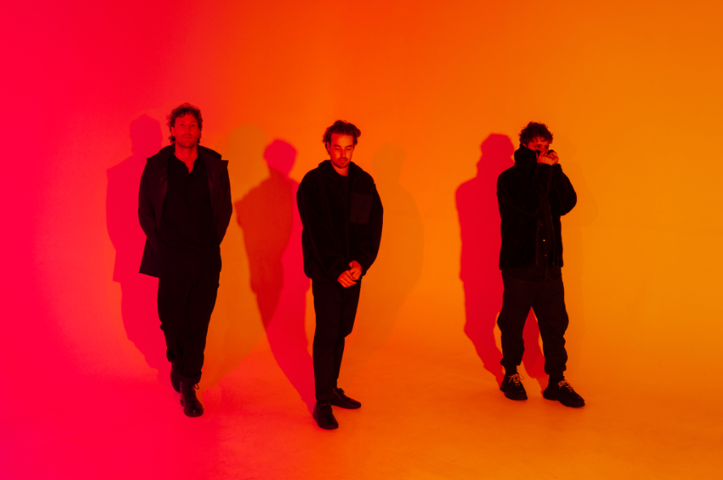
DOWNLOAD PRESS PHOTOS HERE // CREDIT: MATSU

CONNECT WITH CROOKED COLOURS
OFFICIAL | FACEBOOK | INSTAGRAM | TWITTER | YOUTUBE

FOR PRESS INQUIRIES, PLEASE CONTACT:
Jessica Nall // Jessica.Nall@atlanticrecords.com

