FOR IMMEDIATE RELEASE
SEPTEMBER 30, 2022

Daniel Seavey makes solo debut with “Can We Pretend That We’re Good?”

Multi-platinum singer/songwriter, multi-instrumentalist, producer,
and Why Don’t We co-founder’s new single & music video available now

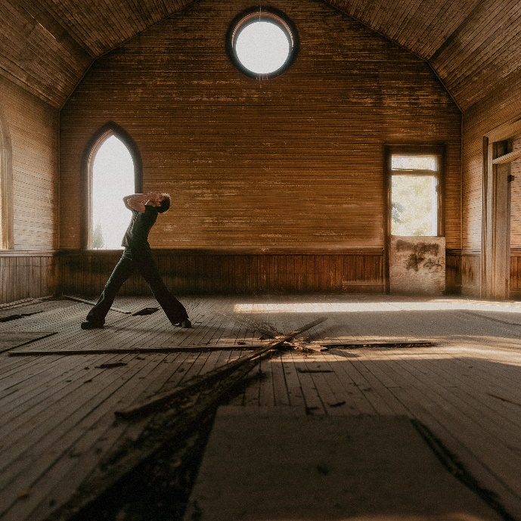
DOWNLOAD HIGH-RES ART/IMAGES

WATCH VIDEO: LINK
BUY/STREAM: LINK

Multi-platinum singer/songwriter, multi-instrumentalist, and producer Daniel Seavey makes his official solo debut with explosive new single “Can We Pretend That We’re Good?” – available now alongside an equally striking music video directed by Evan Hara. Embarking on a new chapter of his career, the Why Don’t We co-founder re-introduces himself as a bold and boundless solo artist with an ever-evolving collage of rock, pop, alternative, and electronic layers, shifting past one another in tectonic fashion.

Self-penned and produced, the unpredictable push-and-pull of “Can We Pretend That We’re Good?” represents the kind of music Seavey was destined to make. On the track, acoustic guitar creaks beneath emotive verses and the pops of a plucked cello. It snaps into a rush of distortion and electronic feedback as his falsetto rings out, “I’ll never find another you.”

“It’s fun to dive into who I am,” said Seavey. “For the last few years, I’ve been jotting down notes without even realizing I’m leaving this trail of who I am in the lyrics and music. I’m definitely a whole different person, but I’ve always been this artist. The texture of what I bring was there, but it’s being seen now. So many curveballs in life have changed me. In terms of the music though, it’s never shifted. I consistently try to take different sounds and assemble something you’ve never heard before. I’ve always wanted to do this, and I’m excited to be able to now.”

At just nine-years-old, Seavey’s father encouraged him to busk at a local art walk on Thursdays. Sitting behind a piano with a small speaker, he attracted crowds of hundreds, filling a hat with enough dough to finance a personal bedroom studio. Since dad also served as a pastor, he developed his chops on the cello by performing in the church band. Growing up as a pastor’s kid, his exposure to secular music was limited until later in life – ultimately leading to an explosion of inspiration and possibility. After hearing “Jungle” by Drake in freshman year of high school, he embraced favorite artists such as Mac Miller, Kendrick Lamar, and The Weeknd.

In 2016, Seavey co-founded Why Don’t We and embarked upon an unbelievable six-year journey highlighted by over 4 billion global career streams, two RIAA Platinum-certified singles, five RIAA Gold-certified singles, two Top 10 albums on the Billboard 200 chart, and sold out tours with multiple stops at legendary venues such as Radio City Music Hall and more. On the road, he often penned and produced nascent ideas that would eventually become the foundation of his own unique sound. In 2022, he hunkered down in his home studio and wrote and recorded what would become his debut, previewed for fans on social media by a gripping cover of Leonard Cohen’s “Hallelujah.” He not only sang and produced, but he also played every instrument, infusing a piece of himself upon each facet.

“For me, it’s special when I listen to an artist and feel them through the music,” he leaves off. “I’ve never been honest to this extent with the lyrics. I’m writing my exact thoughts and feelings. I hope it connects to the moment you’re going through too.”

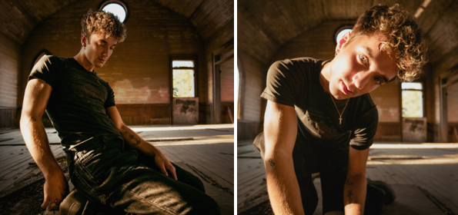
DOWNLOAD HIGH-RES ART/IMAGES (credit: Brandon Phillips)

CONNECT:
Instagram | TikTok | Twitter | YouTube | SoundCloud | Press Assets

CONTACT:
Ted Sullivan (Atlantic Records) | ted.sullivan@atlanticrecords.com

