DEATH CAB FOR CUTIE RELEASES HIGHLY-ANTICIPATED TENTH STUDIO ALBUM ASPHALT MEADOWS

AVAILABLE EVERYWHERE TODAY, SEPTEMBER 16
BUY/STREAM HERE

INDIE ROCK VETERANS’ CURRENT SINGLE “HERE TO FOREVER” IS #4 AND RISING AT ALTERNATIVE RADIO & #1 AT AAA FOR FIFTH STRAIGHT WEEK

FALL HEADLINE TOUR BEGINS SEPTEMBER 22 IN MADISON, WI – FEATURING SUPPORT FROM REAL ESTATE, THAO, CHONG THE NOMAD + YO LA TENGO ON SELECT DATES

WATCH LAST NIGHT’s BROADCAST DEBUT OF TITLE TRACK “ASPHALT MEADOWS” ON “JIMMY KIMMEL LIVE!” + ONLINE-EXCLUSIVE PERFORMANCE OF “ROMAN CANDLES,” “FOXGLOVE THROUGH THE CLEARCUT” & “A MOVIE SCRIPT ENDING” HERE

WATCH THE LYRIC VIDEO FOR TITLE TRACK “ASPHALT MEADOWS” HERE
FALL TOUR TICKETS ON SALE HERE

“Twenty-five years into its career, the band brings its incisive, anguished writing to a particularly 2022 brand of existential angst on its 10th album, ‘Asphalt Meadows’… ‘These nights, I don’t know how I survive,’ Ben Gibbard repeats on the first track, howling over a distorted gnarl of guitar. It’s a tidy thesis statement for an expansive album…” – THE NEW YORK TIMES

“If you haven’t heard yet, Death Cab for Cutie is back back. The long-running rock band looks to be readying its best album in over a decade… which splits the difference between a return to the grandiose form of 2000’s The Photo Album + 2003’s Transatlanticism and new territory.” – VULTURE

“[Gibbard]’s openness to possibility is on full display throughout Asphalt Meadows, the surprising new album from his band Death Cab for Cutie (and their tenth since 1998) that finds the indie mainstays navigating a terrain of exciting new sounds.” – STEREOGUM

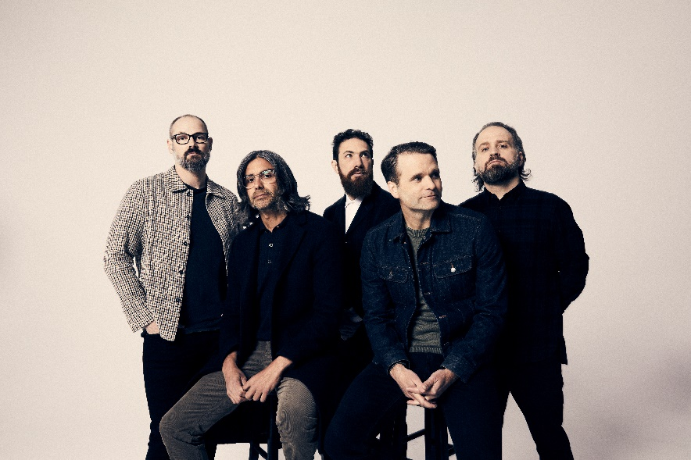
(download hi-res press photo; credit: Jimmy Fontaine)

Today, September 16, 8x GRAMMY® Award-nominated rock band Death Cab for Cutie releases their highly-anticipated tenth studio album Asphalt Meadows on Atlantic Records – available across all DSPs and at physical retailers now. Produced by GRAMMY® Award-winner John Congleton (St. Vincent, Sharon Van Etten, Wallows), the LP has already earned tremendous advance critical acclaim, including from The New York Times, Los Angeles Times, and Vulture, all of whom highlighted the album in their 2022 fall previews. Vulture also lauded spoken-word track “Foxglove Through The Clearcut” as one of “The Best Songs of 2022 (So Far)” and UK music outlet NME declared, “10 albums and 25 years into their career, the Washington indie veterans come back mature and assured but loaded with that early melodic magic.”

“…their best album in years… In Asphalt Meadows, there are elements of the band’s early work… while also feeling fresh — thrashier and livelier than ever before — with some of Gibbard’s sturdiest songwriting...” – SPIN

“…Asphalt Meadows, an album that feels exactly like what Death Cab should ideally sound like 25 years since their formation: At once familiar and like nothing they’ve done before… some of Gibbard’s most introspective lyrics in years.” – CONSEQUENCE OF SOUND

“…some of the most compelling work of the band’s career… one that succeeds in highlighting the best Death Cab components and stretching them farther than ever before…” – FLOOD

“For 10 albums now, plus solo sets and efforts with [Gibbard’s] old combo The Postal Service, the sonic muralist has sketched gorgeous pneumatic panoramas that contain more truth in their tiny brushstroke details than is initially apparent on first inspection… Gibbard’s quirky indie-rock songs are the best kind — growers, like the classic ‘Soul Meets Body,’ that reveal the depths of their brilliance after consecutive listens. The idyllic new Asphalt Meadows — which sets up a paradoxical conundrum in its title alone — follows intellectual, multi-layered suit.” – PASTE

Lead single “Here to Forever” is currently #4 at Alternative radio (and rising), while maintaining a fifth straight week at #1 at AAA (the track was the most-added song at AAA and Alternative upon its mid-July release).

Of Asphalt Meadows, the band shares:
“The day that for so long felt so far away is finally here. Our new album is out, and we could not be more relieved and thankful. We made it. We found our way through a very dark time and have arrived with a record that is a reflection of everything we’ve done and everything still to come. We hope you love Asphalt Meadows as much as we do – it belongs to you now. We can’t wait to see you at all the shows ahead. As always, thank you for listening.”

Last night, the band made the broadcast debut of title track “Asphalt Meadows” on Jimmy Kimmel Live! (watch here) and played previously-released songs “Roman Candles” and “Foxglove Through The Clearcut,” along with the classic “A Movie Script Ending,” as an online exclusive for the show.

“Asphalt Meadows” is accompanied by a striking lyric video – also out today – designed by frequent visual collaborator Juliet Bryant (Justin Vernon, Japanese Breakfast, Laura Jane Grace).

Earlier this week, all five band members hosted a ‘Live From Home’ livestream performance – highlights included a cover of R.E.M.’s “Near Wild Heaven” and the stripped-down debut of album track “Pepper” – within lead vocalist and guitarist Ben Gibbard’s Seattle-based studio, raising funds for reproductive rights nonprofit, The Brigid Alliance (donate here).

Last Friday, September 9, the band unveiled a one-of-a-kind listening experience for then-unreleased “Rand McNally,” which has been available for exclusive, in-person listening all week (via geotagged map) anywhere the band has played throughout their storied 25-year career. Fans were able to unlock the song at over 800 locations across the globe, ranging from The Pacer House in Bellingham, WA to New York’s legendary Madison Square Garden to Tokyo’s Astro Hall. Wired, who interviewed founding member and bassist Nick Harmer for a feature story on the unique initiative, declared, “Launching ‘Rand McNally’ via geotag felt like a natural extension of the band’s touring history, as well as a way to pay tribute to the thousands of fans who have come to see Death Cab over the years.”

Death Cab for Cutie will continue to celebrate their 10th studio album on the upcoming Asphalt Meadows US headline tour, featuring support from Real Estate, Thao, Chong the Nomad, and Yo La Tengo on select dates. The run kicks off September 22 at The Sylvee in Madison, WI, includes a much-anticipated return to New York’s Forest Hills Stadium on September 30, and culminates with a sold-out, two-night hometown finale at Seattle, WA’s Paramount Theatre on October 26 and 27.

The full routing of upcoming tour dates is listed below.

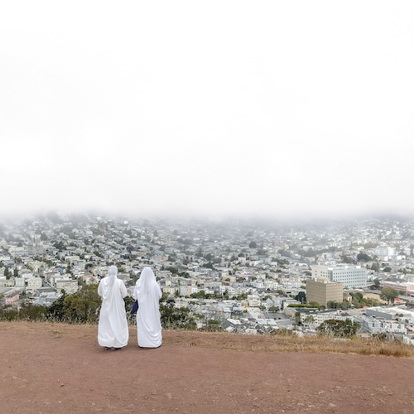
(download hi-res album artwork; photo credit: Benjamin Gibbard)

###

ASPHALT MEADOWS:
- I Don’t Know How I Survive
- Roman Candles
- Asphalt Meadows
- Rand McNally
- Here to Forever
- Foxglove Through The Clearcut
- Pepper
- I Miss Strangers
- Wheat Like Waves
- Fragments From The Decade
- I’ll Never Give Up On You

###

Death Cab for Cutie’s ninth studio album Thank You for Today was released in 2018. That album saw the band entering its second decade by both expanding and refining its signature sound, with highlights including lead single, “Gold Rush,” which reached #1 on Billboard’s “Adult Alternative Songs” chart.

The band continued to affirm their lasting artistic legacy with a wide range of creative activity in the years that followed, including diverse collaborations such as Chance the Rapper’s 2019 album track, “Do You Remember (ft. Death Cab for Cutie),” and Tycho & Gibbard’s acclaimed 2021 single, “Only Love.”

Gibbard presented a series of “Live From Home” livestreams throughout the duration of the COVID-19 pandemic, helping raise over $250K in donations and supplies for various Seattle-area relief organizations. The livestreams – which showcased songs from Death Cab for Cutie, The Postal Service and his solo material, along with covers and other surprises – drew over 4.5 million total views as well as high profile media attention from The New York Times, The New Yorker, Rolling Stone, Newsweek, Variety, NPR, and Stereogum, the latter of which pondered, “Is Ben Gibbard going to single-handedly get us all through quarantine?”

December 2020 saw Death Cab for Cutie release The Georgia EP, initially offered as a 24-hour Bandcamp exclusive in advance of the crucial Georgia runoff elections that ultimately turned the state blue and secured Democratic control of the US Senate. The five-song project – which features covers of iconic artists from the great state of Georgia – raised over $100K for Fair Fight Action, the national voting rights organization founded by Stacy Abrams to promote fair elections around the country through voter education, election reform, and combating voter suppression. “Fair Fight is grateful for the support of Death Cab for Cutie in our fight for free and fair elections in Georgia and nationwide,” Abrams said later. “The Georgia EP helps tell the story of Georgia just as their contributions have helped us write the next chapter.”

In February of this year, Gibbard conceived, curated, and executive produced Ocean Child: Songs of Yoko Ono, an acclaimed tribute to the groundbreaking singer, songwriter, multimedia artist, and activist released in celebration of her 89th birthday. The collection – which includes Death Cab for Cutie’s own cover of “Waiting For The Sunrise” – also features contributions from a stunning range of diverse artists, including David Byrne, Japanese Breakfast, The Flaming Lips, and Sharon Van Etten. Ocean Child earned worldwide critical acclaim spanning The New York Times, Rolling Stone, NPR, The Guardian and more.

Formed in Bellingham, WA in 1997, Death Cab for Cutie almost immediately entered the ranks of the era’s definitive bands, fueled in large part by the remarkable power of co-founder, vocalist, guitarist, and lead songwriter Benjamin Gibbard’s complex, often bittersweet songcraft. The band made their worldwide popular breakthrough with 2003’s RIAA gold certified Transatlanticism, later named by NPR as one of “The Decade's 50 Most Important Recordings.” Plans, their 2005 Atlantic Records debut release, saw Death Cab for Cutie ascending to even greater heights, earning RIAA platinum certification and a GRAMMY® Award nomination for “Best Alternative Album” while spawning the chart-topping singles, “Soul Meets Body” and “I Will Follow You into the Dark,” the latter of which was honored with a GRAMMY® nod for “Best Pop Performance By Duo Or Group With Vocals.” Their following albums – including Narrow Stairs (2008), The Open Door (2009), Codes and Keys (2011), and Kintsugi (2015) – all received various GRAMMY® Award nominations, bringing their total career nominations to eight overall.

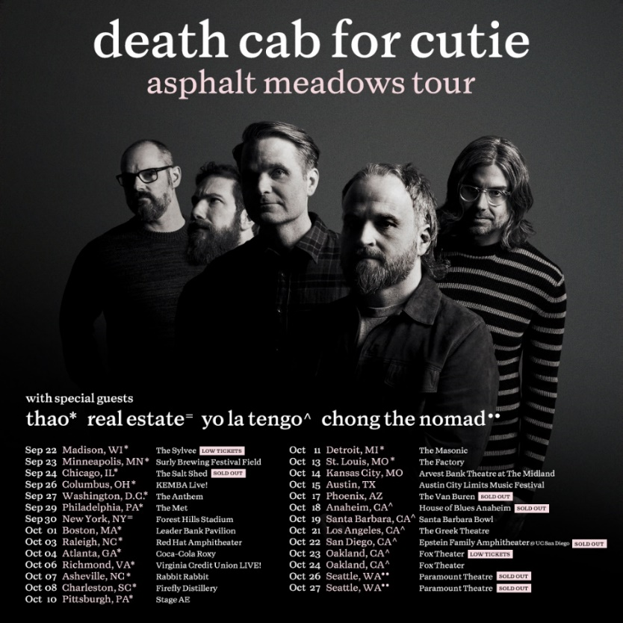
(download hi-res admat)

###

DEATH CAB FOR CUTIE | ASPHALT MEADOWS TOUR

SEPTEMBER
22 – Madison, WI – The Sylvee ^ – LOW TICKETS
23 – Minneapolis, MN – Surly Brewing Festival Field ^
24 – Chicago, IL – The Salt Shed ^ – SOLD OUT
26 – Columbus, OH – KEMBA Live! ^
27 – Washington, DC – The Anthem ^
29 – Philadelphia, PA – The Met ^
30 – New York, NY – Forest Hills Stadium =

OCTOBER
1 – Boston, MA – Leader Bank Pavilion ^
3 – Raleigh, NC – Red Hat Amphitheater ^
4 – Atlanta, GA – Coca-Cola Roxy ^
6 – Richmond, VA – Virginia Credit Union LIVE! ^
7 – Asheville, NC – Rabbit Rabbit ^
8 – Charleston, SC – Firefly Distillery ^
10 – Pittsburgh, PA – Stage AE ^
11 – Detroit, MI – The Masonic ^
13 – St. Louis, MO – The Factory ^
14 – Kansas City, MO – Arvest Bank Theatre at The Midland
15 – Austin, TX – Austin City Limits Music Festival †
17 – Phoenix, AZ – The Van Buren – SOLD OUT
18 – Anaheim, CA – House of Blues Anaheim # - SOLD OUT
19 – Santa Barbara, CA – Santa Barbara Bowl #
21 – Los Angeles, CA – The Greek Theatre #
22 – San Diego, CA – Epstein Family Amphitheater @ UC San Diego # – SOLD OUT
23 – Oakland, CA – Fox Theater # – LOW TICKETS
24 – Oakland, CA – Fox Theater #
26 – Seattle, WA – Paramount Theatre % – SOLD OUT
27 – Seattle, WA – Paramount Theatre % – SOLD OUT

MARCH 2023
1 – Milan, Italy – Fabrique *
2 – Zurich, Switzerland – X-Tra *
5 – Copenhagen, Denmark – Den Grå Hal *
6 – Stockholm, Sweden – Filadelfia *
7 – Oslo, Norway – Sentrum Scene *
9 – Berlin, Germany – Columbiahalle *
10 – Tilburg, Netherlands – 013 *
11 – Amsterdam, Netherlands – Paradiso *
12 – Cologne, Germany – E-Werk *
14 – Antwerp, Belgium – De Roma *
15 – Luxembourg, Luxembourg – Atelier *
16 – Paris, France – Salle Pleyel *
18 – Nottingham, United Kingdom – Rock City *
19 – Dublin, Ireland – Bord Gais Energy Theatre *
21 – Birmingham, United Kingdom – 02 Institute *
22 – Edinburgh, United Kingdom – Usher Hall *
23 – Glasgow, United Kingdom – Barrowland *
25 – Manchester, United Kingdom – O2 Apollo *
27 – Brighton, United Kingdom – Dome *
29 – London, United Kingdom – Royal Albert Hall *

† Festival Performance
^ w/ Special Guest Thao
= w/ Special Guest Real Estate
# w/ Special Guest Yo La Tengo
% w/ Special Guest Chong the Nomad
* w/ Special Guest Slow Pulp

# # #

