DEATH CAB FOR CUTIE RELEASES NEW TRACK “FOXGLOVE THROUGH THE CLEARCUT”

8X GRAMMY® AWARD-NOMINATED BAND’s HIGHLY-ANTICIPATED TENTH STUDIO ALBUM ASPHALT MEADOWS ARRIVES SEPTEMBER 16

CURRENT SINGLE “HERE TO FOREVER” TOP 15 AND RISING AT ALTERNATIVE RADIO + RECENTLY HIGHLIGHTED DURING CRITICALLY ACCLAIMED PERFORMANCES ON THE LATE SHOW WITH STEPHEN COLBERT & CBS SATURDAY MORNING

FALL HEADLINE TOUR BEGINS SEPTEMBER 22ND IN MADISON, WI

BUY/STREAM “FOXGLOVE THROUGH THE CLEARCUT” HERE
WATCH THE LYRIC VIDEO HERE
PRE-ORDER ASPHALT MEADOWS HERE

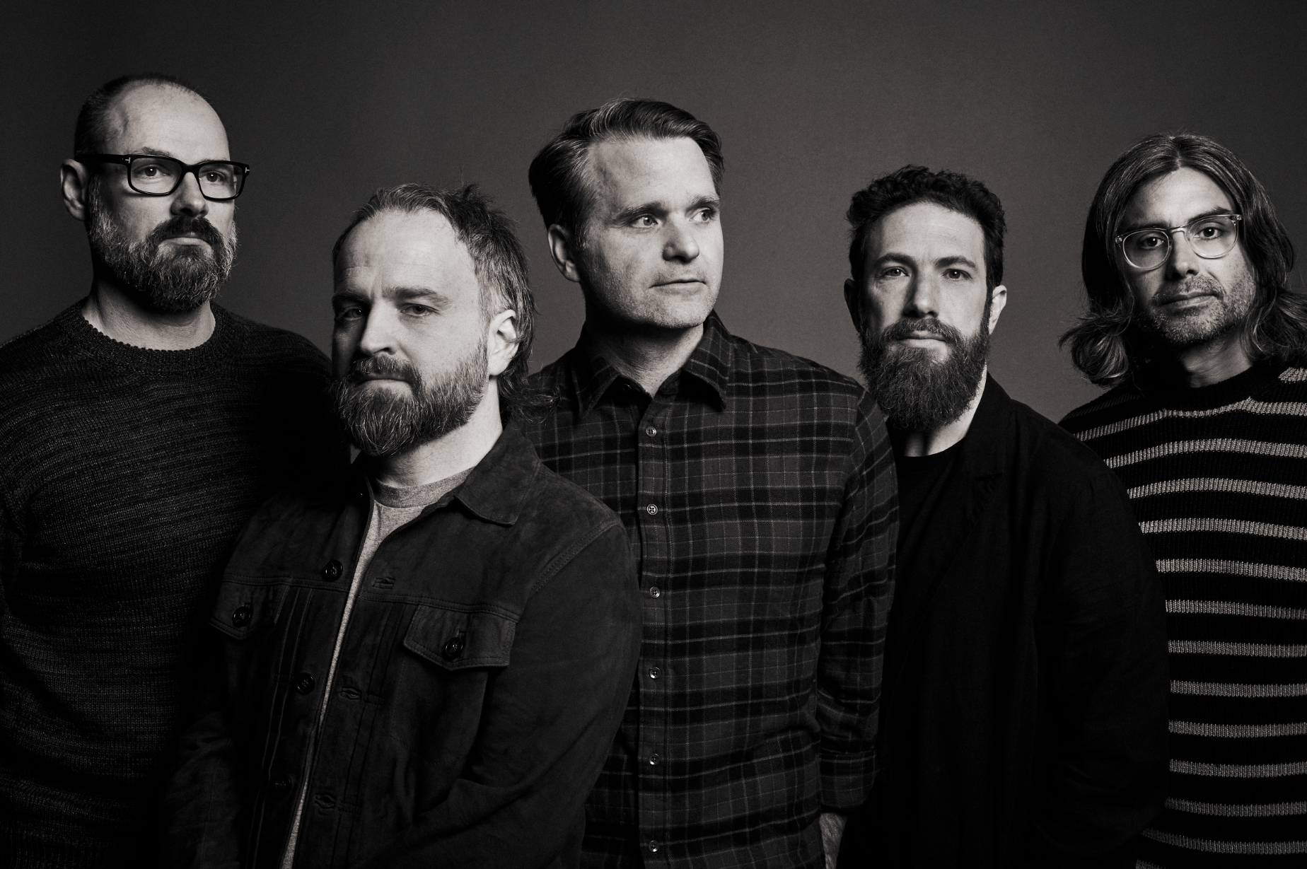
(download hi-res press photo; credit Jimmy Fontaine)

Today, 8x GRAMMY® Award-nominated rock band Death Cab for Cutie releases new track “Foxglove Through The Clearcut” (buy/stream here). Featuring meditative instrumentation and moving spoken word elements that ultimately crescendo into a sweeping outro, the song arrives accompanied by a striking lyric video designed by frequent visual collaborator Juliet Bryant (Justin Vernon, Japanese Breakfast, Laura Jane Grace).

Of “Foxglove Through The Clearcut,” lead vocalist and guitarist Ben Gibbard shares:
“Foxglove is by far the most personal song on the record. While I was writing it, I thought I was merely the narrator. But the longer I sat with it, I realized I was both the protagonist AND the narrator.”

Today’s new song follows “Here to Forever,” which was the most-added song at AAA and Alternative radio upon its release in mid-July. Currently, the single sits at #2 at AAA radio and has already quickly risen to #13 at Alternative. The track has also amassed tremendous critical acclaim, with Stereogum hailing it: “a grand and stirring rocker, one that mixes the soft-eyed sensitivity of the band’s early days with their arena-sized major-label work.”

The first song to be released off the album – “Roman Candles” – arrived with a (quite literally) explosive one-take music video directed by Lance Bangs (Sonic Youth, Nirvana). That track was featured on NPR’s All Songs Considered, with host Bob Boilen highlighting its “two bursting minutes.”

All three songs are lifted off the band’s highly-anticipated tenth studio album Asphalt Meadows, due out September 16th (tracklist enclosed). Pre-orders are available here.

Last month, Death Cab for Cutie made the television debut of “Here to Forever” on The Late Show with Stephen Colbert (watch), with a performance that was praised as “high-energy” by Rolling Stone. The band also appeared on CBS Saturday Morning, performing “Here to Forever,” “Roman Candles,” and “Fake Frowns,” a favorite cut from their 1998 debut, Something About Airplanes.

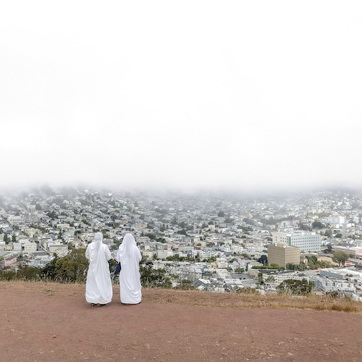
(download hi-res album artwork; photo credit: Benjamin Gibbard)

Asphalt Meadows was produced by GRAMMY® Award-winner John Congleton (St. Vincent, Sharon Van Etten, Wallows). Alongside news of the forthcoming album, the band also unveiled plans for their wide-ranging fall US headline tour. The run kicks off September 22 at The Sylvee in Madison, WI and culminates with a two-night hometown finale at Seattle, WA’s Paramount Theatre on October 26 and 27 (full routing enclosed). The tour will feature support from Low and Yo La Tengo on select dates and includes a much anticipated return to NY’s Forest Hills Stadium on September 30.

Death Cab for Cutie’s ninth studio album Thank You for Today was released in 2018. That album saw the band entering its second decade by both expanding and refining its signature sound, with highlights including lead single, “Gold Rush,” which reached #1 on Billboard’s “Adult Alternative Songs” chart.

The band continued to affirm their lasting artistic legacy with a wide range of creative activity in the years that followed, including diverse collaborations such as Chance the Rapper’s 2019 album track, “Do You Remember (ft. Death Cab for Cutie),” and Tycho & Gibbard’s acclaimed 2021 single, “Only Love.”

Gibbard presented a series of “Live From Home” livestreams throughout the duration of the COVID-19 pandemic, helping raise over $250K in donations and supplies for various Seattle-area relief organizations. The livestreams – which showcased songs from Death Cab for Cutie, The Postal Service and his solo material, along with covers and other surprises – drew over 4.5 million total views as well as high profile media attention from The New York Times, The New Yorker, Rolling Stone, Newsweek, Variety, NPR, and Stereogum, the latter of which pondered, “Is Ben Gibbard going to single-handedly get us all through quarantine?”

December 2020 saw Death Cab for Cutie release The Georgia EP, initially offered as a 24-hour Bandcamp exclusive in advance of the crucial Georgia runoff elections that ultimately turned the state blue and secured Democratic control of the US Senate. The five-song project – which features covers of iconic artists from the great state of Georgia – raised over $100K for Fair Fight Action, the national voting rights organization founded by Stacy Abrams to promote fair elections around the country through voter education, election reform, and combating voter suppression. “Fair Fight is grateful for the support of Death Cab for Cutie in our fight for free and fair elections in Georgia and nationwide,” Abrams said later. “The Georgia EP helps tell the story of Georgia just as their contributions have helped us write the next chapter.”

In February of this year, Gibbard conceived, curated, and executive produced Ocean Child: Songs of Yoko Ono, an acclaimed tribute to the groundbreaking singer, songwriter, multimedia artist, and activist released in celebration of her 89th birthday. The collection – which includes Death Cab for Cutie’s own cover of “Waiting For The Sunrise” – also features contributions from a stunning range of diverse artists, including David Byrne, Japanese Breakfast, The Flaming Lips, and Sharon Van Etten. Ocean Child earned worldwide critical acclaim spanning The New York Times, Rolling Stone, NPR, The Guardian and more.

Formed in Bellingham, WA in 1997, Death Cab for Cutie almost immediately entered the ranks of the era’s definitive bands, fueled in large part by the remarkable power of co-founder, vocalist, guitarist, and lead songwriter Benjamin Gibbard’s complex, often bittersweet songcraft. The band made their worldwide popular breakthrough with 2003’s RIAA gold certified Transatlanticism, later named by NPR as one of “The Decade's 50 Most Important Recordings.” Plans, their 2005 Atlantic Records debut release, saw Death Cab for Cutie ascending to even greater heights, earning RIAA platinum certification and a GRAMMY® Award nomination for “Best Alternative Album” while spawning the chart-topping singles, “Soul Meets Body” and “I Will Follow You into the Dark,” the latter of which was honored with a GRAMMY® nod for “Best Pop Performance By Duo Or Group With Vocals.” Their following albums – including Narrow Stairs (2008), The Open Door (2009), Codes and Keys (2011), and Kintsugi (2015) – all received various GRAMMY® Award nominations, bringing their total career nominations to eight overall.

ASPHALT MEADOWS TRACKLISTING:
- I Don’t Know How I Survive
- Roman Candles
- Asphalt Meadows
- Rand McNally
- Here to Forever
- Foxglove Through The Clearcut
- Pepper
- I Miss Strangers
- Wheat Like Waves
- Fragments From The Decade
- I’ll Never Give Up On You

###

DEATH CAB FOR CUTIE
TOUR 2022

SEPTEMBER
4 – All IN Festival – Indianapolis, IN *
22 – Madison, WI – The Sylvee ^
23 – Minneapolis, MN – Surly Brewing Festival Field ^
24 – Chicago, IL – The Salt Shed ^ – SOLD OUT
26 – Columbus, OH – KEMBA Live! ^
27 – Washington, DC – The Anthem ^
29 – Philadelphia, PA – The Met ^
30 – New York, NY – Forest Hills Stadium ^

OCTOBER
1 – Boston, MA – Leader Bank Pavilion ^
3 – Raleigh, NC – Red Hat Amphitheater ^
4 – Atlanta, GA – Coca-Cola Roxy ^
6 – Richmond, VA – Virginia Credit Union LIVE! ^
7 – Asheville, NC – Rabbit Rabbit ^
8 – Charleston, SC – Firefly Distillery ^
10 – Pittsburgh, PA – Stage AE ^
11 – Detroit, MI – The Masonic ^
13 – St. Louis, MO – The Factory ^
14 – Kansas City, MO – Arvest Bank Theatre at The Midland ^
15 – Austin, TX – Austin City Limits Music Festival *
17 – Phoenix, AZ – The Van Buren – SOLD OUT
18 – Anaheim, CA – House of Blues Anaheim # - SOLD OUT
19 – Santa Barbara, CA – Santa Barbara Bowl #
21 – Los Angeles, CA – The Greek Theatre #
22 – San Diego, CA – Epstein Family Amphitheater @ UC San Diego # - SOLD OUT
23 – Oakland, CA – Fox Theater #
24 – Oakland, CA – Fox Theater #
26 – Seattle, WA – Paramount Theatre † – SOLD OUT
27 – Seattle, WA – Paramount Theatre † – SOLD OUT

* Festival Performance
^ w/ Special Guests Low
# w/ Special Guests Yo La Tengo
† w/ Special Guests Chong the Nomad

# # #

CONNECT WITH DEATH CAB FOR CUTIE
DEATHCABFORCUTIE.COM | FACEBOOK | TWITTER | INSTAGRAM | YOUTUBE | TIKTOK

