FOR IMMEDIATE RELEASE
SEPTEMBER 2, 2022
ENISA IS BACK WITH HER LATEST SINGLE “ZOOM”
SINGLE IS FOLLOW UP TO COLLABORATION WITH RAABAN RELEASED LAST WEEK
MADE HER TV DEBUT ON “AMERICAN SONG CONTEST” EARLIER THIS YEAR
FAKE LOVE EP RELEASED EARLIER THIS YEAR AVAILABLE NOW
STREAM “ZOOM” | WATCH “ZOOM”
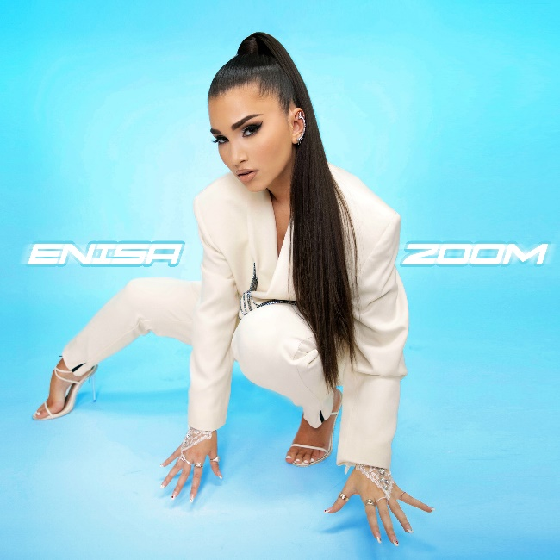
(DOWNLOAD HI-RES ARTWORK)
Brooklyn-based songstress Enisa has shared her latest single “Zoom” available now at all DSPs. The single is accompanied by a fun, upbeat visual streaming now via YouTube. The single is also produced by Space Primates (Alesso & Katy Perry “When I’m Gone”) and self-written by the talented artist.
“The song is about the beginning stages of falling in love with someone, when everything feels wild, fast & exciting. I’m telling this person to give me the feeling of excitement so my heart could feel something that keeps me moving with him. I say “make my heart beat go make that sound like zoom, zoom, zoom.”
With over 39M worldwide streams and more than 157M total video views, Enisa has proven a truly global favorite, earning chart-topping success in Nigeria, Gambia, Portugal, Algeria, Tunisia, Morocco, Sri Lanka, and India, to name a few. “Get That Money” marked the latest in a continuing series of increasingly popular releases from the First Lady of Highbridge The Label, following “Tears Hit The Ground” (2.6M views), “Love Cycle” (15M views), “Dumb Boy” (15M views), and the smash hit, “Count My Blessings” (49M views). Earlier this year, Enisa made her TV debut with her performance of her song “Green Light” on NBC’s American Song Contest.
Enisa has spent her whole life preparing for this journey as a first-generation American born to Albanian immigrant parents. Following her graduation from Brooklyn’s esteemed Edward R. Murrow High School, she attended Brooklyn College where she continued to develop her unique musical vision. A series of distinctive cover versions exploded across social media, earning her millions of views and critical acclaim from the likes of Complex, XXL, ThisSongIsSick, and more. With the wind at her back, Enisa continued to hone her diverse musical approach, infusing contemporary soul pop with Balkan and Middle Eastern flourishes with a touch of European pop inspired by her own Muslim heritage. Track releases like Scridge and Genda’s viral smash “Karma (Remix)” and such solo singles as “Burn This Bridge” and “Wait for Love” showcased a spectacular knack for raw soul and endless attitude, earning her more than 16M views and over 3M global streams as an independent artist.
2021 proved a milestone year for Enisa, highlighted by a cover appearance in Out Now, debut live performances at NYC’s legendary SOB’s and Sacramento, CA’s Lost In Riddim festival, and a social media explosion that now sees close to 8M total followers around the world, including 3.8M on TikTok and over 1M YouTube subscribers.
Early 2022 saw the release of Enisa’s Fake Love EP, a body of work that Enisa describes as “empowering” and “authentic” which features the standout tracks “Tears Hit The Ground” and “One Thing,”. The new year also brought with it, Enisa’s television debut as a contestant on the NBC musical reality competition “American Song Contest” in which she represented her home state of New York. With so much in the works it’s clear that 2022 will be another blockbuster year for the Brooklyn-based songstress.

CONNECT WITH ENISA
OFFICIAL | INSTAGRAM | FACEBOOK | TWITTER | TIKTOK | YOUTUBE
PRESS CONTACT
SELAM BELAY | SELAM.BELAY@ATLANTICRECORDS.COM

