FOR IMMEDIATE RELEASE
SEPTEMBER 28, 2022

WEST COAST CHAMPION FENIX FLEXIN DROPS OFFICIAL VISUAL FOR
“1,2,3,4"

ANNOUNCES HEADLINING “FENIX FLEXIN TOUR”
BEGINNING OCTOBER 18

FENIX FLEXIN VOL. 2 AVAILABLE NOW LISTEN HERE

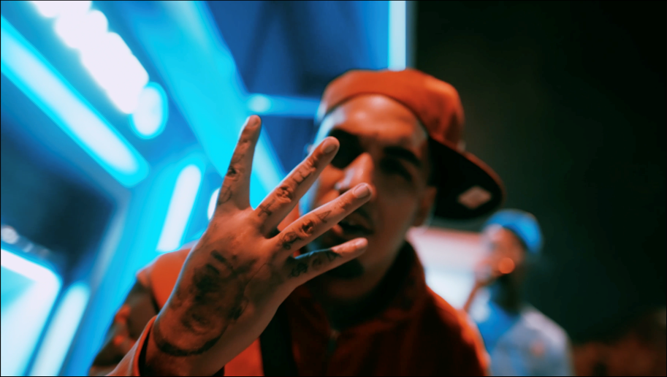
DOWNLOAD THUMBNAIL HERE

West coast phenomenon Fenix Flexin shares an official video for “1,2,3,4” off recently released mixtape of FENIX FLEXIN VOL. 2. Fenix schools us on the game while counting down on the catchy, rhythmic track listen here /watch here.

Following the arrival of his sequel mixtape FENIX FLEXIN VOL. 2, he has announced his headlining tour “Fenix Flexin Tour”. The tour will begin October 18th in Oakland, CA and wraps in Portland, Oregon on November 20th. Previously, he released tracks “Red Flag,” “Threat“ and “ZaZa,” and dropped his first single “Fenix Flexin Vol. 2 Intro,” late last year followed by the bold and boastful “Dead Homies,” both joined by official visuals streaming now at YouTube HERE.

Known worldwide for his flashy West Coast flow, Fenix Flexin kicked off his solo career in style with last summer’s debut mixtape, FENIX FLEXIN VOL. 1, reaching Spotify’s “Top 10 – USA” while earning more than 35M global streams thanks to such stand-out singles as “10 Toes,” the Ron-Ron and Menace-produced “For Me,” “NDS,” “True 2 This (Feat. Bravo The Bagchaser),” and the fan favorite, “Risky.” Fenix followed the successful project with his first ever solo multi-city tour, “Fenix Flexin Vol. 1 Tour,” as well as show-stealing sets at such festivals as Rolling Loud LA. In addition, last year saw Fenix open the doors on his own Burnt Co, a new lifestyle and skateboard apparel company launched with a top team of pro skaters including Kevin Viernes, Blazzy, Kevin Scott, and others.

Fenix Flexin is of course renowned as a founding member of the multi-platinum certified hip-hop group, Shoreline Mafia, propelling them to over 1B worldwide streams, sold out arena tours, and a long string of hugely popular, critically acclaimed releases including 2017’s now-classic debut mixtape, gold certified SHORELINEDOTHATSHIT, as well as such singles as the RIAA platinum certified “Musty” and “Nun Major,” the gold certified “Whsssuss The Deal” and “Bottle Service,” and the 2x platinum smash, “Bands (Feat. Rob Vicious).”

“The group had a bunch of respect, a huge following, and a whole lot of people behind us,” Fenix Flexin says. “Now I’m claiming all of those things for myself as an individual, and I’m off to a good start.”

FENIX FLEXIN VOL.2 TOUR

October
18 – Oakland, CA
19 – Santa Cruz, CA
20 – Los Angeles, CA
22 – Las Vegas, NV
27 – Phoenix, AZ
28 – Tucson, AZ

November
3 – Salt Lake City, UT
4 – Denver, CO
5 – Col. Springs, CO
9 – Indianapolis, IN
10 – Iowa City, IA
11 – Minneapolis, MN
12 – Chicago, IL
13 – Louisville, KY
15 – Missoula, MT
16 – Idaho Falls, ID
18 – Spokane, WA
19 – Bend, OR
20 – Portland, OR

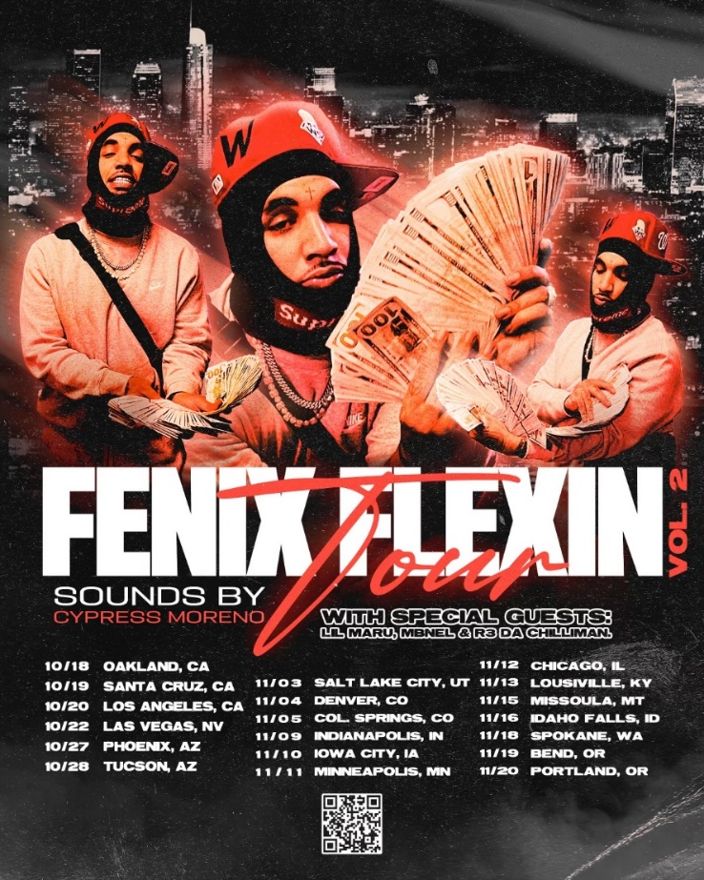
# # #

CONNECT WITH FENIX FLEXIN
WEBSITE | INSTAGRAM | SOUNDCLOUD | TWITTER | YOUTUBE | BURNT CO.

PRESS CONTACT:
Brittany Bell | Brittany.Bell@atlanticrecords.com

