FOR IMMEDIATE RELEASE

SEPTEMBER 9, 2022

**forest blakk is back with “another love song”**

**ACCLAIMED SINGER/SONGWRITER ANNOUNCES FORTHCOMING *EVERY LITTLE DETAIL* EP,**

**ARRIVING OCTOBER 28TH & AVAILABLE FOR PRE-SAVE/ORDER NOW**

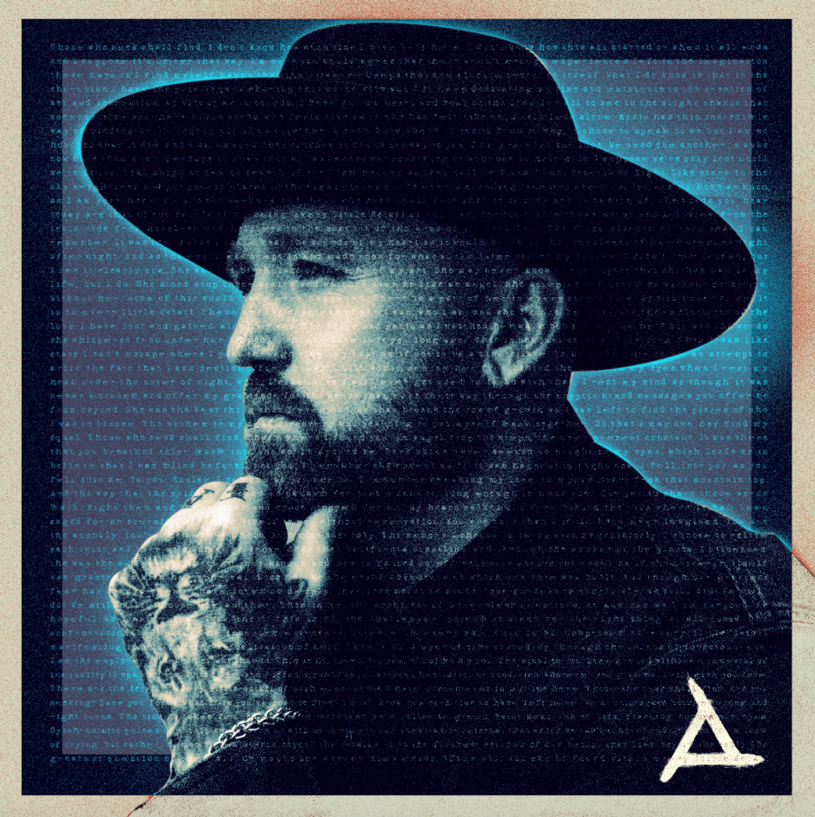

[DOWNLOAD HIGH-RES ARTWORK HERE](http://press.atlanticrecords.com/forest-blakk/)

**STREAM/BUY “ANOTHER LOVE SONG”:** [LINK](https://forestblakk.lnk.to/anotherlovesong)

**PRE-SAVE/ORDER *EVERY LITTLE DETAIL* EP:** [LINK](forestblakk.lnk.to/ELD)

Acclaimed singer/songwriter **Forest Blakk** is back with fiery new single “**Another Love Song**” – available now via **Atlantic Records**. Co-written with **JT Daly** (**Benson Boone**, **K. Flay**, **Demi Lovato**), the track is the latest taste of Blakk’s forthcoming third EP ***Every Little Detail***,arriving October 28th and available now for pre-save/order via [LINK](forestblakk.lnk.to/ELD).

*“****’Another Love Song’*** *is the product of my failed attempt to not write another love song. I guess the heart wants what it wants though and there ain't much you can do about it. The night before my session, I had a bad dream about my ex that really got me. The next day I walked into that studio with a heart full of memories I didn’t want and within minutes all the words poured out of me.”* – **FOREST BLAKK**

In addition to “**Another Love Song**,” ***Every Little Detail***will feature Blakk’s 2021 smash single **“**[**If You Love Her**](https://www.youtube.com/watch?v=wDaiiluanQc).” Having amassed over 290 million total global streams to date and certified Gold in the United States (along with Platinum in his native Canada), “**If You Love Her**” earned Blakk his official US chart debut on **Billboard**’s **Emerging Artists** chart, his national US TV debut on **ABC**’s **Live with Kelly & Ryan,** top 30 placement on the Hot AC radio chart & saw the singer/songwriter collaborate with **Meghan** **Trainor** on a stunning duet version. Meanwhile follow-up singles “[**Give You Love**](https://www.youtube.com/watch?v=kuoo4ipaXsk)” and “[**Fall Into Me**](https://www.youtube.com/watch?v=NCUI2ziMzgw)” (co-written alongside **Matchbox Twenty** front man **Rob Thomas**) have amassed over 77 million streams with the latter also reaching top 30 on the Hot AC radio chart.

Highlighted as one of **PEOPLE Magazine**’s *“talented emerging artists making their mark on the musical landscape”* and deemed an *“artist on the rise”* by **Billboard**, Blakk made his debut with his 2018 EP ***Minutes*** and follow-up 2020 sophomore EP ***Sideways*** – the latter of which saw Blakk collaborate with the likes of **Will** **IDAP** (**Train**, **Florida** **Georgia** **Line**), **Nick Long** (**King Princess**), **Carl Ryden** (**Ricky Martin**, **David Guetta**), **Ollie** **Green** (**Freya** **Ridings**, **Gavin** **James**) & more to tell a love story through an incredibly realistic and candid lens. The 6-track collection featured singles “**I Wish I Knew**” (deemed an *“introspective look at love and love lost”* by **American Songwriter**) and uplifting anthem of resilience “**Put Your Hands Up**,” which debuted on an episode of **ABC**’s ***Grey’s Anatomy***. A compelling live performer, Blakk has toured extensively supporting **NEEDTOBREATHE**, **Gavin James** & most recently this past summer throughout North America with **Dean Lewis**.

***Every Little Detail* EP tracklist:**

1. Another Love Song

2. Give You Love

3. I Remember

4. I Hope You Know

5. Me

6. If You Love Her

7. Fall Into Me

8. Every Little Detail

CREDIT: JIMMY FONTAINE – [DOWNLOAD HIGH-RES HERE](http://press.atlanticrecords.com/forest-blakk/)

**CONNECT WITH FOREST BLAKK:**

[TIKTOK](https://www.tiktok.com/@forestblakk?lang=en) | [TWITTER](https://twitter.com/forestblakk) | [FACEBOOK](https://www.facebook.com/forestblakk) | [INSTAGRAM](https://www.instagram.com/forestblakk) | [YOUTUBE](https://www.youtube.com/channel/UC9vKX9Hz5dGVrhD5v3-UnAQ) | [FORESTBLAKK.COM](http://forestblakk.com/)

**CONTACT:**

[ted.sullivan@atlanticrecords.com](mailto:ted.sullivan@atlanticrecords.com)