FOR IMMEDIATE RELEASE
SEPTEMBER 14, 2022

FRED AGAIN.. ANNOUNCES NEW STUDIO ALBUM ACTUAL LIFE 3 (JANUARY 1 - SEPTEMBER 9 2022)
DUE OUT OCTOBER 28 VIA ATLANTIC RECORDS - PRE-ORDER HERE

SHARES BRAND NEW TRACK ‘DANIELLE (SMILE ON MY FACE)’ - LISTEN HERE

US HEADLINE TOUR KICKS OFF SEPTEMBER 23
INCLUDES TRIO OF SOLD-OUT SHOWS AT HOLLYWOOD FOREVER CEMETERY (LA) & TERMINAL 5 (NYC)

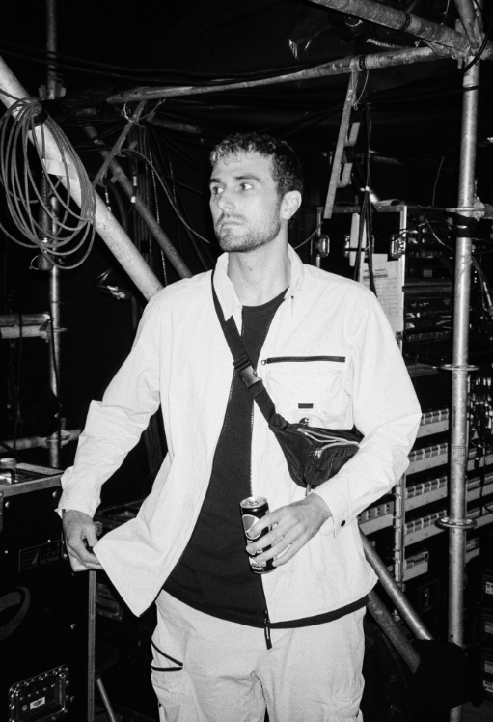
DOWNLOAD PRESS PHOTO HERE // CREDIT: THEO BATTERHAM

Groundbreaking artist and producer Fred again.. today announces his new album Actual Life 3 (January 1 - September 9 2022), the third of his hugely successful Actual Life trilogy, releasing October 28th via Atlantic Records. To celebrate the announcement, Fred has shared a new track taken from the album, ‘Danielle (smile on my face)’ which samples the acapella of 070 Shake’s ‘Nice To Have’ - his most listened to track this year and a song that has soundtracked his “actual life”. Listen to ‘Danielle (smile on my face)’ HERE and pre-order Actual Life 3 HERE.

Building on the template already laid down with his debut LP, Actual Life (February 2nd - July 19th) and its companion follow up Actual Life 2 (February 2 - October 15 2021), Actual Life 3 sees Fred again.. resume his diary-esque approach to production. His intimate use of voice notes from friends, videos found whilst scrolling on Instagram and samples from important records in his life serves as a personal record of his life experiences, offering insight into his world over the past year. Actual Life 3 is a continuation of an autobiographical body of work that both references and pushes forwards the heritage of UK electronic music while standing as testament to the power of music in facilitating catharsis, healing and celebrating the realities of friendship, love and life.

Today’s announcement follows on from a run of acclaimed club-ready singles under Fred’s ‘USB’ playlist series: last month’s collaboration with Swedish House Mafia ‘Turn On The Lights again..’ featuring Future (his highest charting single to date), June’s thunderous ‘Jungle’, January’s ‘Lights Out’ in collaboration with HAAi and Romy and March’s ‘Admit It (U Don’t Want 2)’ with I. Jordan. All four are now fixtures in DJ sets around the world, as well as Fred’s own live performances - a stunningly honed show that takes crowds through material from the achingly beautiful moments of his Actual Life album series and unifying, standout tracks of last summer ‘Marea (We’ve Lost Dancing)’ and ‘Billie (Loving Arms)’. One of the places where this was experienced in all its glory was for the Coachella festival in California - where Forbes noted, “Fred Again.. caught quite the Coachella buzz, and for good reason. The aesthetic of his vibrant set somehow perfectly encapsulated our collective nervous breakdown of the past two years and then set us all free.”

So far in his short career, the prolific London artist has released two acclaimed, deeply personal albums from his Actual Life series which were beloved by fans and critics alike. Last year also saw Fred again.. become one of the year's most talked about live acts as he transformed his Actual Life records into an immersive, communal real-life experience for the first time. With shows selling out across the UK and USA, he was named one of Mixmag's "Top 10 Live Acts Of 2021". Fred continued his upwards trajectory with the viral success release of his Boiler Room set last month, which has to date surpassed over 5 million streams in only 4 weeks.

After wrapping up an extensive summer tour with festival appearances at the likes of Coachella, Primavera, Melt, Way Out West, Rock En Seine and All Points East, Fred again.. will continue his live ascendency with sold out shows around the world throughout the autumn of 2022, including three nights at New York’s 3000 capacity Terminal 5 and three nights at LA’s Hollywood Forever Cemetery. Tickets available here: https://www.fredagain.com/tour/

FRED AGAIN.. – 2022 NORTH AMERICA TOUR DATES

September 23rd - The Warfield, San Francisco, CA, US (SOLD OUT)
September 24th - Portola Festival, San Franciso, CA, US
September 28th - Hollywood Forever Cemetery, Los Angeles, CA, US (SOLD OUT)
September 29th - Hollywood Forever Cemetery, Los Angeles, CA, US (SOLD OUT)
September 30 - Hollywood Forever Cemetery, Los Angeles, CA, US (SOLD OUT)
October 1st - Gorge Amphitheatre, George, WA, US
October 2nd - Mission Ballroom, Denver, CO, US (SOLD OUT)
October 5th - Riviera Theater, Chicago, IL, US (SOLD OUT)
October 6th - History, Toronto, Canada (SOLD OUT)
October 8th - 9:30 Club, Washington, DC, US (SOLD OUT)
October 11th - Roadrunner, Boston, MA, US (SOLD OUT)
October 13th - Terminal 5, New York, NY, US (SOLD OUT)
October 14th - Terminal 5, New York, NY, US (SOLD OUT)
October 16th - Terminal 5, New York, NY, US (SOLD OUT)

Follow Fred again..
OFFICIAL SITE / INSTAGRAM / TIKTOK

Contact:
Kelly McWilliam / Atlantic Records
Kelly.McWilliam@AtlanticRecords.com

