FOR IMMEDIATE RELEASE
SEPTEMBER 14, 2022

R&B HEARTTHROB JOSH LEVI UNVEILS OFFICIAL MUSIC VIDEO FOR
“ALL OVER AGAIN”

WATCH OFFICIAL VISUAL HERE

ACCLAIMED SOPHOMORE EP, DISC TWO, AVAILABLE NOW
VIA RAEDIO/ATLANTIC RECORDS HERE

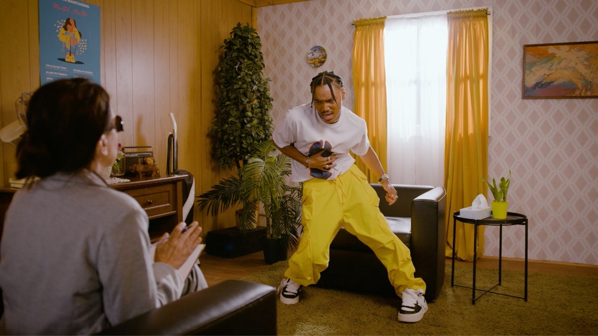
DOWNLOAD THUMBNAIL HERE

R&B sensation Josh Levi has shared the official music video for “All Over Again,” premiering today on YouTube HERE. Taking you into the mind of Levi, the Blair Caldwell-directed visual is the therapy session you’ve been needing.

“All Over Again” is among the highlight tracks featured on Levi’s acclaimed sophomore EP, DISC TWO, available everywhere now HERE. The eight-track collection also includes such powerhouse singles as“NASA,” “DON’T THEY REMIX (FEAT. NORMANI)” (which exclusively premiered on Apple Music’s The Zane Lowe Show), and “She Keeps Comin,” the latter joined by an astonishing self-shot live performance video streaming via YouTube HERE.

DISC TWO also includes the luxurious hit single, “VICES” – a personal favorite of Justin Bieber, who shared the song on his Instagram feed and story. Levi celebrated the EP’s release with a stunning live performance of “VICES” on The Terrell Show, as well as an exclusive interview with Rated R&B. The rising star further displayed his intimate approach to modern R&B with a spectacular live performance video of “NASA,” streaming HERE.

In addition, Levi marked DISC TWO by lighting up stages across the US on “The Vices Tour.” His biggest headline run to date, the tour kicked off with a sold-out show at Los Angeles, CA’s Peppermint Club, followed by full houses at top venues across the country including San Francisco, Chicago, Houston, Brooklyn, and Atlanta.

Named by PEOPLE as one of last year’s “25 Emerging Musical Artists You Should Add to Your Playlist This Fall,” Levi was featured in Disney/Pixar’s blockbuster, Turning Red, starring as the voice of Aaron Z., a member of the teenage heartthrob boyband 4*Town. Previously nominated in the “Best Musical Moment” category for the 2022 MTV Movie & TV Awards, the soundtrack’s feel-good first single, “Nobody Like U,” written by GRAMMY® Award-winning singer-songwriters Billie Eilish and Finneas O’Connell, proved an immediate smash, ascending to the upper half of Billboard’s “Hot 100” and sending Levi’s monthly Spotify listeners to more than 4.5M.

Josh Levi immediately captivates with each inhale of experience and exhale of emotion. The Houston, TX-raised and Los Angeles-based singer, songwriter, and actor developed a fervent fan base through roles on such hit series as Friday Night Lights as well as a series of viral YouTube covers and consistent touring. Hailed by Earmilk as “an all-encompassing showcase of how much of an anomaly he is,” Levi’s 2020 debut EP, DISC ONE – highlighted by such tracks as “IF THE WORLD,”– earned high profile media attention from the likes of Billboard, Wonderland, and V, which declared him “your classic triple threat.” As a result, Levi caught the attention of Issa Rae's label imprint, Raedio, featuring his 2021 single, “What’s The Use,” on the soundtrack to her critically acclaimed HBO Series, Insecure: Season 5. The track proved an instant smash for Levi, named by Billboard at #6 on their “Tunefind Top TV/Movie Syncs of 2021.”

CONNECT WITH JOSH LEVI
OFFICIAL | FACEBOOK | INSTAGRAM | TIKTOK | TWITTER | YOUTUBE

PRESS CONTACT:
Brittany Bell | Brittany.Bell@atlanticrecords.com

