FOR IMMEDIATE RELEASE
SEPTEMBER 30, 2022

DANCEHALL GIANT KRANIUM IS BACK WITH THE QUEEN NAIJA ASSISTED “WITHOUT YOU”

FOLLOW UP TO PREVIOUSLY RELEASED SINGLE “WI DEH YAH”

HIGHLY ANTICIPATED SINGLE RELEASE AFTER SPRING AND SUMMER FULL OF PERFORMANCES

STREAM “WITHOUT YOU (FEAT. QUEEN NAIJA)”

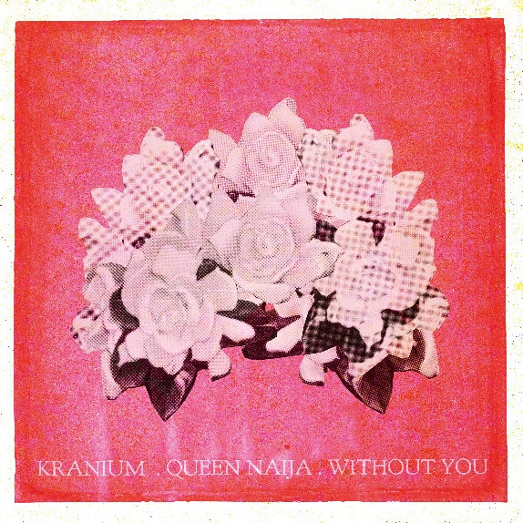
DOWNLOAD HI-RES ARTWORK

Global Dancehall superstar Kranium is back with his latest single “Without You (Feat. Queen Naija)” available now for streaming. The single is the perfect blend of Dancehall, Afrobeats, and R&B with the smooth vocals provided by Queen Naija. “Without You (Feat. Queen Naija)” is produced by iO (UK producer and Afro Soul composer behind songs from Burna Boy's Africa Giant album, J Hus' chart-topping album "Big Conspiracy", and more). The single also serves as the follow up to this year’s earlier release of single “Wi Deh Yah” available for streaming via YouTube now.

“"Without You" is about a complicated love story. There's someone you fall for, that you got in too deep and too quickly knowing it wouldn’t work. Complicated part is you want it to work.” - KRANIUM

“Without You (Feat. Queen Naija)” shows the softer side of Kranium and unlike most of his sexy, party driven catalog, its built on the idea of finding true love, losing it, going through withdrawal, and wanting to do anything to get it back. The single has the makings to be a true classic and timeless Dancehall record with Queen Naija's verse is the perfect response to Kranium's verse/lyrics and her soulful tone takes everything up a notch.

With multiple plaque achievements within the U.S., Canada, and U.K. markets, Kranium has proven to be one of R&B/Dancehall’s greatest superstars, driving Dancehall music and culture into the future on his own characteristic terms. The dancehall superstar is now also currently boasting nearly 1 BILLION streams globally.

Over the span of his career, Kranium has established himself as one of the hottest international dancehall artists in the world. In 2019, Kranium unveiled his debut album, Midnight Sparks to the world. The album saw Kranium continuing to craft a simmering sonic cocktail of reggae, R&B, hip-hop, and soul, including superstar features from the likes of AJ Tracey, Mahalia, Burna Boy, and longtime collaborator Ty Dolla $ign. The album showcased fiery singles as “So Me Move,” “Just The Style (Feat. Alkaline),” “Talkin’ (Feat. PJ),” and “In Charge.” Kranium’s sparkling debut was followed in 2020 with the release of “Gal Policy,” a fan-favorite with a lyric video that accumulated over 14 million views in six months of its release. In addition, Kranium also unveiled “Through The Window,” afterwards closing out the year with a fiery collaboration “Block Traffic (feat. Rytikal).” In 2021, Kranium released his EP, Toxic, and followed up with the “Wi Deh Yah” single earlier this year. A true “set the tone” record that showcases Kranium’s clever lyricism, gift for melodies, and the perfect balance of vocals, “Wi Deh Yah,” displayed the smoothness he’s known for but with a bit of street Dancehall flare.

# # #

DOWNLOA HI-RES IMAGE

CONNECT WITH KRANIUM
OFFICIAL | TWITTER | INSTAGRAM | FACEBOOK | YOUTUBE

FOR ALL INQUIRIES
SYDNEY MARGETSON
SYDNEY.MARGETSON@ATLANTICRECORDS.COM

