FOR IMMEDIATE RELEASE
SEPTEMBER 9, 2022

GENEVIEVE STOKES TAKES YOU DOWN THE RABBIT HOLE IN “HABITS” VIDEO

ALT-POP SINGER-SONGWRITER SHARES OFFICIAL VISUAL FOR VIRAL SINGLE

LISTEN TO “HABITS” | WATCH THE OFFICIAL VIDEO

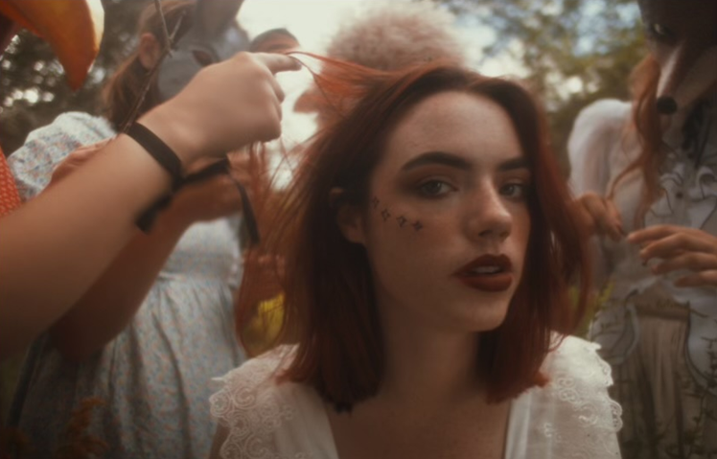
DOWNLOAD HI-RES VIDEO STILL

“The 21-year-old pianist and vocalist delivers the woodland fairy fantasy of your dreams...”
- TEEN VOGUE

Acclaimed alt-pop singer-songwriter-pianist Genevieve Stokes has released the official music video for her latest single, “Habits,” streaming now at YouTube HERE. The video, directed by Abbie Pitre and Roman Spataro, takes inspiration from Alice’s Adventures in Wonderland, imagery from Midsommar, and the humorous tonality of Wes Anderson.

“The Habits music video is an introduction to the world of my new music,” Genevieve shares. “It’s inspired by Alice in Wonderland and the idea of falling down the rabbit hole.”

Written by Genevieve, “Habits” was produced by the esteemed Tony Berg (Phoebe Bridgers, Paul McCartney, Taylor Swift). The fan favorite track, which earned over 50M views across teases on TikTok prior to release, has already garnered 4.3M+ global streams in just a few weeks. Upon release, PAPER instantly praised the 21-year-old musician for channeling “beautiful scenery” and performing “gut wrenching ballads,” while Ones To Watch applauded her sonic ability to “alternate between moments of quiet tenderness, playful self-exasperation, and raw pain.”

“Habits” follows the Portland, ME-based musician’s acclaimed 2021 debut EP, Swimming Lessons, which features standout tracks “Surface Tension,” “Parking Lot” and “Running Away.” The critically acclaimed EP went on to earn over 16M streams worldwide while receiving praise from publications including Flaunt, NYLON, Billboard, Refinery29, FLOOD and more. Named by Alternative Press as a “New Artist You Need To Hear,” Stokes recorded her debut EP in a cabin just a stone’s throw from her Maine childhood home, bringing a delicate, youthful and intimate touch to her storytelling. Over the past year, she celebrated the success of Swimming Lessons with a series of US tour dates alongside artists including Noah Kahan, Briston Maroney, and Sarah Kinsley.

At only 21-years-old, Genevieve has quickly drawn attention and applause for her intimate yet lush approach to alternative pop. Having taught herself piano at the age of eight, Stokes spent much of her teens developing her own unique sound, inspired by iconic female musicians like Cat Power and Regina Spektor but infused with personal experience and perspective. Before releasing her debut EP, Stokes had already amassed over 7M streams independently, ascended esteemed playlists and garnered support from Complex, EARMILK and more.

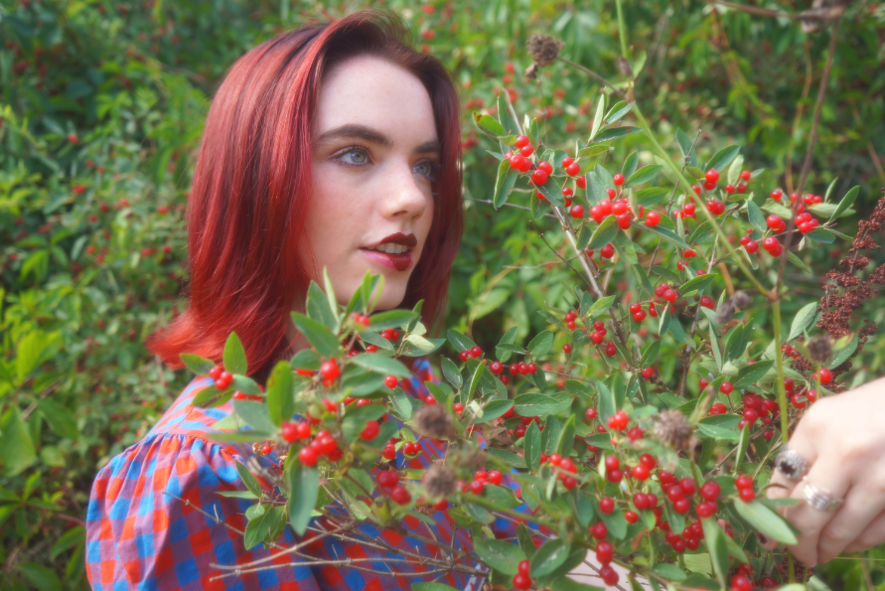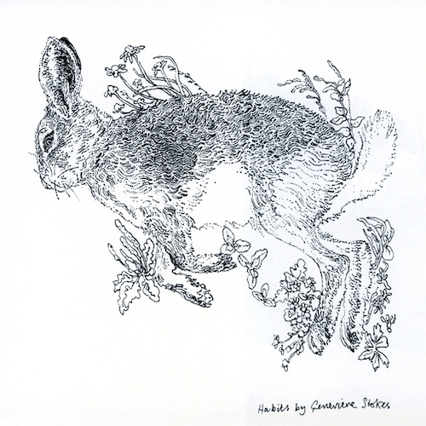
(DOWNLOAD HIGH-RES PHOTOS + ARTWORK // CREDIT: ABBIE PITRE, ILLUSTRATOR: JOHN HEWITT)

CONNECT WITH GENEVIEVE STOKES
OFFICIAL | INSTAGRAM | TWITTER | YOUTUBE | FACEBOOK | TIKTOK | PRESS ASSETS

PRESS CONTACT:
ANDREW.GEORGE@ATLANTICRECORDS.COM

