FOR IMMEDIATE RELEASE

AUGUST 26, 2022

**INGRID ANDRESS SHARES NEW ALBUM *GOOD PERSON*TODAY**

([**LISTEN HERE**](https://ingridandress.lnk.to/goodperson))

**ICYMI: WATCH *JIMMY KIMMEL LIVE! PERFORMANCE OF “FEELING THINGS”***

**(**[**WATCH HERE**](https://www.youtube.com/watch?v=7Wx0-FlfmfE)**)**

**CURRENT SINGLE “WISHFUL DRINKING (WITH SAM HUNT)” TOP 10 AT COUNTRY RADIO NOW**

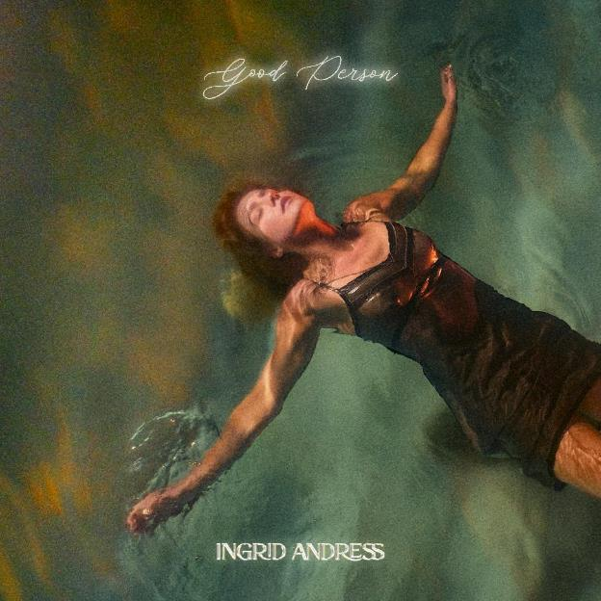

[Download Images Here](https://warnermusicgroup.box.com/s/su6xea72w1awvo862rmpcwdgtn44ibh7)

***Good Person,*** the highly anticipated sophomore album from 3x GRAMMY-nominated singer-songwriter **Ingrid Andress**is available everywhere now ([LISTEN HERE)](https://ingridandress.lnk.to/goodperson). Hailed by ***The New York Times***as “a Nashville outsider who paved her own way in” ([READ HERE](https://www.nytimes.com/2022/08/25/arts/music/ingrid-andress-good-person.html)), the acclaimed singer/songwriter celebrated the LP’s arrival with a week full of performances, culminating with an appearance on ABC’s ***Jimmy Kimmel Live!*** Thursday evening (8/25) to share the poignant track “**Feel Like This**,” co-written with Julia Michaels ([WATCH HERE](https://www.youtube.com/watch?v=7Wx0-FlfmfE)). Meanwhile, her current Gold-certified single, “**Wishful Drinking (with Sam Hunt)**,” continues to be a fan-favorite as it heads toward Top 5 at country radio.

“*When people describe something as an adventure, it’s all fun and exciting,*” says Andress. “*But if it’s a real adventure, there’s some struggle in there, too—it’s not all fun new things, there can be some dark days. But the contrast of that is what I enjoy. Making this album was one of the most painful processes I’ve ever been through, but it was also the brightest and the best. It’s crazy how you can experience both those things at the same time. I didn’t think I could be more open, but I guess I am. Just when you think you’ve exposed it all, you see that you only just cracked it*.”

On *Good Person*, Andress returns to the reflection and confession at the core of her acclaimed debut, *Lady Like*, and plumbs even deeper. Returning to the co-producer’s chair on *Good Person* (alongside Sam Ellis, who played the same role on *Lady Like*), Andress claims that she went “a little mad scientist” this time around. She pushed for bold, experimental sounds that blended banjos with vocoders; swung from sweeping orchestration to spare, acoustic-based arrangements; and showcased previously unexplored parts of her vocal range. “I realized how scared a lot of people are to push boundaries and how I am not, that’s my bread and butter,” she says. “Isn’t that the goal, to discover new things? What are we doing here if we’re not trying to make new art?”

As the world shut down around her in 2020, Andress dove into songwriting as a way to process everything. “When I’m not distracted, I immediately go inward and assess how I’m doing. I was kind of forced to look at my personal life—again. So I had to really sink into what my reality was and what I was feeling, and it led me to what this album is, which is me realizing I wasn’t happy and that I needed to fix it.”

The song that became the new album’s title track marked an initial turning point in her songwriting narrative. Described by ***Rolling Stone***as “a gripping examination of the way we perceive others and compare ourselves without ever knowing the full story,” she also performed the track on ***The Tonight Show Starring Jimmy Fallon***earlier this summer ([WATCH HERE](https://nam04.safelinks.protection.outlook.com/?url=https%3A%2F%2Fwww.youtube.com%2Fwatch%3Fv%3DsBb2gXP-0vw%26list%3DRDsBb2gXP-0vw%26start_radio%3D1&data=05%7C01%7CMaryCatherine%40wmg.com%7Ce7490132e36842290c4f08da81f74d24%7C8367939002ec4ba1ad3d69da3fdd637e%7C0%7C0%7C637965196427144067%7CUnknown%7CTWFpbGZsb3d8eyJWIjoiMC4wLjAwMDAiLCJQIjoiV2luMzIiLCJBTiI6Ik1haWwiLCJXVCI6Mn0%3D%7C3000%7C%7C%7C&sdata=I8tM1rqDTTrunb2E0eCCDUlOxXShuwmH81u6J%2B9baHQ%3D&reserved=0)). “**’Good Person’** was when I realized that I was starting to question a lot of things,” she says. “What makes somebody good and what does that look like, and in a world of being so judgmental of other people, what makes you better than them? That was my first look into myself and the questions I had about humanity.”

A breakthrough of another kind came with a song called “**Pain**,” which started out on a back porch with an acoustic guitar. “I had ended a pretty toxic relationship that I hadn’t realized was toxic—until I realized it,” says Andress. “Once you see it, you can’t un-see it, and ‘Pain’ was me walking into it willingly—I know this is going to hurt terribly, but I have to do it, and with that came a feeling of liberation. It hurts, but it makes you feel good, and when I was writing it, it made me feel understood, like I was listening to myself.”

“Pain,” which she debuted on ***Late Night with Seth Meyers***([WATCH HERE](https://nam04.safelinks.protection.outlook.com/?url=https%3A%2F%2Fwww.youtube.com%2Fwatch%3Fv%3DIm-dX9JOQx0&data=05%7C01%7CMaryCatherine%40wmg.com%7Ce7490132e36842290c4f08da81f74d24%7C8367939002ec4ba1ad3d69da3fdd637e%7C0%7C0%7C637965196426987825%7CUnknown%7CTWFpbGZsb3d8eyJWIjoiMC4wLjAwMDAiLCJQIjoiV2luMzIiLCJBTiI6Ik1haWwiLCJXVCI6Mn0%3D%7C3000%7C%7C%7C&sdata=bWDs76sQWTIPkmcq4lJtqVhIofp3LVky55RA2a86GZo%3D&reserved=0)) earlier this year, is one of a few spots on the album (which includes contributions from such powerhouse songwriters as Shane McAnally, Julia Michaels, Derrick Southerland, and Jesse Frasure) that harks back to the classic ‘60s pop sound of writers like Burt Bacharach. “I love contrasting older sounds with modern flair,” says Andress. “Rihanna’s ‘Love on the Brain’ was an influence, too, because I love how she did that throwback thing. I wondered if there was a way that could live in the country space—how throwback can we get, but also make it country, but still fit my voice?”

At the same time, Andress found that changes were happening in her own life, and that the songs were actually leading the way, revealing emotions she wasn’t fully aware of yet. The “stunning piano ballad” (***Billboard***) “**Blue**” “encompassed everything that I was feeling in finding love that is actually healthy,” she says. “My mind figured it out before my body did—I must be feeling this way if I’m writing it. I listened to it and thought ‘Oh, I must be in love, maybe.’ It was wild how writing these songs, and the realizations I was having in real time, were changing my trajectory.”

The genre-pushing power ballad, “**Seeing Someone Else**,” explores the complexities and consequences that arise with self-growth and evolution. “We all grow and change, but not everyone wants us to,” Andress shares. “Some people want to keep you exactly where you are for as long as possible, even if it’s hurting you. Sometimes you don’t even realize it’s happening. But then one day you wake up and decide the person they want you to be isn’t you anymore, so you pack your shit and break free from their grip.”

Having gone through two years that were transformational in every way, and triumphing in the face of some unprecedented obstacles, Andress knew that the best way forward was a brave willingness to be even more truthful and real. “The first album was me trying to discover who I was as an artist,” she says, “and this one is just me being purely raw with what I was going through. I didn’t know what it’s going to sound like, I just stuck to the experiences I was having and it all came together naturally from being honest and processing my life.”

She points to the last song on *Good Person*, the spare and intimate “**Things That Haven’t Happened Yet**,” as an especially significant moment. “I learned so much in this chapter of my life—and I’m still so young, so I’m terrified of what else I’m going to learn on the next album,” she says. “Ending with that song was a very intentional reminder to myself. ‘You think you’ve got it figured out now, so you’re worrying about the next thing.’ Don’t do that, there’s no point. It’s all going to happen the way it’s going to happen, whether you want it to or not. The journey isn’t over.”

*Good Person* sees Andress entering the next chapter of her career following her record-breaking debut, *Lady Like*, named “one of the year’s strongest albums” by *Associated Press* and one of *Billboard*’s Top 10 Best Country Albums of 2020. The celebrated LP scored Andress three GRAMMY nominations including Best New Artist, Best Country Album and Best Country Song for the multi-platinum No. 1 radio single “More Hearts Than Mine.” She is also a 4x ACM Award, 3x CMA Award and 2x CMT Music Award nominee.

With nearly one billion global streams and fans spanning the globe, Andress is currently on the road now with Keith Urban for his 52-date North American “The Speed of Now World Tour.”

***Good Person* Track List:**

**1. Good Person**

Written by: Ingrid Andress, Steph Jones, Sam Ellis

Produced by: Ingrid Andress & Sam Ellis

**2. Yearbook**

Written by: Ingrid Andress, Pete Good, Shane McAnally, Derrick Southerland

Produced by: Ingrid Andress & Sam Ellis

**3. Seeing Someone Else**

Written by: Ingrid Andress, Derrick Southerland, Jesse Frasure

Produced by: Ingrid Andress & Sam Ellis

**4. Talk**

Written by: Ingrid Andress, Alex Stacey, Tommy Gee, David Fremberg, Mich Hansen

Produced by: Ingrid Andress & Sam Ellis

**5. How Honest Do You Want Me to Be?**

Written by: Ingrid Andress, Sam Ellis, Derrick Southerland

Produced by: Ingrid Andress & Sam Ellis

**6. No Choice**

Written by: Ingrid Andress, AJ Pruis, Derrick Southerland

Produced by: Ingrid Andress & AJ Pruis

**7. Pain**

Written by: Ingrid Andress, Laura Veltz, Sam Ellis

Produced by: Ingrid Andress & Sam Ellis

**8. Feel Like This**

Written by: Ingrid Andress, Julia Michaels, Sam Ellis

Produced by: Ingrid Andress & Sam Ellis

**9. Blue**

Written by: Ingrid Andress, Sam Ellis, Derrick Southerland, Shane McAnally

Produced by: Ingrid Andress & Sam Ellis

**10. Falling For You**

Written by: Ingrid Andress, Derrick Southerland, Sam Ellis

Produced by: Ingrid Andress & Sam Ellis

**11. All the Love**

Written by: Ingrid Andress, Derrick Southerland, Sam Ellis

Produced by: Ingrid Andress & Sam Ellis

**12. Things That Haven't Happened Yet**

Written by: Ingrid Andress, Derrick Southerland, Sam Ellis

Produced by: Ingrid Andress & Sam Ellis

**13. Wishful Drinking**

Written by: Ingrid Andress, Jonny Price, JP Saxe, Lucky Daye, Rykeyz

Produced by: Ingrid Andress & Jordan M. Schmidt

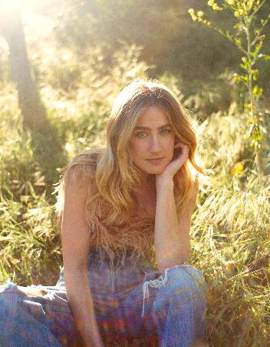

[DOWNLOAD HERE](https://warnermusicgroup.box.com/s/su6xea72w1awvo862rmpcwdgtn44ibh7) // CREDIT: OLIVIA BEE

###

**CONNECT WITH INGRID ANDRESS:**

[FACEBOOK](https://nam04.safelinks.protection.outlook.com/?url=https%3A%2F%2Fwww.facebook.com%2FIngridAndress%2F&data=05%7C01%7COlivia.Lee%40atlanticrecords.com%7C36376b982ed640121af208da821457a2%7C8367939002ec4ba1ad3d69da3fdd637e%7C0%7C0%7C637965321131795674%7CUnknown%7CTWFpbGZsb3d8eyJWIjoiMC4wLjAwMDAiLCJQIjoiV2luMzIiLCJBTiI6Ik1haWwiLCJXVCI6Mn0%3D%7C3000%7C%7C%7C&sdata=WC0si8emyHA%2FgNYzZxbI2E8RLaZ6qb4RaKuHRH9Lk9w%3D&reserved=0) | [TWITTER](https://nam04.safelinks.protection.outlook.com/?url=https%3A%2F%2Ftwitter.com%2Fingridandress&data=05%7C01%7COlivia.Lee%40atlanticrecords.com%7C36376b982ed640121af208da821457a2%7C8367939002ec4ba1ad3d69da3fdd637e%7C0%7C0%7C637965321131795674%7CUnknown%7CTWFpbGZsb3d8eyJWIjoiMC4wLjAwMDAiLCJQIjoiV2luMzIiLCJBTiI6Ik1haWwiLCJXVCI6Mn0%3D%7C3000%7C%7C%7C&sdata=5OdGTnf85%2FJ3U5quWBAy9yGYQi3aiyXHPMtncnY4gSs%3D&reserved=0) | [INSTAGRAM](https://nam04.safelinks.protection.outlook.com/?url=https%3A%2F%2Fwww.instagram.com%2Fingridandress%2F&data=05%7C01%7COlivia.Lee%40atlanticrecords.com%7C36376b982ed640121af208da821457a2%7C8367939002ec4ba1ad3d69da3fdd637e%7C0%7C0%7C637965321131795674%7CUnknown%7CTWFpbGZsb3d8eyJWIjoiMC4wLjAwMDAiLCJQIjoiV2luMzIiLCJBTiI6Ik1haWwiLCJXVCI6Mn0%3D%7C3000%7C%7C%7C&sdata=M5nNDAqrNq9eBRCnQVVltvLK7EdZzMEEc6D%2FQxLnrtQ%3D&reserved=0) | [YOUTUBE](https://nam04.safelinks.protection.outlook.com/?url=https%3A%2F%2Fwww.youtube.com%2Fchannel%2FUCztSwKRcz_jZC4KcGVZH69w&data=05%7C01%7COlivia.Lee%40atlanticrecords.com%7C36376b982ed640121af208da821457a2%7C8367939002ec4ba1ad3d69da3fdd637e%7C0%7C0%7C637965321131951887%7CUnknown%7CTWFpbGZsb3d8eyJWIjoiMC4wLjAwMDAiLCJQIjoiV2luMzIiLCJBTiI6Ik1haWwiLCJXVCI6Mn0%3D%7C3000%7C%7C%7C&sdata=ot%2BoGHBhV20a%2BnU6IapT0BQ7jKl8q2iwmIeJph6dD3M%3D&reserved=0)

**PRESS CONTACTS**

Andrew George | Atlantic Records

[Andrew.George@atlanticrecords.com](mailto:Andrew.George@atlanticrecords.com)

Mary Catherine Rebrovick | Warner Music Nashville

[MaryCatherine@wmg.com](mailto:MaryCatherine@wmg.com)