FOR IMMEDIATE RELEASE

AUGUST 19, 2022

**INGRID ANDRESS SET TO PERFORM ON *JIMMY KIMMEL LIVE!* NEXT THURSDAY (8/25)**

**NEW ALBUM *GOOD PERSON* AVAILABLE EVERYWHERE NEXT FRIDAY (8/26)**

**CURRENT SINGLE ‘WISHFUL DRINKING (WITH SAM HUNT)” TOP 10 AT COUNTRY RADIO NOW**

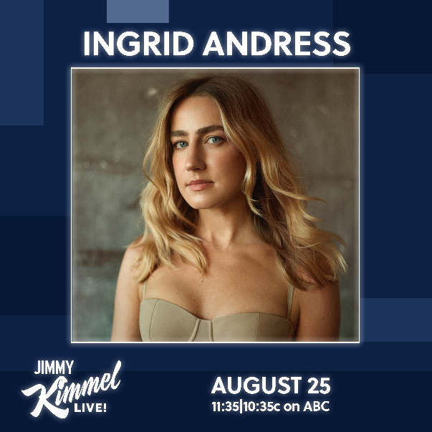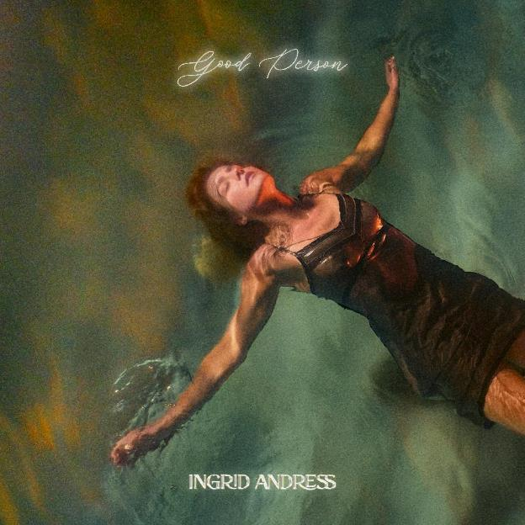

[DOWNLOAD IMAGES HERE](https://nam04.safelinks.protection.outlook.com/?url=https%3A%2F%2Fwarnermusicgroup.box.com%2Fs%2F39n2gmcg74g7ha8nn1sc3pkrraaq9r51&data=05%7C01%7COlivia.Lee%40atlanticrecords.com%7C36376b982ed640121af208da821457a2%7C8367939002ec4ba1ad3d69da3fdd637e%7C0%7C0%7C637965321131795674%7CUnknown%7CTWFpbGZsb3d8eyJWIjoiMC4wLjAwMDAiLCJQIjoiV2luMzIiLCJBTiI6Ik1haWwiLCJXVCI6Mn0%3D%7C3000%7C%7C%7C&sdata=VWgXQaK6BwJ%2FbMTeE5iMElTLrsG0CmYl2Mv3RbOnkso%3D&reserved=0)

3x GRAMMY-nominated singer-songwriter **Ingrid Andress** has officially begun the one-week countdown until the release of her highly anticipated sophomore album, ***Good Person***, available everywhere next Friday, August 26th ([PRE-SAVE/ORDER HERE](https://nam04.safelinks.protection.outlook.com/?url=https%3A%2F%2Fingridandress.lnk.to%2Fpreorder-goodperson&data=05%7C01%7COlivia.Lee%40atlanticrecords.com%7C36376b982ed640121af208da821457a2%7C8367939002ec4ba1ad3d69da3fdd637e%7C0%7C0%7C637965321131795674%7CUnknown%7CTWFpbGZsb3d8eyJWIjoiMC4wLjAwMDAiLCJQIjoiV2luMzIiLCJBTiI6Ik1haWwiLCJXVCI6Mn0%3D%7C3000%7C%7C%7C&sdata=dd6O7%2FFa8ZQ%2BRoQrMgfjtcWnTc0WqDeGxn0In0ZMUrU%3D&reserved=0)). Fans will have the opportunity to stay up late with Andress on Thursday, August 25th, as she rings in the album launch with a performance of “Feel Like This” on ABC’s *Jimmy Kimmel Live!*.

In addition, her current Gold-certified single, “Wishful Drinking (with Sam Hunt),” has moved inside the Top 10 at country radio having already earned more than 175 million global streams to date. The “moving country-pop ballad” (*V Magazine*) debuted at No. 8 on Spotify’s all-genre Top 10 USA Song Debuts Chart and made its TV debut on *The Late Show with Stephen Colbert*earlier this year ([WATCH HERE](https://nam04.safelinks.protection.outlook.com/?url=https%3A%2F%2Fwww.youtube.com%2Fwatch%3Fv%3DBYm2kIKY8Zg&data=05%7C01%7COlivia.Lee%40atlanticrecords.com%7C36376b982ed640121af208da821457a2%7C8367939002ec4ba1ad3d69da3fdd637e%7C0%7C0%7C637965321131795674%7CUnknown%7CTWFpbGZsb3d8eyJWIjoiMC4wLjAwMDAiLCJQIjoiV2luMzIiLCJBTiI6Ik1haWwiLCJXVCI6Mn0%3D%7C3000%7C%7C%7C&sdata=6zZxE6Y3MHdrDez5AaNjJ5zzSlB7zAkOysii1BQfGOs%3D&reserved=0)).

“Wishful Drinking” will be featured on the forthcoming LP alongside recent releases like “Blue,” called a “stunning piano ballad” by *Billboard*, “Pain” as seen on *Late Night with Seth Meyers*([WATCH HERE](https://nam04.safelinks.protection.outlook.com/?url=https%3A%2F%2Fwww.youtube.com%2Fwatch%3Fv%3DIm-dX9JOQx0&data=05%7C01%7COlivia.Lee%40atlanticrecords.com%7C36376b982ed640121af208da821457a2%7C8367939002ec4ba1ad3d69da3fdd637e%7C0%7C0%7C637965321131795674%7CUnknown%7CTWFpbGZsb3d8eyJWIjoiMC4wLjAwMDAiLCJQIjoiV2luMzIiLCJBTiI6Ik1haWwiLCJXVCI6Mn0%3D%7C3000%7C%7C%7C&sdata=TJxtDBAtFmgpLKZdKBr7dQ393e3Os%2FmPWhdAUB0IoOM%3D&reserved=0)) and the titular track, “Good Person.” Described by *Rolling Stone* as “a gripping examination of the way we perceive others and compare ourselves without ever knowing the full story,” she also performed the track on *The Tonight Show Starring Jimmy Fallon*earlier this summer ([WATCH HERE](https://nam04.safelinks.protection.outlook.com/?url=https%3A%2F%2Fwww.youtube.com%2Fwatch%3Fv%3DsBb2gXP-0vw%26list%3DRDsBb2gXP-0vw%26start_radio%3D1&data=05%7C01%7COlivia.Lee%40atlanticrecords.com%7C36376b982ed640121af208da821457a2%7C8367939002ec4ba1ad3d69da3fdd637e%7C0%7C0%7C637965321131795674%7CUnknown%7CTWFpbGZsb3d8eyJWIjoiMC4wLjAwMDAiLCJQIjoiV2luMzIiLCJBTiI6Ik1haWwiLCJXVCI6Mn0%3D%7C3000%7C%7C%7C&sdata=cT4OXZXuViz39FmOnI2c0nuNdxn9HX4llp19TY7tgmA%3D&reserved=0)). All 13 songs on *Good Person* were co-produced and co-written by Andress, who returns to the reflection and confession at the core of her GRAMMY-nominated debut – and plumbs even deeper.

*Good Person* sees Andress entering the next chapter of her career following her record-breaking debut, *Lady Like*, named “one of the year’s strongest albums” by *Associated Press* and one of Billboard’s Top 10 Best Country Albums of 2020. The celebrated LP scored Andress three GRAMMY nominations including Best New Artist, Best Country Album and Best Country Song for the multi-platinum No. 1 radio single “More Hearts Than Mine.” She is also a 4x ACM Award, 3x CMA Award and 2x CMT Music Award nominee.

With nearly a billion global streams and fans spanning the globe, Andress is currently on the road now with Keith Urban for his 52-date North American “The Speed of Now World Tour.”

***GOOD PERSON* TRACK LIST**

**1. Good Person**

Written by: Ingrid Andress, Steph Jones, Sam Ellis

Produced by: Ingrid Andress & Sam Ellis

**2. Yearbook**

Written by: Ingrid Andress, Pete Good, Shane McAnally, Derrick Southerland

Produced by: Ingrid Andress & Sam Ellis

**3. Seeing Someone Else**

Written by: Ingrid Andress, Derrick Southerland, Jesse Frasure

Produced by: Ingrid Andress & Sam Ellis

**4. Talk**

Written by: Ingrid Andress, Alex Stacey, Tommy Gee, David Fremberg, Mich Hansen

Produced by: Ingrid Andress & Sam Ellis

**5. How Honest Do You Want Me to Be?**

Written by: Ingrid Andress, Sam Ellis, Derrick Southerland

Produced by: Ingrid Andress & Sam Ellis

**6. No Choice**

Written by: Ingrid Andress, AJ Pruis, Derrick Southerland

Produced by: Ingrid Andress & AJ Pruis

**7. Pain**

Written by: Ingrid Andress, Laura Veltz, Sam Ellis

Produced by: Ingrid Andress & Sam Ellis

**8. Feel Like This**

Written by: Ingrid Andress, Julia Michaels, Sam Ellis

Produced by: Ingrid Andress & Sam Ellis

**9. Blue**

Written by: Ingrid Andress, Sam Ellis, Derrick Southerland, Shane McAnally

Produced by: Ingrid Andress & Sam Ellis

**10. Falling For You**

Written by: Ingrid Andress, Derrick Southerland, Sam Ellis

Produced by: Ingrid Andress & Sam Ellis

**11. All the Love**

Written by: Ingrid Andress, Derrick Southerland, Sam Ellis

Produced by: Ingrid Andress & Sam Ellis

**12. Things That Haven't Happened Yet**

Written by: Ingrid Andress, Derrick Southerland, Sam Ellis

Produced by: Ingrid Andress & Sam Ellis

**13. Wishful Drinking**

Written by: Ingrid Andress, Jonny Price, JP Saxe, Lucky Daye, Rykeyz

Produced by: Ingrid Andress & Jordan M. Schmidt

###

**CONNECT WITH INGRID ANDRESS:**

[FACEBOOK](https://nam04.safelinks.protection.outlook.com/?url=https%3A%2F%2Fwww.facebook.com%2FIngridAndress%2F&data=05%7C01%7COlivia.Lee%40atlanticrecords.com%7C36376b982ed640121af208da821457a2%7C8367939002ec4ba1ad3d69da3fdd637e%7C0%7C0%7C637965321131795674%7CUnknown%7CTWFpbGZsb3d8eyJWIjoiMC4wLjAwMDAiLCJQIjoiV2luMzIiLCJBTiI6Ik1haWwiLCJXVCI6Mn0%3D%7C3000%7C%7C%7C&sdata=WC0si8emyHA%2FgNYzZxbI2E8RLaZ6qb4RaKuHRH9Lk9w%3D&reserved=0) | [TWITTER](https://nam04.safelinks.protection.outlook.com/?url=https%3A%2F%2Ftwitter.com%2Fingridandress&data=05%7C01%7COlivia.Lee%40atlanticrecords.com%7C36376b982ed640121af208da821457a2%7C8367939002ec4ba1ad3d69da3fdd637e%7C0%7C0%7C637965321131795674%7CUnknown%7CTWFpbGZsb3d8eyJWIjoiMC4wLjAwMDAiLCJQIjoiV2luMzIiLCJBTiI6Ik1haWwiLCJXVCI6Mn0%3D%7C3000%7C%7C%7C&sdata=5OdGTnf85%2FJ3U5quWBAy9yGYQi3aiyXHPMtncnY4gSs%3D&reserved=0) | [INSTAGRAM](https://nam04.safelinks.protection.outlook.com/?url=https%3A%2F%2Fwww.instagram.com%2Fingridandress%2F&data=05%7C01%7COlivia.Lee%40atlanticrecords.com%7C36376b982ed640121af208da821457a2%7C8367939002ec4ba1ad3d69da3fdd637e%7C0%7C0%7C637965321131795674%7CUnknown%7CTWFpbGZsb3d8eyJWIjoiMC4wLjAwMDAiLCJQIjoiV2luMzIiLCJBTiI6Ik1haWwiLCJXVCI6Mn0%3D%7C3000%7C%7C%7C&sdata=M5nNDAqrNq9eBRCnQVVltvLK7EdZzMEEc6D%2FQxLnrtQ%3D&reserved=0) | [YOUTUBE](https://nam04.safelinks.protection.outlook.com/?url=https%3A%2F%2Fwww.youtube.com%2Fchannel%2FUCztSwKRcz_jZC4KcGVZH69w&data=05%7C01%7COlivia.Lee%40atlanticrecords.com%7C36376b982ed640121af208da821457a2%7C8367939002ec4ba1ad3d69da3fdd637e%7C0%7C0%7C637965321131951887%7CUnknown%7CTWFpbGZsb3d8eyJWIjoiMC4wLjAwMDAiLCJQIjoiV2luMzIiLCJBTiI6Ik1haWwiLCJXVCI6Mn0%3D%7C3000%7C%7C%7C&sdata=ot%2BoGHBhV20a%2BnU6IapT0BQ7jKl8q2iwmIeJph6dD3M%3D&reserved=0)

**PRESS CONTACTS**

Andrew George | Atlantic Records

[Andrew.George@atlanticrecords.com](mailto:Andrew.George@atlanticrecords.com)

Mary Catherine Rebrovick | Warner Music Nashville

[MaryCatherine@wmg.com](mailto:MaryCatherine@wmg.com)