FOR IMMEDIATE RELEASE
SEPTEMBER 16, 2022

SUECO UNVEILS IT WAS FUN WHILE IT LASTED (DELUXE)

21-TRACK DELUXE EDITION OF ACCLAIMED DEBUT ALBUM
FEATURES FAN FAVORITES, HIT SINGLES, AND FIVE BRAND NEW SONGS
INCLUDING THE POP PUNK ANTHEM, “LAST THING I DO”

SOLD OUT NORTH AMERICAN HEADLINE TOUR NOW UNDERWAY

IT WAS FUN WHILE IT LASTED (DELUXE) AVAILABLE NOW VIA ATLANTIC RECORDS – LISTEN HERE

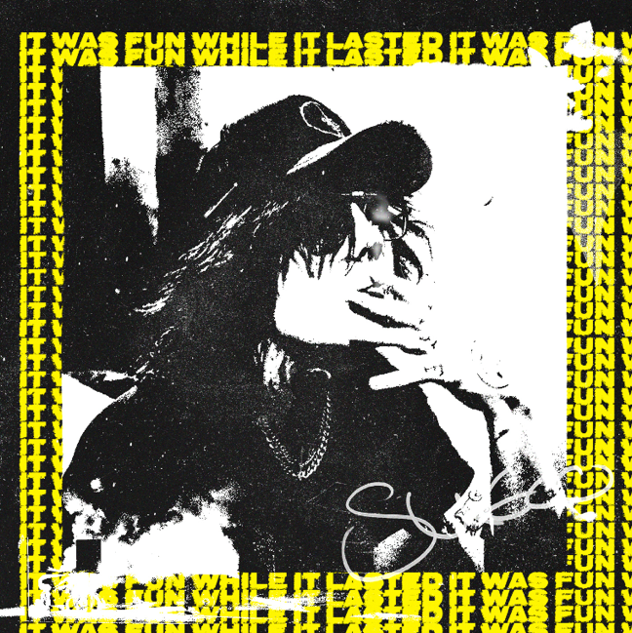
DOWNLOAD HI-RES ARTWORK HERE

“Sueco is responsible for some of the most insatiable and interesting tracks to come out of the recent mainstream pop-punk resurgence…This is an artist who has lived and breathed alternative culture his whole life, whilst experimenting with different musical styles along the way and is now figuring out how to bring everything he has loved together as one joyous sound.” – ROCK SOUND

RIAA platinum certified singer/producer Sueco has announced today’s release of It Was Fun While It Lasted (Deluxe), available now via Atlantic Records HERE. The deluxe album releases alongside the official music video for standout single, “Last Thing I Do,” directed by JakeTheShooter - premiering today at YouTube HERE.

An expanded new edition of Sueco’s acclaimed debut LP, It Was Fun While It Lasted (Deluxe) now boasts 21 tracks in total, among them fan favorites like the RIAA platinum certified breakthrough smash, “Fast,” as well as such recent singles as “Next Ex“ and the tender piano ballad, “Salt,” the latter two joined by official music videos streaming now at the official Sueco YouTube channel HERE.

In addition, the deluxe edition features five brand new songs including the irresistible punk pop anthem, “Funeral,” available at all DSPs and streaming services HERE. Produced by longtime collaborator Colin “DOC” Brittain (5 Seconds of Summer, All Time Low, Papa Roach, Sum 41), the track was met by applause from such outlets as Rock Sound, which declared it to be “cheeky, catchy and brimming with the classic Sueco craziness…a blink-and-miss-it piece of foot-tapping pop-punk loveliness.” An official lyric video is streaming now at YouTube HERE.

It Was Fun While It Lasted is now available on vinyl for the first time, exclusively through the record club Bandbox. This special edition of Sueco’s debut, pressed on clear vinyl with black and yellow swirl accents, arrives in November alongside Bandbox’s signature artist fanzine. The Sueco issue will feature his track-by-track guide to the album, rare photos and much more. The LP + zine package is up for pre-order: bandboxrocks.com

Hailed by Ones To Watch as an artist “whose humor and meteoric success is unexpected, unpredictable, and nothing short of enthralling,” Sueco has spent much of this summer traveling the world on his biggest headline tour thus far. North American dates are now underway through late October, with most shows already sold out. Special guests include Lil Aaron and KILLBOY. In addition, Sueco will also light it up with an eagerly awaited performances at Dover, DE’s Firefly Music Festival on Saturday, September 24. For complete details and ticket information, please visit www.sueco.com

SUECO
IT WAS FUN WHILE IT LASTED TOUR ‘22

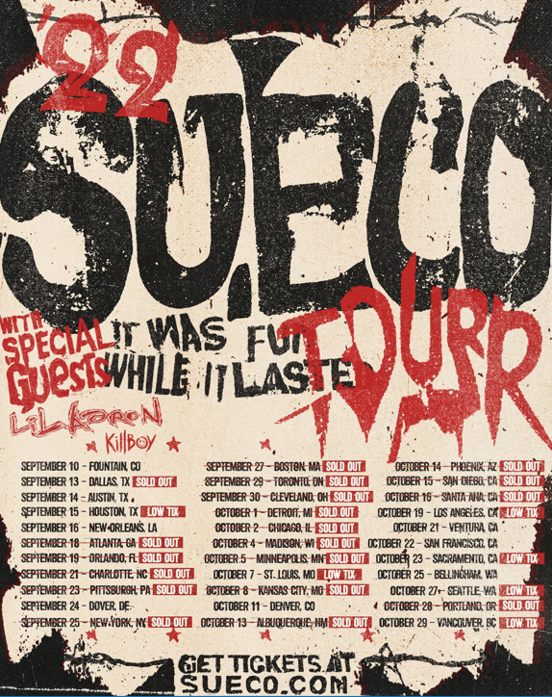

SEPTEMBER
16 – New Orleans, LA – Toulouse Theatre
18 – Atlanta, GA – The Masquerade – Purgatory – SOLD OUT
19 – Orlando, FL – Abbey – SOLD OUT
21 – Charlotte, NC – Neighborhood Theatre – SOLD OUT
23 – Pittsburgh, PA – Thunderbird Music Hall – SOLD OUT
24 – Dover, DE – Firefly Music Festival *
25 – New York, NY – Gramercy Theater – SOLD OUT
27 – Boston, MA – Brighton Music Hall – SOLD OUT
29 – Toronto, ON – Velvet Underground – SOLD OUT
30 – Cleveland, OH – Mahall’s – SOLD OUT

OCTOBER
1 – Detroit, MI – El Club – SOLD OUT
2 – Chicago, IL – Lincoln Hall – SOLD OUT
4 – Madison, WI – High Noon – SOLD OUT
5 – Minneapolis, MN – Amsterdam – SOLD OUT
7 – St. Louis, MO – Old Rock House – LOW TICKET WARNING
8 – Kansas City, MO – recordBar – SOLD OUT
11 – Denver, CO – Bluebird Theater
13 – Albuquerque, NM – Launch Pad – SOLD OUT
14 – Phoenix, AZ – Crescent Ballroom – SOLD OUT
15 – San Diego, CA – House of Blues Voodoo Room – SOLD OUT
16 – Santa Ana, CA – Constellation Room – SOLD OUT
19 – Los Angeles, CA – The Roxy
21 – Ventura, CA – Ventura Music Hall
22 – San Francisco, CA – August Hall
23 – Sacramento, CA – Harlow’s
25 – Bellingham, WA – Wild Buffalo
27 – Seattle, WA – Neumos
28 – Portland, OR – Hawthorne – SOLD OUT
29 – Vancouver, BC – Fortune

* FESTIVAL PERFORMANCE

# # #

It Was Fun While It Lasted sees Sueco – who starred on a recent cover of Alternative Press – channeling the spirit of 90’s pop-punk through a 21st century lens, tapping into the unpredictability of hyperpop and the catharsis of punk rock. The project includes such breakthrough singles as “Loser,” “SOS (Feat. Travis Barker),” “Sober/Hungover (Feat. Arizona Zervas),” “Drunk Dial,” and the RIAA gold certified #1 hit, “Paralyzed,” the latter of which first exploded last summer with a hugely popular TikTok teaser and has since gone on to earn more than 150M worldwide streams, reaching #1 on Spotify’s “Viral 50 US” while proving the Los Angeles-based singer, producer, and multi-instrumentalist’s first ever Billboard “Hot 100” and Rolling Stone “Top 100” hit. “Paralyzed” further saw Sueco make his Rolling Stone “Top 500 Popular Artists” chart debut after landing at #1 on Billboard’s “Rock Digital Song Sales,” #2 on “Alternative Digital Song Sales,” and #2 on Rolling Stone’s “Top 25 Breakthrough Music Artists.”

“The album is a journey from dark to light,” Sueco says, “going from a place of emptiness to everything being alright. It’s the end of one chapter, and the beginning of another. It really was fun while it lasted.”

Sueco recent unveiled Sueco’s Split Personalities, a trailblazing experience in the metaverse via the social gaming platform, The Sandbox. A single player voxel game inspired by Sueco’s artistic evolution as a musician and iconic fashion exploration, Sueco’s Split Personalities features three distinct worlds representing various Sueco music videos. Players will work through each of the levels while listening to select tracks from It Was Fun While It Lasted (Deluxe). Built on WMG’s music metaverse, which is centrally located on the map and in the heart of The Sandbox’s music district, The Sueco Portal is featured in The Sandbox’s Alpha Season 3, available now HERE.

# # #

CONNECT WITH SUECO
WEBSITE | INSTAGRAM l TIKTOK | TWITTER l SOUNDCLOUD l YOUTUBE

For press inquiries, please contact:
Jessica Nall // Jessica.Nall@atlanticrecords.com

