FOR IMMEDIATE RELEASE
SEPTEMBER 9, 2022

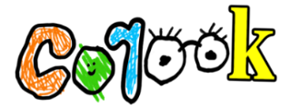

corook says “hell yeah” to self-love

comedic alt-pop artist creates super hot song about loving yourself

debut achoo! EP out now

listen to “hell yeah”

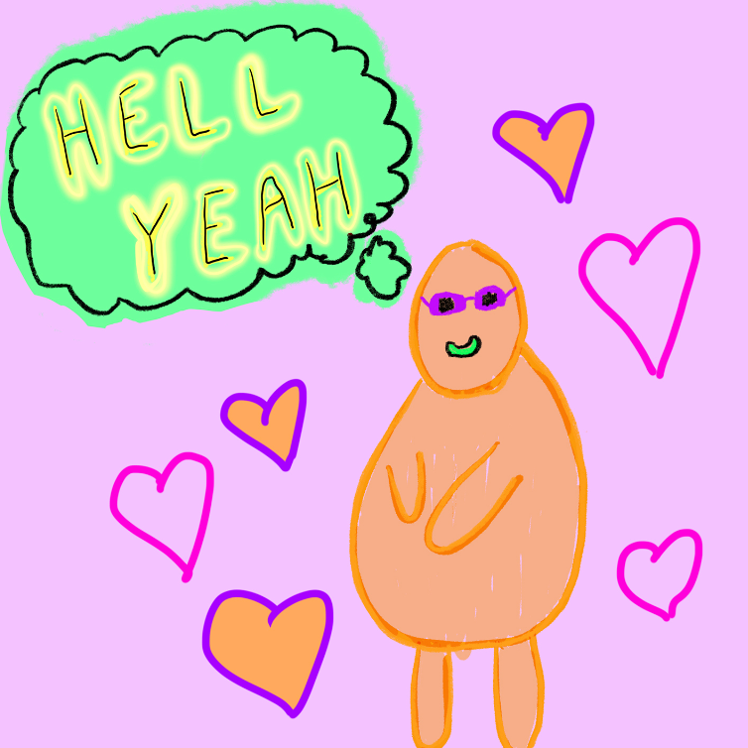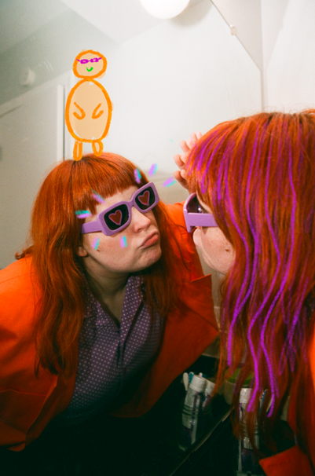
download hi-res artwork + press photos // photo credit: christina coleman

“corook is the next thing to bless your music downloads.” – PEOPLE

“If specificity is the soul of narrative, then corook is one of the most naturally gifted storytellers in the game.” – BILLBOARD

Self-described “singer, songwriter, producer, multi-instrumentalist, and huge f*ckin dork,” corook [pronounced ‘co-rook’], is back with a super hot and super sultry song about self love. The track is available now at all DSPs and streaming services and is perfect for when you need a super boost of confidence – LISTEN HERE.

"I wrote this super hot song about a liking a super hot person and how fun it is to look at someone that is so super hot,” shares corook. “In fact i find them so hot that i think anyone that doesn’t think they’re super hot is just plain stupid. I’ve found myself singing it to myself on mornings where i don’t feel so hot. “If they don’t like you they’re fucking stupid!” Self love baby."
Recently named one of The Advocate’s “7 Queer Artists For Your Fall Playlist,” the genre-busting musician, corook, tackles deeply personal themes in her music and visuals through a unique, quirky and humorous lens. This past spring, the queer, Nashville-based musician blessed the world with her debut achoo! EP. Comprised of surprising, humorous, and insightful tracks including “idk god,” “degree,” “bad friend,” and “sims,” achoo! also includes the fan favorite, “snakes,” which she added to the EP following a series of well-received teases across social media and live performances on tour.

Prior to release, corook’s adult lullaby and latest release “it’s ok!” had already garnered an incredible response on TikTok, earning nearly 4K+ video creates in under a week. Last week, corook shared the stripped back “it’s ok! (bedroom demo)” version. “it’s ok!” followed the release of her unrestrained single, “BDSM,” which arrived on the heels of her debut festival performance at Bonnaroo where she was featured in Rolling Stone’s official portrait gallery HERE. This year also saw corook hit the road on her first-ever North American live run traveling as special guest on K.Flay’s sold out “Inside Voices Outside Voices Tour.” Following her opening performance for X Ambassadors at “A Night Benefitting Reproductive Rights” at The Troubadour in LA, corook will team up with NYC-based piano pop/rock trio Jukebox the Ghost for a US tour, beginning September 28 at Philadelphia, PA’s Union Transfer and traveling through mid-October. For details and ticket information, please visit www.corook.com.

corook by corook
corook aka Corinne Savage (yes that’s her real last name) is a singer, songwriter, producer, multi-instrumentalist and a huge fuckin dork. No but seriously. She can solve a Rubix cube in under a minute (depending on how she’s feeling that day.) This ~freckled chubby babe~ was born and raised just outside of downtown Pittsburgh, Pennsylvania, where she grew up listening to Drake, Gwen Stefani and Mac Miller (RIP). She went to a performing arts high school (yes, just like Victorious) where she came out as QUEERAF her senior year. She then went to Berklee College of Music (wow – Owen Wilson voice) and graduated with TWO degrees (barely.) corook currently resides in Nashville, Tennessee (howdy.) She spends most of her time writing and producing music for her artist project “corook” (boop!) locked away in her room, alone (she blames it on Coronavirus but she’s actually just anti-social.) She’s 27 and VERY cute.

corook on tour

SEPTEMBER
28 – Philadelphia, PA – Union Transfer*
29 – Virginia Beach, VA – Elevation 27*
30 – Charlottesville, VA – Jefferson Theater*

OCTOBER
1 – Carrboro, NC – Cat’s Cradle*
2 – Atlanta, GA – The Loft*
3 – Nashville, TN – The Basement East*
5 – St Louis, MO – Off Broadway*
6 – Lawrence, KS – The Bottleneck*
7 – Oklahoma City, OK – Beer City Music Hall*
8 – Dallas, TX – Trees*
10 – Phoenix, AZ – Crescent Ballroom*
11 – San Diego, CA - Voodoo Room @ House of Blues San Diego*
13 – Pioneertown, CA – Pappy & Harriet’s Pioneertown Palace*
14 - Los Angeles, CA – Echoplex*
15 - San Francisco, CA – August Hall*
17 – Portland, OR – Wonder Ballroom*
18 – Seattle, WA – Neptune Theatre*

NOVEMBER
18 – Mexico City, Mexico – Corona Capital

*All Dates w/Jukebox the Ghost

###

connect with corook:
corook.com | instagram | tiktok | press assets

press contact:
andrew.george@atlanticrecords.com

