FOR IMMEDIATE RELEASE
AUGUST 31, 2022

QUANDO RONDO RELEASES POIGNANT HEARTFELT SINGLE
“GIVE ME A SIGN (FEAT. YOUNGBOY NEVER BROKE AGAIN)”

LISTEN/DOWNLOAD TO “GIVE ME A SIGN”

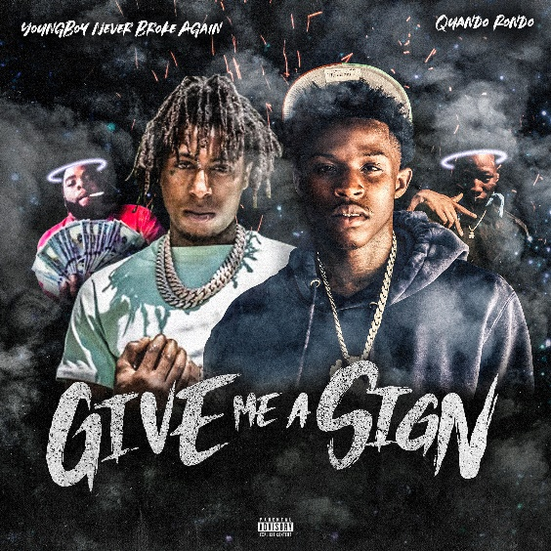
DOWNLOAD HI-RES ART

Multi-platinum rapper Quando Rondo is continuing his landmark year with today’s release of his latest rousing single, “Give Me A Sign (Feat. Young Boy Never Broke Again)” available now at all DSPs HERE. Against all odds, Quando has been able to impress fans with his versatility and lyrical flow, keeping them hooked and waiting for upcoming releases. “Give Me A Sign” serves as Quando’s first public response after the untimely and tragic loss of his cousin/best friend earlier this month.

“Give Me A Sign” finds Quando pouring his heart out and truly speaking his mind as he reflects on his life up until this point. The melancholic track features YoungBoy and is one that many will be able to relate to as it gives them an outlet to express their emotions. Diehard Quando fans will notice the rapper going back to his roots on this record, with slowed down yet still hard-hitting bars reminiscent of fan favorites “Imperfect Flower,” “I Remember,” and more.

The multi-platinum Savannah, GA rapper spits with classic dexterity as he spouts off modern melodies with emotional precision and a head-nodding bounce. Since 2017, he has consistently amplified the spirit of the streets throughout the mainstream on his own terms, translating the struggles of Savannah (and hoods everywhere) into a dynamic documentary-style sound. “Give Me A Sign (Feat. YoungBoy Never Broke Again)” continues the rising star’s high-volume year, following such recently released tracks as “War Baby,” “24,” “10.27,” “Six-0 Business,” “Jakiyah” and his recent guest verse on YoungBoy Never Broke Again’s “Gangsta (Ft. Quando Rondo)” – the only feature on YoungBoy’s chart-topping 2022 mixtape, COLORS. What’s more, YoungBoy shouts out Quando on two of the mixtape’s standout tracks, “Bring It On” and “No Switch.”

Quando officially kicked off his busy 2022 with the recently released single, “Dead Wrong,” available for streaming and download HERE; an official music video is streaming HERE. The creative hot streak commenced with last year’s release of the critically acclaimed album, Still Taking Risks, and was swiftly followed by guest verses on the explosive Never Broke Again: The Compilation Vol. 1. A stunning series of singles also dropped, including “Blueprint,” “The Realest,” “Time Spent,” and “Shine,” all available now with official music videos streaming via YouTube.

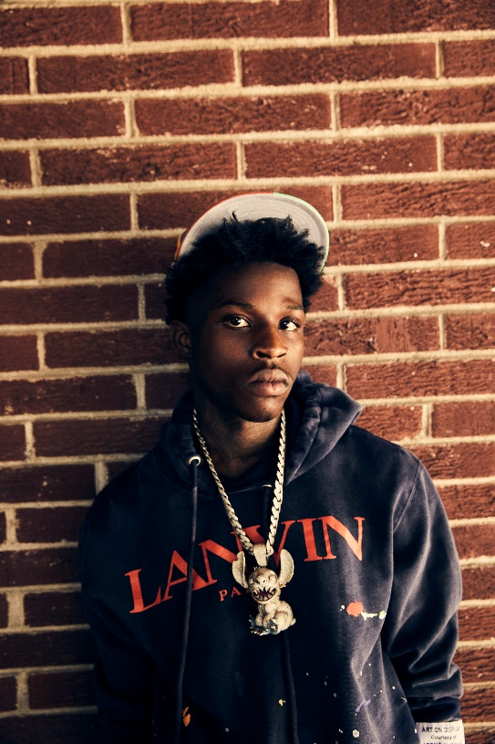

# # #

CONNECT WITH QUANDO RONDO
OFFICIAL | INSTAGRAM | TWITTER | FACEBOOK | YOUTUBE

FOR ALL PRESS INQUIRIES, PLEASE CONTACT:
ARIANA.WHITE@ATLANTICRECORDS.COM

