FOR IMMEDIATE RELEASE
SEPTEMBER 2, 2022

SUECO SHARES NEW POP PUNK ANTHEM, “FUNERAL”

LATEST SINGLE HERALDS DELUXE EDITION OF ACCLAIMED DEBUT ALBUM,
IT WAS FUN WHILE IT LASTED OUT EVERYWHERE FRIDAY SEPTEMBER 16TH

21-TRACK EXPANDED RELEASE INCLUDES FIVE BRAND NEW SONGS
ALONGSIDE FAN FAVORITES AND RECENT SINGLES “NEXT EX” AND “SALT”

SOLD OUT NORTH AMERICAN HEADLINE TOUR BEGINS SEPTEMBER 13 IN DALLAS, TX

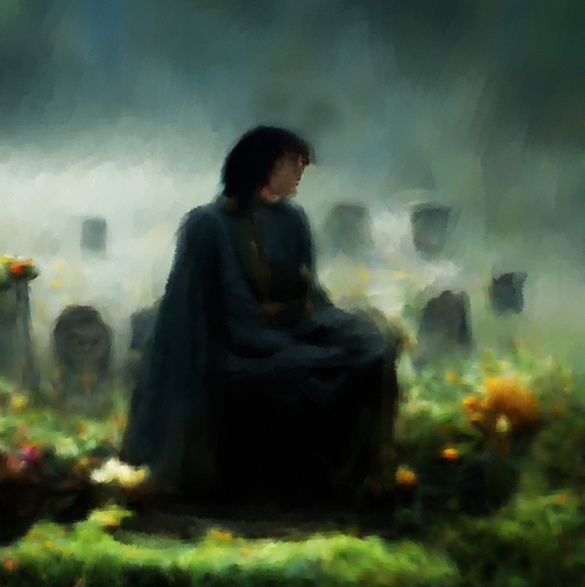
DOWNLOAD SINGLE ARTWORK HERE

LISTEN TO “FUNERAL” HERE | WATCH LYRIC VIDEO HERE

RIAA platinum certified singer/producer Sueco has shared his new single, “Funeral,” available now via Atlantic Records at all DSPs and streaming services HERE. The official lyric video premieres today at YouTube HERE.

Produced by longtime collaborator Colin “DOC” Brittain (5 Seconds of Summer, All Time Low, Papa Roach, Sum 41), “Funeral” marks one of five brand new songs featured on It Was Fun While It Lasted (Deluxe), an expanded release of Sueco’s acclaimed debut LP set to arrive everywhere on Friday, September 16. The new edition now boasts 21 tracks in total, including fan favorites like the RIAA platinum certified breakthrough smash, “Fast“, as well as such recent singles as “Next Ex“ and “Salt,” the latter two joined by official music videos streaming now at the official Sueco YouTube channel HERE.

Hailed by Ones To Watch as an artist “whose humor and meteoric success is unexpected, unpredictable, and nothing short of enthralling,” Sueco has spent much of this summer traveling the world on his biggest headline tour thus far, with North American dates getting underway September 13 at Dallas, TX’s Trees and then continuing through late October. Special guests include Lil Aaron and KILLBOY. Tickets for all dates are on sale now. What’s more, Sueco will also light it up with eagerly awaited performances at such top festivals as Fountain, CO’s #GRIDLIFE - Alpine Horizon Festival (September 10), Atlanta, GA’s Music Midtown (September 17-18), and Dover, DE’s Firefly Music Festival (September 24). For complete details and ticket information, please visit www.sueco.com

SUECO
IT WAS FUN WHILE IT LASTED TOUR ‘22

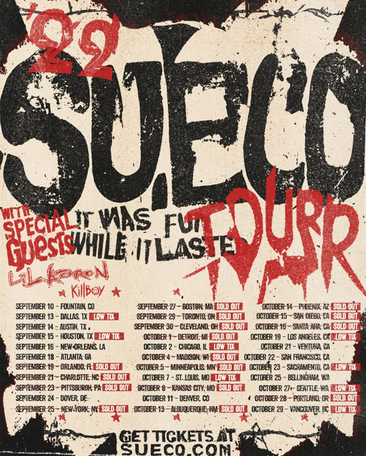

SEPTEMBER
10 – Fountain, CO – #GRIDLIFE - Alpine Horizon Festival *
13 – Dallas, TX – Trees
14 – Austin, TX – Antone’s Night Club
15 – Houston, TX – Studio @ Warehouse Live
16 – New Orleans, LA – Toulouse Theatre
18 – Atlanta, GA – The Masquerade – Purgatory
19 – Orlando, FL – Abbey – SOLD OUT
21 – Charlotte, NC – Neighborhood Theatre – SOLD OUT
23 – Pittsburgh, PA – Thunderbird Music Hall – SOLD OUT
24 – Dover, DE – Firefly Music Festival *
25 – New York, NY – Gramercy Theater – SOLD OUT
27 – Boston, MA – Brighton Music Hall – SOLD OUT
29 – Toronto, ON – Velvet Underground – SOLD OUT
30 – Cleveland, OH – Mahall’s – SOLD OUT

OCTOBER
1 – Detroit, MI – El Club – SOLD OUT
2 – Chicago, IL – Lincoln Hall
4 – Madison, WI – High Noon – SOLD OUT
5 – Minneapolis, MN – Amsterdam – SOLD OUT
7 – St. Louis, MO – Old Rock House
8 – Kansas City, MO – recordBar – SOLD OUT
11 – Denver, CO – Bluebird Theater
13 – Albuquerque, NM – Launch Pad – SOLD OUT
14 – Phoenix, AZ – Crescent Ballroom – SOLD OUT
15 – San Diego, CA – House of Blues Voodoo Room – SOLD OUT
16 – Santa Ana, CA – Constellation Room – SOLD OUT
19 – Los Angeles, CA – The Roxy
21 – Ventura, CA – Ventura Music Hall
22 – San Francisco, CA – August Hall
23 – Sacramento, CA – Harlow’s
25 – Bellingham, WA – Wild Buffalo
27 – Seattle, WA – Neumos
28 – Portland, OR – Hawthorne – SOLD OUT
29 – Vancouver, BC – Fortune

* FESTIVAL PERFORMANCE

# # #

It Was Fun While It Lasted sees Sueco – who starred on a recent cover of Alternative Press – channeling the spirit of 90’s pop-punk through a 21st century lens, tapping into the unpredictability of hyperpop and the catharsis of punk rock. The project includes such breakthrough singles as “Loser,” “SOS (Feat. Travis Barker),” “Sober/Hungover (Feat. Arizona Zervas),” “Drunk Dial,” and the RIAA gold certified #1 hit, “Paralyzed,” the latter of which first exploded last summer with a hugely popular TikTok teaser and has since gone on to earn more than 125M worldwide streams, reaching #1 on Spotify’s “Viral 50 US” while proving the Los Angeles-based singer, producer, and multi-instrumentalist’s first ever Billboard “Hot 100” and Rolling Stone “Top 100” hit. “Paralyzed” further saw Sueco make his Rolling Stone “Top 500 Popular Artists” chart debut after landing at #1 on Billboard’s “Rock Digital Song Sales,” #2 on “Alternative Digital Song Sales,” and #2 on Rolling Stone’s “Top 25 Breakthrough Music Artists.”

“The album is a journey from dark to light,” Sueco says, “going from a place of emptiness to everything being alright. It’s the end of one chapter, and the beginning of another. It really was fun while it lasted.”

Sueco recent unveiled Sueco’s Split Personalities, a trailblazing experience in the metaverse via the social gaming platform, The Sandbox. A single player voxel game inspired by Sueco’s artistic evolution as a musician and iconic fashion exploration, Sueco’s Split Personalities features three distinct worlds representing various Sueco music videos. Players will work through each of the levels while listening to select tracks from It Was Fun While It Lasted (Deluxe). Built on WMG’s music metaverse, which is centrally located on the map and in the heart of The Sandbox’s music district, The Sueco Portal is featured in The Sandbox’s Alpha Season 3, available now HERE.

# # #

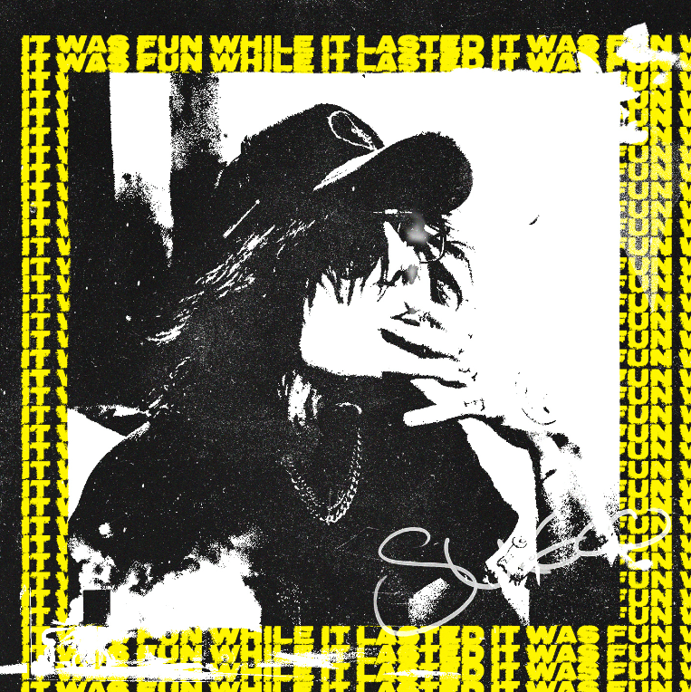
DOWNLOAD DELUXE ARTWORK HERE

CONNECT WITH SUECO
WEBSITE | INSTAGRAM l TIKTOK | TWITTER l SOUNDCLOUD l YOUTUBE

For press inquiries, please contact:
Jessica Nall // Jessica.Nall@atlanticrecords.com

