**THE MARÍAS SET TO PERFORM SOLD-OUT HOMECOMING SHOW AT LA’s FAMED GREEK THEATRE ON OCTOBER 1ST**

***CINEMA CONTINUED* TOUR ALSO INCLUDES FESTIVAL PERFORMANCES AT AUSTIN CITY LIMITS, DESERT DAZE + MIAMI’s III POINTS**

**FOLLOWS SHOWS IN THE DOMINICAN REPUBLIC AND LEAD SINGER MARÍA ZARDOYA’S NATIVE PUERTO RICO**

**BUY TICKETS TO *CINEMA CONTINUED* TOUR** [**HERE**](https://www.themarias.us/shows)

**BUY/STREAM *CINEMA*** [**HERE**](https://themarias.lnk.to/CINEMA)

*“After a global tour, Los Angeles's own The Marías carry Grammy-nominated escapism home to the Greek... a blend of heartfelt bilingual lyrics and luscious sounds that makes you feel like you’re living inside a mind-expanding love story.”* – **LOS ANGELES MAGAZINE**

([download hi-res photo here](https://warnermusicgroup.box.com/s/pci363uau0ypiuwteft35cwvz6benx0m); credit: Ashley Seryn)

Acclaimed alternative-pop band **The Marías** are embarking on the second leg of their ***CINEMA CONTINUED*** tour, bringing their debut album to marquee festivals including **Austin City Limits** and **Miami**’s **III Points** (their first time ever performing in Miami), venues in **Chicago**, **Texas**, and **North Carolina**, and LA’s famed **Greek Theatre**, where the band will celebrate their sold-out homecoming on **Saturday**, **October 1st** (all dates enclosed; buy tickets [here](https://www.themarias.us/shows)).

The *CINEMA CONTINUED* run kicked off in frontwoman **María Zardoya**’s native **Puerto Rico** in late August and was quickly followed by the band’s debut **Dominican Republic** show, as well.

Earlier this summer, **The Marías** made waves with their stunning visual performances at the likes of **Coachella**, **Lollapalooza**, and **Outside Lands**. They were named to **Rolling Stone**’s, **Billboard**’s,and **The LA Times**’ *Best Moments of Coachella 2022*.

In May, they released “**Otro Atardecer**” with **Bad Bunny**, a song featured on his Latin GRAMMY® Award-nominated album, *UN VERANO SIN TI* (listen on [Spotify](https://open.spotify.com/track/0E0DRHf5PfMeor0ZCwB3oT?si=6ff0820a46a447b0) or [Apple Music](https://music.apple.com/us/album/otro-atardecer/1622045624?i=1622046222)). Recently, Zardoya has joined Bad Bunny to perform the song live at his arena shows in Puerto Rico and his Yankee Stadium shows in New York, the latter of which prompted **Rolling Stone** to praise her *“…gauzy voice, identical to the recording.”*

***CINEMA CONTINUED*** is an extension of the band’s highly-regarded ***CINEMA* North American headline tour**, which began in January 2022 at **Las Vegas’** **Brooklyn Bowl** and included two sold-out shows at **NY’s Brooklyn Steel** before culminating with another two sold-out hometown shows at **The Novo** in LA.

Released last year, their debut full-length album ***CINEMA*** via Nice Life Recording Company/Atlantic Records (buy/stream [**HERE**](https://themarias.lnk.to/CINEMA)) was met with strong critical acclaim and has amassed **over** **70 million streams** **globally** and was **#9 on Spotify’s Top 10 Album Debuts**.

*CINEMA* was written and produced entirely by Zardoya and the producer and multi-instrumentalist **Josh Conway** – within their LA apartment. In performing the music, the duo is joined by their closest friends **Jesse Perlman** (guitar), **Edward James** (keys), and **Gabe Steiner** (trumpet) to round out the band.

When dreaming up their first full-length, Zardoya and Conway mined inspiration from such hyper-imaginative filmmakers as **Pedro Almodóvar** and **Wes Anderson**, achieving an untamed emotionality that acutely amplifies the most intimate of feelings.

In addition to those influential classic films, the album’s title also pays homage to the work María and Josh first collaborated on – creating music for film + television scores. (In a nod to the bilingualism of their work, the title ***CINEMA*** carries the same meaning in both English and Spanish).

By sharing their album with the world, the band hopes to ignite a creative impulse within their listeners:

“*We want people to feel inspired to create anything, whether it’s music or art or whatever else they’re drawn to,”* **says María**. “*Hopefully the songs will help them to break away from real life for a while and create some kind of dream world in their heads – something like the scenes to their own little movie.*”

***PRAISE FOR THE MARÍAS***

*“The Marías have dreamed up a flurry of magnetizing tracks with redolent lyrics balanced out by melodies that meld jazz, funk, and electro-lounge… María beguiles with her velvety bilingual vocals, sultry grooves, and striking features.” –* **VOGUE**

*“The Marías play smooth, melodic pop with sensual lyrics in both English and Spanish, not to mention complicated grooves that hint at soul music and Latin jazz... María sings about love in a hushed murmur that invites the listener to lean in to catch every word.” –* **LOS ANGELES TIMES**

*“a slow, jazzy jam, both sensual and soothing” –* **V MAGAZINE**

*"...one of the most visionary and purposeful musical projects in recent years..." –* **ROLLING STONE**

*“It’s hard to describe The Marías without using the adjective 'smooth' in every sentence... the band employs maximal slinkiness in the service of jazzy, gauzy, utterly charming, slyly funky pop.”*

*---*

*"The brilliance of 'Hush' is in its seductive and sultry between-the-genres appeal... With its intimacy, pulsing electronica and Zardoya's confident vocals, 'Hush' stands out." –* **NPR**

*“Right in the pocket is the cotton candy-textured voice of vocalist María that coolly asks you to slow down with her.”* – **THE FADER**

*“Full of stylistic juxtapositions... iridescent synths, supple basslines and moody strings interplay against María’s featherlight coo... horn melodies so spellbinding, your heart could either sink or skip a beat. They conjure up a perfect balance between nostalgia and forward-thinking, sleek pop sung in English and Spanish.”* – **THE RECORDING ACADEMY**

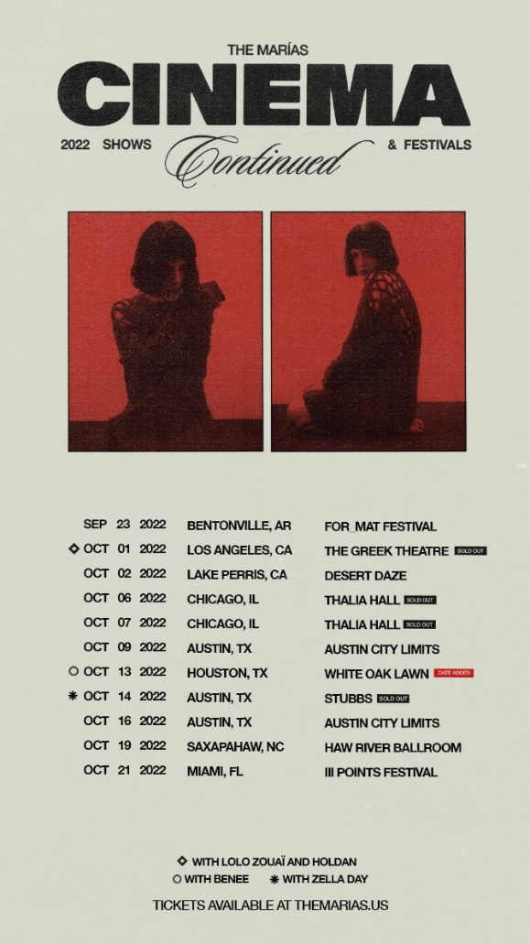

([download hi-res admat here](https://warnermusicgroup.box.com/s/y4c3zxviexvownxrblody9jwtpdwbrwh))

**UPCOMING 2022 TOUR DATES**

**OCTOBER**

01 – Los Angeles, CA – The Greek Theatre ^ – SOLD OUT

02 – Lake Perris, CA – Desert Daze

06 – Chicago, IL – Thalia Hall – SOLD OUT

07 – Chicago, IL – Thalia Hall – SOLD OUT

09 – Austin, TX – Austin City Limits

13 – Houston, TX – White Oak Lawn #

14 – Austin, TX – Stubbs – SOLD OUT *

16 – Austin, TX – Austin City Limits

19 – Saxapahaw, NC – Haw River Ballroom

21 – Miami, FL – III Points Festival

^ with Lolo Zouaï and Holdan

# with Benee

* with Zella Day

***

**The Marías** have fast proven among the most visionary and entrancing new bands in recent memory. Born in Puerto Rico and raised in Atlanta, María Zardoya moved to Los Angeles in 2016 where she met drummer Josh Conway after a performance at the famed Kibitz Room Bar at Canter’s Deli. The two began writing together, crafting a remarkable collection of mesmerizing original songs fusing kaleidoscopic soul, gentle jazz, and imagistic, bilingual lyricism.

The Marías quickly grew a passionate local following, prompting the **Los Angeles Times** to declare them ***“the perfect indie band for L.A. kids.”***With sold out shows and rapidly increasing national attention, the band made an auspicious debut with their twin EPs: ***SUPERCLEAN, VOL. I***(released in 2017) and 2018’s ***SUPERCLEAN, VOL II*** – the latter highlighted by the single, “[**Ruthless**](https://www.youtube.com/watch?v=3moMHMhiq7c),” joined by an official video directed and produced by Ian Lipton and The Marías.

2020 saw The Marías unleash a series of new songs affirming their continued creative evolution. “[**Hold It Together**](https://themarias.lnk.to/HoldItTogether)” and “[**Jupiter**](https://themarias.lnk.to/Jupiter)” were released in the top half the year, accompanied by official music videos. [**Melted**](https://www.meltedmagazine.com/blog/2020/5/29/the-marias-jupiter) hailed “Jupiter” as *“a soothing dream from retro outer-space”* while “Hold It Together” received applause from such publications as [**The FADER**](https://www.thefader.com/2020/03/06/the-marias-hold-it-together-video), which wrote*, “The pop-leaning and low-key love song features guitar and key lines that interlock hand in hand. Right in the pocket is the cotton candy-textured voice of vocalist María that coolly asks you to slow down with her.”*

In October, The Marías released two new songs written and recorded during lockdown – “[**Care For You**](https://themarias.lnk.to/CareForYou)” and “[**bop it up!**](https://themarias.lnk.to/bopitup)” – both joined by official videos co-directed by María with longtime visual collaborator Bethany Vargas. “Care For You” received acclaim from [**V Magazine**](https://vmagazine.com/article/the-marias-drop-new-track-and-video-care-for-you/), which praised it as *“a slow, jazzy jam, both sensual and soothing,”* while [**Órale**](https://oralemag.com/blog/the-marias-return-with-bop-it-up/) enthused, *“‘bop it up!’ is unlike any project The Marías have put out before… Although their signature tenderness is still recognizable, listeners will discover a newfound sense of invigoration.”* *“Both tracks are quarantine jams to dance and cry to, the kind of music we need during this endlessly trying time*, added international art and fashion magazine [**TEETH**](http://www.teethmag.net/interview-the-marias/). *“The Marías have this incredible ability to transport you.”*

# # #

**CONNECT WITH THE MARÍAS**

[**OFFICIAL**](https://www.themarias.us/) **|** [**INSTAGRAM**](https://www.instagram.com/themarias/) **|** [**TWITTER**](https://twitter.com/themarias?) **|** [**YOUTUBE**](https://themarias.lnk.to/YouTube) **|** [**TIKTOK**](https://www.tiktok.com/@themarias?)