FOR IMMEDIATE RELEASE
OCTOBER 17, 2022

CMA AWARDS NOMINEE BRELAND TO PERFORM ON ABC’S JIMMY KIMMEL LIVE! ON THE EVE OF THE 56TH ANNUAL CMA AWARDS (11/8)

THE CROSS COUNTRY RISER IS ONE OF THE MOST ADDED AT COUNTRY RADIO WITH HIS DEBUT SINGLE “FOR WHAT IT’S WORTH”

KICKING OFF FALL HEADLINE HERE FOR IT TOUR
NOVEMBER 16 IN OXFORD, OH

LISTEN TO CROSS COUNTRY HERE

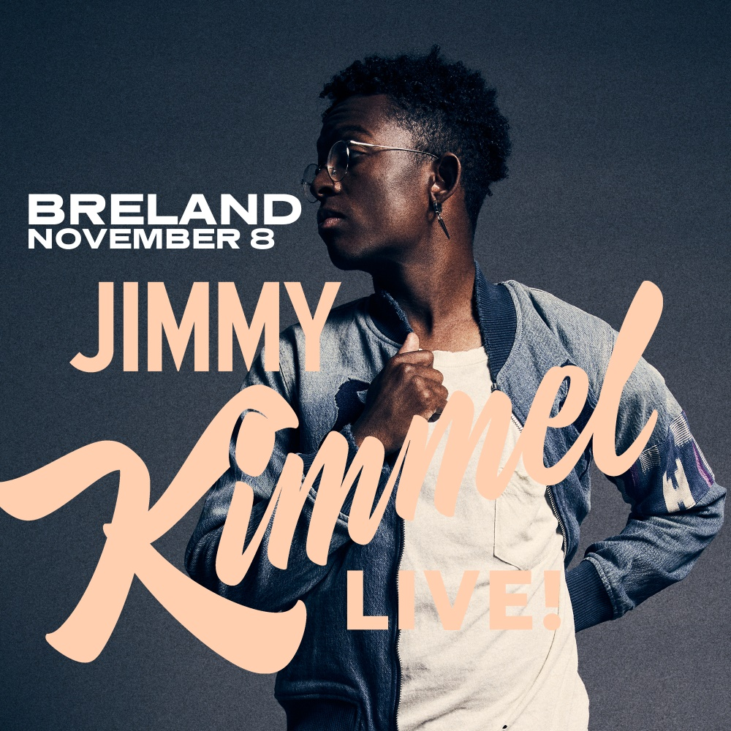
DOWNLOAD HERE

LOS ANGELES, CA. (October 17, 2022) – The night before the 56th Annual CMA Awards, nominee and PLATINUM star BRELAND will bring his debut Country radio single “For What It’s Worth” to ABC’s Jimmy Kimmel Live! airing November 8 at 11:35/10:35c. Vying for his first CMA award, BRELAND is up for Musical Event of the Year alongside Dierks Bentley and HARDY for GOLD-certified, #1 collaboration “Beers On Me.”
Billboard predicts “…BRELAND is set up for his first solo radio single about as well as possible,” and the multi-talent is proving this to be true with “For What It’s Worth” officially hitting Country radio airwaves today as one of the most added songs nationwide. In an exclusive interview for Billboard Country Update’s “Makin’ Tracks” feature, BRELAND explains “It’s tough to put the mirror in front of your own face when a relationship ends, to be able to see some of those areas of weakness or places that you need to grow. It really is about closure. There are a lot of times you never have that follow-up conversation, and you wish that you had.” Written by BRELAND along with Greylan James, Jacob Durrett, and Rocky Block, the single is off BRELAND’s widely lauded debut album CROSS COUNTRY (Bad Realm Records/Atlantic Records/Warner Music Nashville). Watch the “For What It’s Worth” music video here.

BRELAND “blends country, hip-hop, R&B, gospel and pop for a memorable sound,” Forbes applauds. The NJ native will bring his signature Cross Country sound and more to his fall headline HERE FOR IT TOUR, kicking off in Oxford, OH, at Brick Street on November 16. Boasting SOLD-OUT shows in major markets – Mercury Lounge in New York, NY, and The Foundry at The Fillmore in Philadelphia, PA, two new dates have been added on 11/28 and 12/4 respectively. The tour continues through December and tickets are on-sale now via brelandmusic.com.

Expanding his reach internationally, BRELAND’s global monthly streams have increased upwards of 480% month-over-month after his infectious song “Praise The Lord (feat. Thomas Rhett)” was added to the Country Heat playlist and station from Amazon Music in March 2022. The Amazon Music Breakthrough Spotlight Artist is currently touring the UK as direct support for Russell Dickerson and will return to the Grand Ole Opry for their second annual Opry NextStage Live In Concert on November 20, which will showcase some of Country music’s top rising stars who have been a part of the NextStage artist discovery program. Check out all of BRELAND’s tour dates here.

ABOUT BRELAND:
With PLATINUM breakout “My Truck,” singer/songwriter/producer BRELAND has emerged as a bold new force on today’s music landscape. The Breakthrough Spotlight Artist by Amazon Music first popped off when the Hip-Hop and Country hybrid hit #1 on Spotify’s Global Viral 50 in 2019, and a remix featuring Sam Hunt landed on best-of-the-year lists from NPR to The New York Times. Adding to his 700 MILLION+ career streams, BRELAND’s debut album CROSS COUNTRY is out now and features infectious releases “Told You I Could Drink (feat. Lady A),” “Natural,” “Praise The Lord (feat. Thomas Rhett),” GOLD-certified “Throw It Back (feat. Keith Urban) and title track (feat. Mickey Guyton). Hailed as the “symbol of Country music’s ongoing evolution” (Rolling Stone), the Bad Realm Records/Atlantic Records/Warner Music Nashville artist has scored high profile looks on ABC’s Good Morning America, ABC’s Jimmy Kimmel Live!, CBS Mornings, CBS’ New Year’s Eve Live: Nashville’s Big Bash, CMT Crossroads, NBC’s TODAY, The Kelly Clarkson Show, plus performances on the ACM, CMT, and CMA Awards. Currently supporting Russell Dickerson’s UK run, BRELAND will launch his fall headline HERE FOR IT TOUR in Oxford, OH, on November 16 and run through December, with an appearance at the high-profile Stagecoach Festival already announced for 2023.

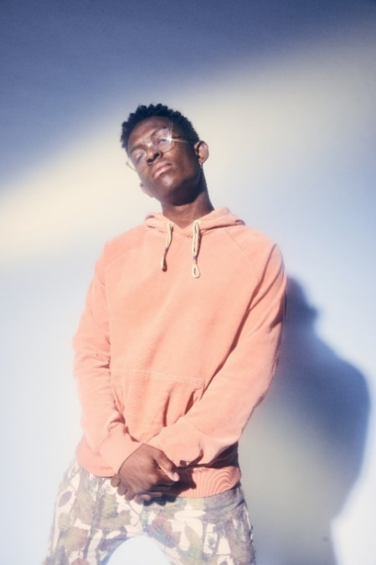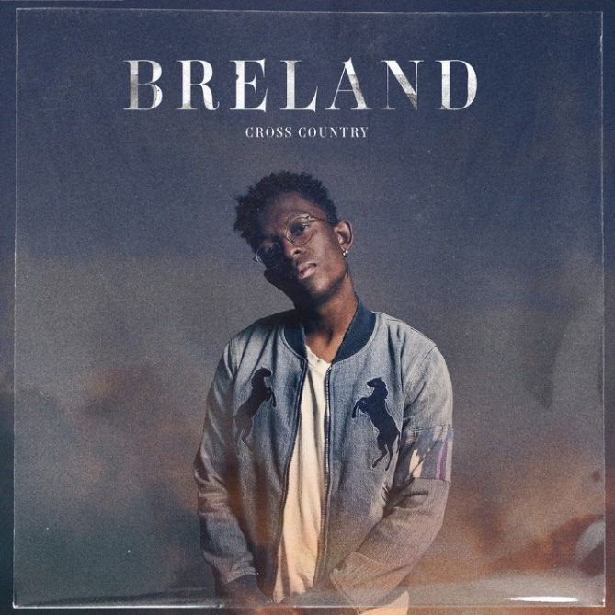
DOWNLOAD HIGH-RES PRESS ASSET(S) HERE DOWNLOAD ARTWORK HERE
PHOTO CREDIT: JIMMY FONTAINE PHOTO CREDIT: JIMMY FONTAINE | ARTWORK: NADA TAHA

# # #

CONNECT WITH BRELAND
WEBSITE | INSTAGRAM | FACEBOOK | TWITTER | YOUTUBE | SOUNDCLOUD | AMAZON MUSIC

BRELAND PR CONTACTS
Fairley McCaskill / Fairley.McCaskill@atlanticrecords.com
Jensen Sussman / jensen@sweettalkpr.com
Mary Catherine Rebrovick / MaryCatherine@wmg.com

