BRISTON MARONEY RELEASES “PARADISE” & ANNOUNCES “PARADISE” FESTIVAL

MARONEY TO CURATE + HEADLINE 2-DAY MUSIC FESTIVAL IN NASHVILLE ON NOV. 3 + 4

LINEUP INCLUDES INDIGO DE SOUZA, MICHELLE, SUNFLOWER BEAN, THE GREETING COMMITTEE & MORE

TICKETS FOR BRISTON’S FALL HEADLINE ALL ABOARD TOUR ON SALE NOW HERE

LISTEN TO “PARADISE” HERE
WATCH THE OFFICIAL MUSIC VIDEO HERE

download artwork here

“Briston Maroney Is Writing Powerful Rock Songs With Grit And Heart” – NPR

“…infectious…” – V MAGAZINE

“…confessional, feel-good music that gets to the heart of being human…” – THE LINE OF BEST FIT

Briston Maroney announces the release of new single “Paradise,” out now via Canvasback Music/Atlantic Records (listen here). The track – which arrives with an official music video also out today (watch here) – was written by Briston and produced by Andrew Sarlo (Big Thief, Bon Iver, Dijon), with additional production by Julian Cruz (Dominic Fike, Kenny Mason, Ambar Lucid).

Today’s news also includes the announcement of “Paradise”, a 2-night festival at Brooklyn Bowl Nashville in November (11/3 + 11/4) which Maroney will curate, headline, and present in partnership with local charities and organizations. Other artists performing include Indigo DeSouza, The Greeting Committee, Sunflower Bean, Annie DiRusso, Cece Coakley, and Canvasback labelmates MICHELLE.

For more info, please visit https://www.bristonmaroney.com/

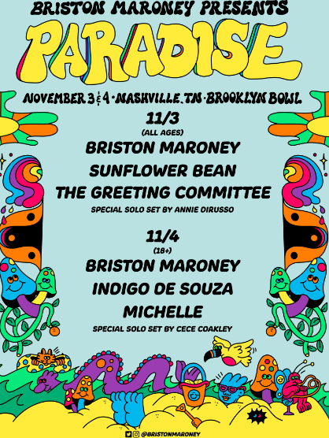
(DL poster here)

Maroney is currently on the road serving as support for Rainbow Kitten Surprise, following his opening for Jack White on select dates of White’s US tour. He also recently performed to large crowds at Hangout Fest and Bonnaroo in his native Tennessee. He will head out on his UK/Europe tour later this month, with a headline US tour set to kick off in September.

“Paradise” follows Sunflower: Deluxe, a deluxe version of Maroney’s 2021 full-length debut Sunflower. It includes new tracks such as “The Kitchen” – heralded by V Magazine as “infectious” – and reworks of original album tracks including “Bottle Rocket,” now featuring Manchester Orchestra, and “Cinnamon,” featuring alt-pop singer-songwriter Genevieve Stokes.

UPCOMING LIVE DATES
7/18/22 – Bristol, UK – Exchange^
7/20/22 – Manchester, UK – Band On The Wall^
7/21/22 – London, UK – The Garage^
7/23/22 – Suffolk, UK – Latitude Festival 2022
7/24/22 – Brighton, UK – Prince Albert^
7/26/22 – Paris, FR – Le Hasard Ludique^
7/27/22 – Amsterdam, NL – Paradiso^
7/29/22 – Hamburg, DE – Molotow^
7/30/22 – Berlin, DE – Prachtwerk^
8/5/22 – St. Charles, IA – Hinterland Music Festival 2022
8/7/22 – San Francisco, CA – Outside Lands Festival 2022
9/6/22 – Charlotte, NC – Neighborhood Theatre #
9/7/22 – Charleston, SC – Music Farm #
9/8/22 – Athens, GA – Georgia Theatre #
9/9/22 – 9/11/22 Bristol, TN – Bristol Rhythm & Roots Reunion 2022
9/10/22 – 9/11/22 Chattanooga, TN – Moon River Music Festival 2022
9/12/22 – Carrboro, NC – Cat’s Cradle #
9/14/22 – Charlottesville, VA – Jefferson Theater #
9/16/22 – Columbus, OH – Newport Music Hall #
9/17/22 – Pittsburgh, PA – Roxian Theatre #
9/19/22 – Grand Rapids, MI – Elevation at The Intersection #
9/20/22 – Toronto, ON – Phoenix Concert Theatre #
9/22/22 – Dover, DE – Firefly Festival
9/23/22 – Morgantown, WV – Metropolitan Theatre #
9/24/22 – Louisville, KY – Headliners Music Hall #
10/2/22 – Dana Point, CA – Ohana Music Festival 2022
11/3/22 – Nashville, TN – Paradise Festival @ Brooklyn Bowl Nashville
11/4/22 – Nashville, TN – Paradise Festival @ Brooklyn Bowl Nashville

^ with Special Guest Francis of Delirium
# with Special Guest Medium Build

***

ABOUT BRISTON MARONEY:
After a childhood spent between Tennessee and Florida, 24-year-old recording artist Briston Maroney landed in Nashville and developed a style steeped in the sweat and scrappy sounds of the city's DIY house parties, winning over fans one living room at a time.

Maroney’s 2018 EP Carnival –his take on the modern coming-of-age story and debut for Canvasback Music/Atlantic Records – amassed millions of streams, is highlighted by RIAA-Gold certified track “Freakin' Out On The Interstate,” and opened the door to tours with Wallows and Liz Cooper. The following year saw the release of Indiana, lauded by such tracks as “Fool’s Gold” (later featured on fellow Nashvillian Taylor Swift’s hugely popular Apple Music “Playlist by ME!”). Indiana was met with wide-ranging critical acclaim, with PAPER praising the EP for its “mixture of absolute tension and mounting significance” and NPR applauding his “buoyant guitar-pop” and “taut, hooky romanticism.” Indiana was ultimately cited on a number of 2019 “Best Of” lists, including Consequence of Sound, Vulture, and PAPER. At the top of 2020, Maroney released his third EP Miracle, heralded by “Chattanooga” and “The Garden” which Consequence of Sound declared “refreshingly raw.”

Briston released his full-length debut Sunflower in 2021, which earned critical acclaim from Billboard, NME and more, had a sold out accompanying tour, and has amassed 40+ million streams. Earlier this year, Maroney released Sunflower: Deluxe, which includes “Bottle Rocket” featuring Manchester Orchestra, as well as a rework of album track “Cinnamon” featuring alt-pop singer-songwriter Genevieve Stokes.

An energetic live performer with a craft honed in basements, living rooms, and jam-packed clubs, Maroney’s live touring includes sold out headline shows around the world, dates alongside Cold War Kids, Jack White and Rainbow Kitten Surprise, and international festival performances spanning Austin City Limits Music Festival to Pitchfork Paris.

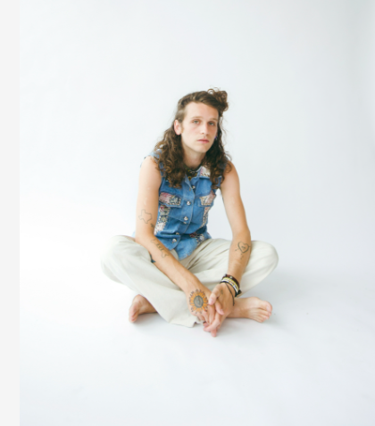
Download press photo here (credit Danica Robinson)

CONNECT WITH BRISTON MARONEY:
OFFICIAL I INSTAGRAM I YOUTUBE I FACEBOOK I TWITTER

FOR ALL PRESS INQUIRIES, PLEASE CONTACT:
Libby Kober (National) | Libby.Kober@AtlanticRecords.com
Gabby Reese (Tour/Online) | gabrielle.reese@AtlanticRecords.com

